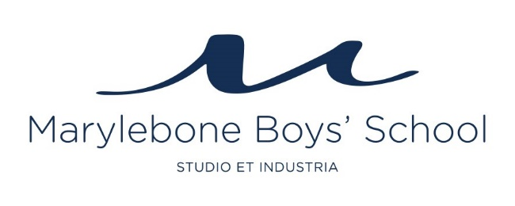

VACANCY DETAILS

Job title: Examinations Officer
Responsible to: Deputy Headteacher
Salary: Negotiable upon experience
Hours of work: 08.00-17.00 Monday - Friday
Terms: Permanent, full time
Starting: January 2018

OVERVIEW

Marylebone Boys' School is a Free School that opened in September 2014. We now have 480 boys in Years 7-10 and we will keep growing year by year until the school is full. We will add a mixed Sixth Form from 2019 and will eventually have over 800 pupils studying at our school.

We are an inner-city boys’ school with a cohort of 50% Pupil Premium students. We an academically rigorous school with an emphasis on good behaviour, commitment to learning and outstanding teaching, where knowledge is valued and available to all who are prepared to work for it. Expectations are high for all pupils. Those who need extra time and support will be helped and expected to achieve their full potential. Our motto is “studio et industria”, which can be translated as “through application and hard work”.

We follow safer recruitment practices and appointments are subject to a satisfactory enhanced DBS.

SUMMARY OF MAIN DUTIES / RESPONSIBILITIES

Job Title: Examinations Officer

Job Purpose: To be responsible for the efficient and effective professional administration, organisation and management of internal and external examinations within MBS.

Main Duties / Responsibilities:

ORGANISATION

- Organising recruitment and training for appropriate personnel (staff, invigilators etc.)
- Liaising with Heads of Departments / SLT for the collection of academic information on students and input of the same onto the MIS
- Establishing effective links and consultation procedures with examination bodies
- Producing timetable for internal examinations and the invigilation programme
- To be responsible for all external examination matters including:
- registering MBS with all the appropriate examination boards
- collecting and dealing with all correspondence from examination boards and taking appropriate action where necessary
- disseminating information from examination boards to departments
- collecting and sending entries, provisional, final and forecast grades, to examination boards at the appropriate times
- providing examination information to students (timetables, examination start times)
- ensuring papers are in safe keeping until required
- preparation and planning of the examinations season including contact with the various examination boards
- co-ordination of the release of information to the students
- assisting the SLT with the provision of statistical information and collating results
- sending off of completed papers and obtaining proof of postage
- Working closely with the Deputy Head Teacher by providing administrative support to the teaching and learning of students
- Provide advice and guidance to staff, students, parents/carers and others

ADMINISTRATION

- Undertaking accurate and efficient administrative tasks in order to ensure effective planning and preparation of internal and external examinations
- Producing staff and student timetables, and examination timetables
- Co-ordinating the collection and maintenance of examination information via the school management information system.

RESOURCES

- Operate relevant equipment/ICT packages (e.g. MS Office, internet, intranet, Progresso, email)
- Prepare Examinations budget for approval by SLT
- Monitor and control devolved Examination budget

MANAGEMENT

- Line manage direct reports (including Examination Invigilators) ensuring the effective and efficient operation of examinations to ensure individuals are effectively deployed

WIDER SCHOOL ROLES
- Assisting the DHT by providing administrative support.
- Working closely with the Data manager in ensuring the school MIS (Progresso) is effectively utilised for student tracking and exams systems.

PERSON SPECIFICATION

We are looking for someone with previous experience in an exams officer role or someone who shows potential to fulfil the demands of that role quickly.

Essential Skills

- Enjoys working in an educational setting
- A sense of humour
- Adaptability and someone who enjoys change
- Highly efficient and organised
- Calm and professional
- Ability to deal with confidentiality
- Excellent attendance
- Confidence in learning new skills and knowledge, especially around the technical aspects of the management information system.
- Confident to use email, Word, Excel, Outlook and able to mail merge
- Confident in handling exam based and numerical data
- Ability to communicate effectively both in written form and orally
- Initiative and resourcefulness
- Excellent telephone manner
- Degree level qualification

APPLICATION PROCESS
- Contact us if you would like more information about the school or the position on jobs@maryleboneschool.org.
- Please complete the required application form as well as a supporting statement (no more than two sides of A4).
- We will only interview candidates who provide two satisfactory referees.
- The deadline for applications is Wednesday 6 December 2017.

INTERVIEW PROCESS
- The interview process will include an interview and a series of administrative tasks to complete.
- We will inform all invited candidates of the outcome of their interview and offer feedback to those who are unsuccessful.

