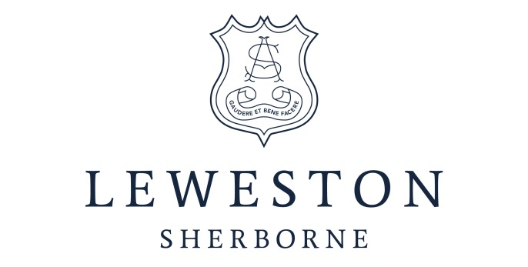

Independent Co-educational Boarding and Day School

Nursery Prep Senior Sixth Form
GSA/CISC

HEAD OF MATHEMATICS

(MATERNITY COVER)

REQUIRED FROM JANUARY 2019

We are seeking a well-qualified and dynamic teacher to lead the teaching of Mathematics throughout the school.

The ability and willingness to contribute to the extra-curricular life of the school is expected.

For further information and to request an application pack please contact:

Fiona McCarthy
Leweston School,
Sherborne, Dorset DT9 6EN
Tel: 01963 211016
Email: recruitment@leweston.dorset.sch.uk
www.leweston.co.uk

Closing date for Applications: 24th September 2018
Interviews: w/c 1st October 2018

Leweston is committed to safeguarding and promoting the welfare of children
and young people and expects all staff to share this commitment.
An enhanced Disclosure and Barring Service check will be required.

A Catholic Foundation which welcomes pupils of all Denominations

Leweston School Trust is a registered charity number 295175

