Mathematics Department

The Mathematics Department is a successful department which achieves excellent GCSE and A-level results.
Among the dedicated staff there is an emphasis on high expectations. Mainly, this is achieved through close teamwork and a willingness to adopt a wide variety of teaching styles and strategies.
Mathematics classes are set according to student ability. Teachers are expected to differentiate teaching and learning within each group. The setting of homework and marking of books are seen as integral parts of the learning process.
All teaching rooms are equipped with an interactive whiteboard and there is a set of classroom laptops for exclusive use in the department. The Maths team is large, currently consisting of 17 full-time members.
The Academy implements a condensed two-year Key Stage 3 and at Key Stage 4 students follow the Edexcel linear syllabus. Students in Years 7-13 take part in the UKMT Mathematics Challenge and have successfully achieved many Gold, Silver and Bronze awards.
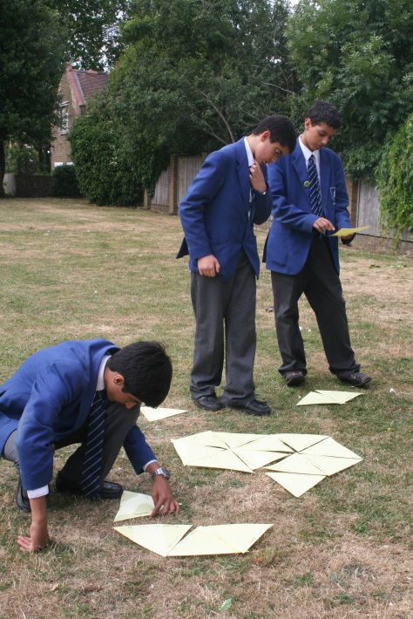
A true reflection of the Academy’s commitment to Mathematics is seen in the large numbers of students continuing with the subject in Sixth Form. Students study the Edexcel AS and A Level Mathematics and Further Mathematics courses and the Academy also offers the International Baccalaureate Diploma Programme.
Standards at the end of KS4 are excellent. In 2018, 90% of our GCSE students achieved grades 4-9, 77% achieved grades 5-9, with 48% of students achieving grades 7-9. 13% of students achieved a grade 9.
Standards at the end of Year 13 are also excellent with 94% achieving A* to C in A-Level Maths and 54% of our students achieving A*/A.
In Further Maths, 100% achieved A*-C and 70% of students achieved an A or A* grade.
Our IB results were exceptional, with 47% of students achieving a grade 7. Furthermore, 100% of IB Higher Level students achieved this top score.
We offer additional support to low ability students throughout the Academy, as well as additional enrichment sessions to gifted and talented students in all year groups.
We are seeking to appoint a highly enthusiastic Mathematics teacher who would be able to motivate students to achieve their full potential. They would work closely with a team of very dedicated practitioners to deliver a flexible and dynamic curriculum.

