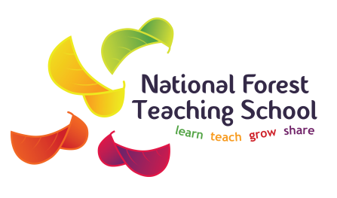

THE STOKE AND STAFFS TEACHING SCHOOLS’ ALLIANCE
C/o National Forest Teaching School
Dunstall Road, Barton under Needwood
Burton upon Trent, Staffordshire DE13 8AZ

Project Coordinator – School Improvement Project
to commence in post 16th April 2018

The Stoke and Staffs Teaching Schools’ Alliance, comprising of 7 Teaching Schools, has been awarded a grant to support 30 local schools to secure improvement in outcomes in English at both Key Stage 2 and Key Stage 4 within 4 school terms.

We are looking to recruit a Project Coordinator for the duration of the project (4 terms) to coordinate and manage the project under the direction of the Project Management Group.
The successful candidate will ideally work out of the Training Centre at John Taylor High School although the role does allow for some flexibility on location

This will be a fixed term, 37 hours per week, term-time only role payable at Grade 8 (SCP 28-33) salary range: £21,583 - £25,351. The post will commence on 16th April 2018 and terminate on 31st July 2019.

For an application form please visit:-
http://www.nationalforestteachingschool.co.uk
Please return completed form to recruitment@jths.co.uk

Closing date 9am Monday 5th March 2018

The teaching school alliance is committed to safeguarding and promoting the welfare of children and young people/vulnerable adults and expect all staff and volunteers to share this commitment.

An enhanced disclosure check will be a requirement of the post.

