

Job Description – Learning Support Assistant (LSA)

September 2024

Job Title: Learning Support Assistant
Grade: LBR Scale Point 3 Fixed Term – permanent contract
Responsible to: SENDCo
Responsible for: Supporting SEND pupils within our LSA model


We are excited to offer the opportunity for you to join our wonderful team at Redbridge Primary School as a Learning Support Assistant. Redbridge Primary School is a large four form entry school, with an ambitious learning community. We strive to achieve an environment where inspirational teaching and enrichment opportunities come together to create a true enjoyment and love of learning for our diverse community.
Main areas of responsibility;
Working with Pupils
- Support children with additional needs under the directions of the teacher and/or SENDCo
- Be a champion for the children that you support and ensure their voice is heard
- Provide a nurturing and purposeful environment for pupils
- Develop an effective personal relationship with children and support them when they are dysregulated
- Promote pupil progress through carefully designed support
- Challenge and motivate pupils and promote and reinforce self-esteem
- Feedback to children in a way that they understand how they have performed and what their next steps are
- Contribute to the assessment of children following the school data system
- Contribute to written assessments and reports of individual pupils
- Attend to pupils’ personal needs, intimate care and assist in their social, health and hygiene development – as directed
- Develop life skills in our pupils through wider opportunities

Working as part of the wider staff team

- Work collaboratively with the SENDCo and external professionals, proactively implementing their advice
- Ensure EHCP provision and any bespoke curriculum is implemented and share in the coordination of that support
- Provide feedback to teachers, SENDCo and parents
- Assist in the development and implementation of individual behavior plans where necessary
- Be responsible for keeping accurate records using the school’s systems
- Recognise own strengths and areas of expertise and use these to advise and support others

General Responsibilities
- Be responsible for promoting and safeguarding the welfare of all children at school, but especially those who are vulnerable and have additional needs
- Attend professional development training sessions and implement that training into practice
- Follow school policies and procedures
- Contribute to wider school life
- Build and maintain positive relationships with children, staff and parents
- Maintain high standards of professional conduct and do not discuss sensitive details about children, families and staff inside or outside of school

Qualifications and Experience
- Experience of working with children with additional needs
- Experience of supporting families with children with additional needs
- Ability to provide nurture and care
- Ability to foster independence in children
- Excellent teamwork
- Creative and forward thinking
- Flexible, excellent time keeper and ability to work to deadlines
- IT literate
- Strong written and oral communication skills


If you're looking for a great place to teach, then Redbridge Primary School should definitely be at the top of your list. Here are some reasons why you should consider teaching at our school:
- Incredible Children: Our children are simply wonderful! They are kind, creative and enthusiastic about their learning. Everyone who visits our school comments on how welcoming and lovely our children are to be around.
- Dynamic Leadership: The school is led by a positive and experienced leadership team who are dedicated to ensuring that every child receives the best possible education. They are committed to being approachable and supportive to ensure that our staff team have the necessary tools and skills to undertake their jobs.
- Learning Environment: Redbridge Primary School prides itself on fostering an inclusive and welcoming environment where children can learn, grow and become the best version of themselves. Our curriculum places a strong focus on developing children's social and emotional wellbeing alongside their academic achievements, ensuring they thrive in all aspects of their lives.
- Family first approach: At Redbridge Primary School we don’t just accept, but we celebrate the fact that our staff have lives and their own families outside of school. Our people are at the heart of our success. We have developed a strong culture of collaboration and best practice. We look after, and invest in our staff with support, coaching, mentoring, as well as providing an award winning employee wellbeing service for all staff.
- Excellent Professional Development: The school places a strong emphasis on professional development, providing ongoing training and support to help you grow and develop as a teacher. You will have access to a wide range of resources, including training programs, coaching, and mentoring, enabling you to continually improve your practice.
- Supportive Community: At Redbridge Primary School, you will be part of a warm and welcoming community that is dedicated to providing the best possible education for its children. The school has strong links with our families, and the wider community, creating a supportive and collaborative learning environment.
Next Steps
If you have any questions about joining the team at Redbridge Primary, please contact us via e-mail, or call to arrange a conversation. We would also be more than happy to show you around our school.
Please have a look at our website and Instagram feed (redbridgeprimary.school) to get an insight into life at RPS!

Closing date for applications: Monday 30th September, 12 noon
Shortlisting will take place on: Monday 30th September, 1pm
Interviews will be held on: Week Commencing 7th October 2024
Application forms should be emailed to: admin.redbridgeprimary@redbridge.gov.uk
or completed online via TES

Link to application form on school website https://redbridgeprimary.redbridge.sch.uk/wp-content/uploads/Vacancies/Redbridge%20Application%20Form.pdf

Please email any queries or questions about the post to admin.redbridgeprimary@redbridge.gov.uk

Safeguarding Notice
Redbridge Primary School is committed to ensuring the highest levels of safeguarding and promoting the welfare of children and young people, and we expect all our staff and volunteers to share this commitment. All offers of employment are subject to an enhanced Disclosure and Barring Service (DBS) check, references, and where applicable, a prohibition from teaching check will be completed. Online searches will also be completed
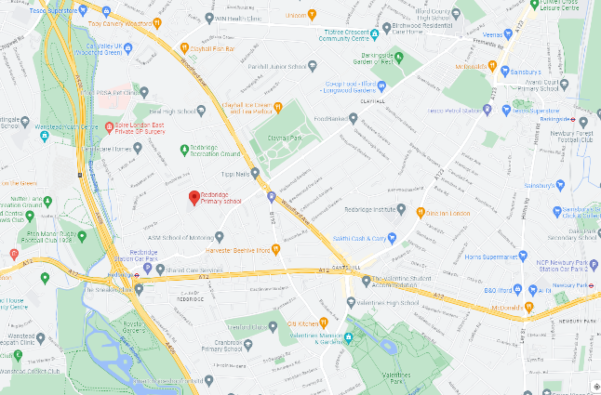
Great Location!
Walking distance to Redbridge and Gants Hill Tube station on the Central Line.
0.5 miles from the A406 and A12

