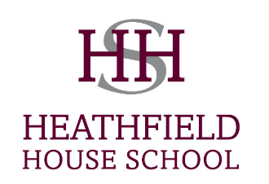
Application and Recruitment Procedure
Heathfield House School’s recruitment and selection procedures observe our equal opportunities policy. Our recruitment procedures ensure that all applicants are selected fairly and our selection procedures provide a fair, reliable and systematic basis for selecting the right candidate.
Heathfield House School is an independent primary school for boys and girls from 4 to 11 years. It opened in September 2004 with eight pupils and now has over 200 pupils. In September 2012 the school expanded by opening an Early Years Centre. Heathfield House School now operates a two form entry in most year groups.

Philosophy of Heathfield House School
The school aims to provide a stimulating, well balanced and varied education helping each child to develop his or her full potential intellectually, socially and physically. The school provides a safe and supportive environment in which children are confident to ‘give it a go’. The friendly and happy atmosphere of the school encourages children to do their best and acquire a positive attitude towards learning. The children of Heathfield House School are confident, enthusiastic and curious learners able to think independently and live happily and co-operatively. We strive to provide an extensive extra-curricular programme in order for children to discover their own strengths and talents.
Job description
An excellent teacher, with energy and commitment is required from April 2019. The successful applicant would be required to take on the role applied for and should be prepared to play a full role in both curricular and extra-curricular activities. A full job description is available on the advert.
Procedure for applying
Please complete the attached job application form in full and also write a letter to support your application. CV’s will not be accepted.
Interviews
An interview will proceed once the shortlist has been agreed. Interviews are with the Headteacher, Proprietor or Deputy Headteacher. We also ask candidates to teach a lesson on the same day as their interview; the year group and topic will be supplied in advance. The applicants will also be given a tour of the school and take part in a children’s interview.

Candidates
The successful candidate will be professional and have a love of teaching. We are looking for a motivated, inspirational teacher who is willing to share best practice and try new ideas.
Salary
The salary will be determined on ability and experience. The School operates its own pay system. The school offers a pension scheme.
Safeguarding Children
Heathfield House School is committed to safeguarding the welfare of our pupils and expect all staff to share this commitment. Successful candidates must be willing to undergo checks with previous employers, a DBS check, an identity check, a completion of a self-certified medical form and training in child protection and first aid if not already trained.
Equal opportunities
Heathfield House School are committed to equal opportunities for all, regardless of race, colour, religion, ethnic or national origin, sexual orientation, age, gender or disability.

