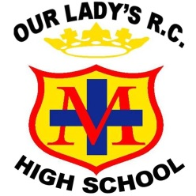
TEACHER OF ART & PHOTOGRAPHY
Start date: Easter/September 2020
Salary: MPS/UPS (Plus photography TLR for the right candidate)
Contract term: Permanent. Contract type: Full Time

We are seeking to appoint a creative and highly motivated teacher of Art & Photography to join our successful art department. The right candidate will be an exceptional teacher with a commitment to excellence and inspiring a love of visual art in young people. They will play a pivotal role in securing the very best outcomes for an already successful department. We are looking for someone who will be significantly involved in providing an enriched curriculum and opportunities to stretch and challenge all students.
We offer a vibrant and diverse community with a calm, positive and innovative learning environment. The facilities are modern and the art department is based in two large studio/classrooms with panoramic windows offering good lighting and scenic views. The department regularly achieves outstanding outcomes and the new teacher will be actively involved in building upon this success.
Our Lady’s is a heavily oversubscribed successful Catholic school with a “Good” judgement from Ofsted and an excellent reputation across the Diocese of Salford. We strive for academic excellence whilst also offering students a vast array of enrichment opportunities to help them discover and nurture their talents. We pride ourselves on meeting the needs of each individual and ensuring positive outcomes for young people of all abilities. The successful candidate will benefit from:
- A supportive and nurturing working environment that provides high quality, professional, developmental experiences.
- The opportunity for career progression
Prospective candidates are encouraged to visit the school to witness our vibrant community. To arrange an informal visit contact Sally Royle (PA to Headteacher) on 0161 507 9670 or s.royle@olsc.manchester.sch.uk
On behalf of our students, thank you for your interest in our school
Closing date: Friday 24th January at 9.00am.
Interviews are anticipated for week commencing Monday 27th January

