Music
Department Information

About the role
We are looking for an enthusiastic teacher of Music who passionately believes in putting students first. You will be joining a committed and hardworking department. It is expected that the successful candidate will be able to teach across the age and ability range, including A-level, CTEC Performing Arts and GCSE. We simply want the best teachers for our students, and that could be you!
About the department

The Music Department is a vibrant and exciting place for staff and pupils alike. Over the past few years we have grown both in the Curriculum and in our Instrumental Programme. Over 250 students now take part in a weekly instrumental/vocal lesson with many more taking part in our extensive extracurricular timetable. The Music Department is situated in the new building with recently upgraded infrastructure giving students access to the latest technology in music. 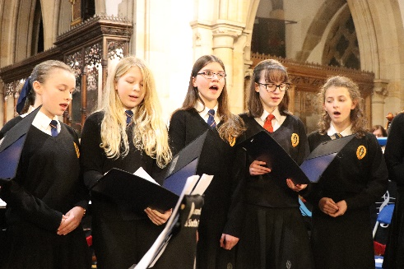
The Department consists of ten teachers. Two curriculum specialists, including the Lead Teacher and eight visiting Instrumental Programme teachers. There is also a Music Technician who supports a variety of roles across the dept. This gives a creative mix of youth, expertise and experience within the team that actively aims to support any new staff joining the team.
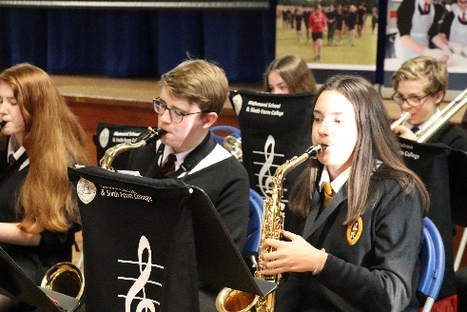
The Department has a collaborative approach to teaching and learning. We believe in sharing ideas and resources, and supporting each other in a continual drive to improve the musical experience we provide for our students. We are a well-resourced department with students having access to Sibelius and Cubase software as well as Logic for more advanced courses. We also are well stocked with instruments to teach focusing on practical development. KS3 is paperless with KS4 & 5 mainly computer based in composition and written work. Student recordings are continuously made and shared via Google Classroom.

About the courses
In KS3 there are approximately 250 students in each year studying Music in mixed ability classes of around 28 students. From Y9 students elect to study GCSE Music and the numbers range from 20 -30 in each year group.
About the results
The Music examination results over the last few years have been continually improving and there is an expectation this will remain for many years to come.
Extra-Curricular
The successful candidate will have responsibility for at least one extracurricular activity in their area of expertise, and will be expected to support others as required. 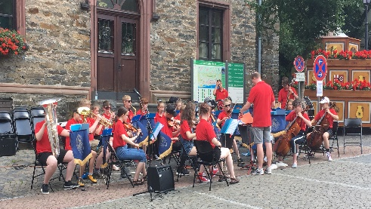
We enjoy our time at Richmond School and find it a rewarding place to work and make music!

