Cover Supervisor
Supply/Relief. Term Time Only
Grade D: £9.55-£9.94 per hour

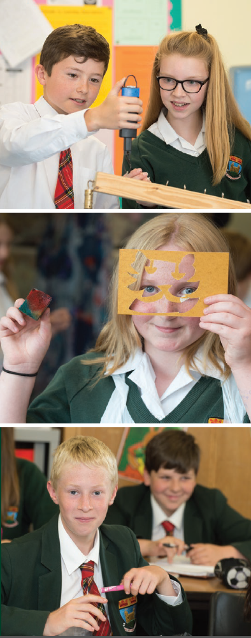
We are seeking to appoint a self-motivated Supply/Relief Cover Supervisor to work on an ad hoc basis to cover short-term absence of teaching staff. The team is responsible for a wide range of duties, which include the supervision of students and delivery of work pre-prepared by the subject teacher.

Term Time Only, Supply/Relief contract. In return, we offer a competitive salary, access to a contributory local government pension scheme and other additional staff benefits. On days where working hours are 6 hours or over, you will receive a 30 minute unpaid break.

You will have a good understanding of classroom rules and procedures and the ability to manage time and communicate effectively to complete tasks to a high standard. You will have the confidence to manage pupil behaviour.

The job will include:
- registration and supervision of pupils
- delivery of pre-prepared activities and learning as set out by the subject teacher, to enable continuity of learning in their absence
- provision of support and encouragement to pupils, and manage classroom organisation during the cover lesson
- management of pupil behaviour
- collection of any completed work at the end of the lesson, provision of feedback and returning work to the appropriate person.

You will be a dynamic and highly motivated individual with the ability to work without supervision. All training will be provided.

The school is committed to safeguarding and promoting the welfare of young people and expects all members of staff to share this commitment. Enhanced DBS disclosure is required for this post.

Completed applications must be submitted via email to: recruitment@king-james.n-yorks.sch.uk and received by:
Friday 20th September 2019, 08.00am

Please note that CVs will not be accepted.

