Job Title |  | Full Time ICT Technician / Mobile Technician Level 4
Grade | 7 | Responsible to: | MAT Director of IT
Date |  | Location | Central Team (Various Locations)
Line Manager |  | MLY
Technician Name

1. JOB PURPOSE

To be a member of a technical support service for the ICT services across the Multi Academy Trust (MAT). You will:

- Provide IT technical support throughout the MAT
- Visit schools in the MAT as directed or by schedule
- Provide a friendly and responsive service to requests for assistance from all users
- Carry out such duties as are required and as are commensurate with the grade of the post
- Work with other member of the team to resolve issues as appropriate

2. MAIN DUTIES AND RESPONSIBILITIES

You will be responsible for general maintenance of computer equipment and for the resolution of basic technical problems, as well as undertaking general tasks which will promote the use of IT across the MAT schools.

You need to::

- Respond to and prioritise routine and emergency ICT requests across the MAT as required or directed. Any issues that cannot be resolved in a timely manner will need to be escalated to other members of the ICT support team.
- Rectify where possible any damage to the rooms.
- Check for health and safety issues and report any potentially dangerous situations.
- Work in compliance with the Codes of Conduct, Regulations and policies of the Local Authority and its commitment to equal opportunities.
- Ensure that output and quality of work is of a high standard and complies with current legislation / standards.
- Use the On-line ticket system for issues that have been logged by schools within the MAT and to update the call status of jobs, including any interim work that has been completed on a job.
- To assist in the maintenance of the IT Inventory that is accurate and up to date including details of location of all equipment, especially in the event of equipment being moved or end of life.
- To assist in any development work at any school in the MAT.
- Liaise with outside organisations with regard to logging service and support calls.
- To request quotations for new equipment but only after having discussed with the line manager
- Meet with your line manager to discuss any outstanding tickets and to plan for the short term.
- Check that all IT equipment is clean and fit for use. Ensure that any relevant filters are cleaned. (Ensuring that H&S procedures are followed, and ensuring you understand the implications of the Working at Heights Legislation)
- To work with end users to ensure that software is configured correctly for use with external peripherals and dongles.
- Ensure phones are working, escalating where required
- Ensure wireless is functional, escalating issues where required including configuration

3 The installation and maintenance of the school’s ICT resource

3.1 Desktop & Application Support

- Connect, maintain, repair, upgrade and check PCs and peripherals for normal operation.
- Perform routine maintenance tasks, this may include installing basic software packages and setting common options.
- Trouble-shoot system problems and escalate where appropriate.
- Advise on compatibility of hardware, applications and operating systems, according to user requirements.
- Maintenance and Administration of cloud services
- Create MSI packages in conjunction with line manager and deploy packages that have been centrally created
- Work with the ICT support team to troubleshoot Apple MAC desktop issues
- Maintenance and Administration of Apple MAC services across the MAT

3.2 Server & Network support

- Perform routine tasks to maintain user accounts and permissions, including implementing disk space and printer quota policies.
- Check active network components including switches, routers and bridges are working effectively; check remote access to the school’s network services and adjust as appropriate.
- Assist with the changing of network passwords.
- Ensure that all synchronisation is happening correctly including with Unify and Google.
- Ensure that all server updates are applied, both Microsoft and RM patches were appropriate
- Monitor disk utilisation and advise the Director of IT or Deputy Director of IT where space issues are perceived to be an issue.
- Ensure that user disk quotas are applied according to MAT policy
- Support colleagues with the configuration of infrastructure across schools in the MAT (including but not limited to switches, routers and wireless controllers)
- Analyse risks to key ICT systems and agree priorities.
- Configure and maintain wireless deployments documenting the process in conjunction with the line manager
- Configure and maintain switch configurations documenting the process in conjunction with the line manager.
- Provide network and scripting support of Apple MAC solutions with in the MAT

Whilst on any site, you will need to consider:

3.3 Health & Safety

- Ensure that you are conversant with H&S as it applies to employees in the workspace
- Follow relevant H&S procedures and raise awareness among staff, pupils and other users.
- Ensure that all rooms have up to date fire evacuation documentation. If these are missing you need to inform the relevant senior staff in that establishment.
- Advise all staff, where appropriate of any issues that may affect the functioning of computers in a room.
- Advise site staff of any contraventions of Portable Appliance Testing that may be noticed while around the school.
- Undertake any H&S training as advised by your line managers to ensure that you are fully up to date with any recent legislation
- Ensure that any ladders that are used are on the school’s ladder register
- Make recommendations to school leaders and line managers about H&S concerns

4 The support and management of the School’s ICT service

4.1 Continuity, Maintenance & Security

- Follow routine maintenance procedures.
- Follow the MAT backup, virus protection and security procedures.
- Note risks to ICT systems and report to line manager.
- Note risks to ICT systems and suggest precautions; follow extended maintenance procedures.
- Plan for system downtime so that it least affects the users.

4.2 Support Request Management

- Prioritise resolution of problems and determine whether external support is required
- Prioritise resolution of problems and determine whether external support is required; allocate tasks between support staff, including recording requests, following up calls and implementing a maintenance schedule. Provide second and third level of in-school support for more complex requests.
- Advise the team leader of outstanding issues and seek advice in prioritising issues.

5. Person Specification

Person Specification | Essential (E) or Desirable (D)
Education and Educational awareness
Relevant educational qualifications, but a minimum of 5 GCSE at Grade 5 or above including English and Maths. | E
Qualifications in TITS Practitioner or ITIL Foundation | D
Keep up to date with IT technologies | E
Committed to own continuing professional development including attending technical seminars | E
Experience
In depth Knowledge of MAC login scripts | E
In depth knowledge of Apple MAC networking | E
In depth knowledge of Apple MAC desktop operating system | E
In depth knowledge of supporting current Windows desktop operating system | E
In depth knowledge of supporting iOS in an enterprise environment | D
Knowledge of standard networking technologies including WAN and LAN | E
Knowledge of switches and switching technologies including the creation of VLANS and routing. | E
In depth knowledge of standard networking technologies including but not limited to DNS and DHCP | E
Experience with working with a virtualised server environment | E
Excellent working knowledge of desktop applications including MS Office | E
Experience of maintaining Google G-Suite | E
Experience of managing Google G-Suite | E
Experience of print management solutions, ideally PaperCut | E
Working knowledge of schools MIS systems | E
Knowledge of supporting VOIP | E
Behaviours
Natural communicator | E
Professional, approachable, reliable and trustworthy | E
Confident and logical approach to problem solving | E
Self confident, adaptable and flexible | E
Confident at following through on tasks and resolving enquiries | E
Proactive and innovative | E
Positive attitude to change | E
Able to take on board constructive criticism and learn from mistakes | E
Able to work unsupervised for periods of time | E
Show a willingness to be involved with special projects as requested by your line manager. | E
Skills
Excellent written and verbal communication skills | E
Excellent planning and organisational skills | E
Good organisational skills | E
Ability to prioritise and multitask | E
Ability to diagnose and troubleshoot issues | E
Current UK driving license and access to a vehicle to allow travel between sites | E

6. Special Conditions

- This is a full time position working 37 hours per week normally between 8.30am-4.30pm however some flexibility will be required.
- The post holder will be required to be on a site by 8.30am in the morning, unless agreed in advance by the director of ICT.
- Overtime may be paid for certain work but only with the prior agreement of the line manager.
- The post-holder will be required to negotiate their holiday entitlement so that it does not clash with other members of the team. Some of this will need to be taken in term time as holiday times are used for some of the significant development on the ICT systems.
- This job description is not necessarily a comprehensive definition of the post. It will be reviewed at least once a year and it may be subject to modification or amendment at any time after consultation with the holder of the post.
- The post holder will undergo an annual appraisal meeting with the Director of ICT.
- This job description does not form part of the contract of employment. It describes the way the post holder is expected and required to perform and complete the particular duties as set out in the foregoing detail
- This job description only contains the main accountabilities relating to this post and does not describe in detail all the duties required to carry them out. Additional duties may be assigned by the Director or Deputy Director of ICT.
- This appointment will be subject to the satisfactory completion of a six month probationary period.

7. Safeguarding Young People

Midsomer Norton Schools Partnership is committed to safeguarding and promoting the welfare of children and young people and expects all staff and volunteers to share this commitment. An enhanced DBS and ISA Registration are required prior to appointment.
The post holder must promote and safeguard the welfare of children, young and vulnerable people that they are responsible for or come into contact with.
The postholder will be expected to contribute to the protection of children as appropriate, in accordance with any agreed policies and/or guidelines, reporting any issues or concerns to their immediate line manager.
This job description only contains the main accountabilities relating to the post and does not describe in detail all of the duties required to carry them out.

8. ORGANISATION
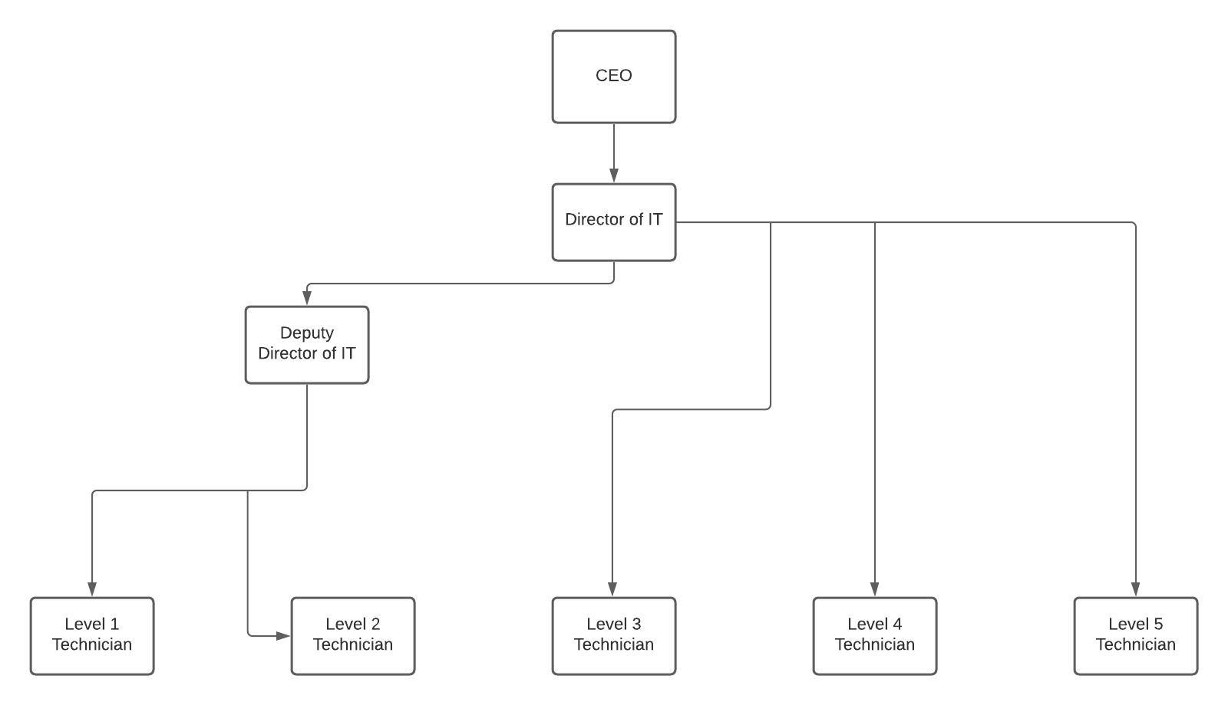

Post Holder: Line Manager:

Name: Name:

Signature: ________________ Signature: ________________

Date: ________________ Date: ________________

