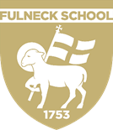
FULNECK SCHOOL
PUDSEY, LEEDS, LS28 8DS

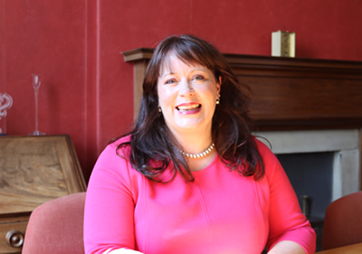
Principal’s Welcome
Fulneck School’s academic results speak for themselves and the School is proud of its position in the top 5% of all schools and colleges in England last year. With our diverse curriculum, we are constantly able to help our pupils to fulfil, if not exceed, their academic potential. Whether it be pupils with Oxbridge aspirations or those needing expert care from our award-winning Learning Support Unit, Fulneck School is equipped to help each individual succeed.
Just as important, however, are the ambitions, skills and personal attributes that are developed through a Fulneck education. Whether it be music, sport, drama or the Duke of Edinburgh Award scheme, pupils learn how to succeed as individuals and as teams. As adults, we know that those characteristics are, in the end, as important as exam qualifications in determining our success in the real world.
A Fulneck education opens doors for its pupils, giving them the tools and skills, they need to approach the next stage of their careers with confidence and enthusiasm. Our committed and expert staff inspire our pupils to gain a love of learning, an inquisitive mind, the confidence to try new things and old-fashioned Yorkshire grit to pick themselves up if at first they don’t succeed.
Where we differ from other schools, however, is in our emphasis on making a positive contribution to the society around us, whether that be in West Yorkshire, the UK or further afield like Benjamin Latrobe. Our pupils are outward-looking, empathetic and humble.
We are a diverse yet close-knit community with a family feel to it. The welcome you will receive is incredibly warm – do come and experience it for yourself.
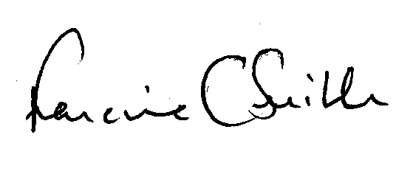
​Principal

Fulneck fulfils….
Fulneck has a warm, family atmosphere and is a vibrant, inclusive community in which to live, learn and achieve. The wonderful rural location in the historic and unique settlement of Fulneck provides an inspirational and stimulating environment for children and young people to fulfil their potential.
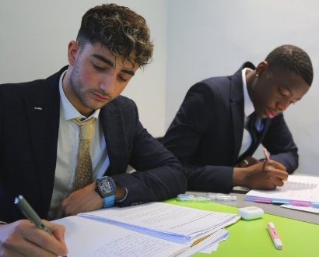
For over two hundred and fifty years, Fulneck has delivered a distinctive education which values individuals, and it is the quality of the relationships and the personalised approach that makes our school so successful. Our students are at the heart of everything we do; they are happy, creative, aspirational and form life-long friendships. Small acts of kindness are valued in equal measure alongside achievements in national competitions.
Our community is enriched by its diversity, with pupils coming to us from across Yorkshire, the UK and all over the world. Our small boarding house provides a real family atmosphere and is a ‘home away from home’ whether that is for the occasional night, weekly or full, termly boarding.
As a School we work with our learners to develop a strength of character, resilience and growth mind-set that will help them to overcome the challenges they are likely to encounter in adult life.

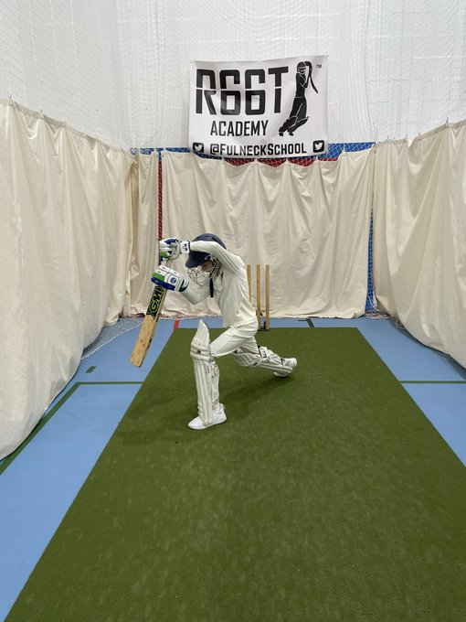
By providing a range of enrichment opportunities and real-world experiences, we allow our pupils to succeed in the next stage of their education, training or employment. By developing an appreciation of the “real world”, we believe that our students wholeheartedly deserve a learning experience that does not narrow their life chances but enables social equity, mobility, builds cultural capital and a sense of being able to take on the world.
We are also proud of our collaboration with The Root Collaboration and Fulneck School is proud to provide the opportunity for talented young cricketers from around the world, to combine a first-class cricket coaching programme with a full academic pathway for students from Year 7 - Year 13.
What our staff say about Fulneck:
“I remember my first week, starting mid-term which is more nerve wracking than normal and I was instantly welcomed by staff who made me feel at home and invited me to lunch, and the students were welcoming and engaged and I felt at home”
“I love the small class sizes it allows me to tailor my lessons and feedback to the individual learner and allows every learner to progress”
“Being part of Fulneck really feels like being part of a family, you get to know all of the students really well and there are many opportunities to interact with staff outside of your department which you just don’t get in larger schools.”
What our students say about Fulneck:
“The teachers allow me to be individual as it allows me to express myself and they respect my uniqueness”
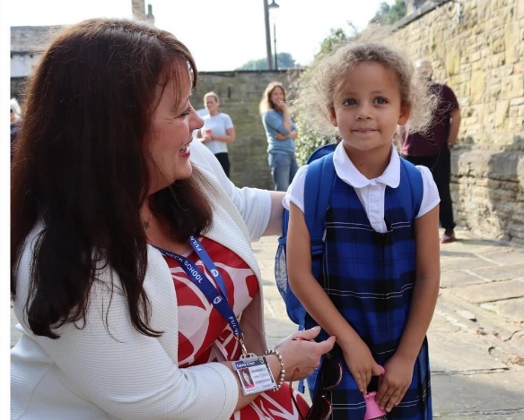
“I have been at Fulneck for Sixth form since 2020 and having been at another independent school, I can say that the teachers here, care more about their students and their well-being”
“I love being in boarding as it helps me to experience different cultures and get to know people from around the world and the boarding trips help enrich my creativity and I feel well looked and cared for by boarding and teaching staff”

What our parents say from our recent parent survey:
“The school is amazing with my child we have made a great decision to send him here despite having good state schools around where we live, the small class sizes are a huge bonus and allow for good friendships to be made.”
“The support offered to my daughter since joining Fulneck is excellent. We have received total understanding and support of her situation and thanks to this she achieved good GCSE results. Now in sixth form that support is continuing with many teachers going that extra mile to help.”
“I will be forever grateful to these staff for helping to turn things around for my child as she previously missed 3 years of education and since starting at Fulneck has progressed so much. Fulneck’s approach to helping SEND children is amazing and it has given both my child and us as a family a new lease of life.”

