
Job Title: Behaviour Mentor

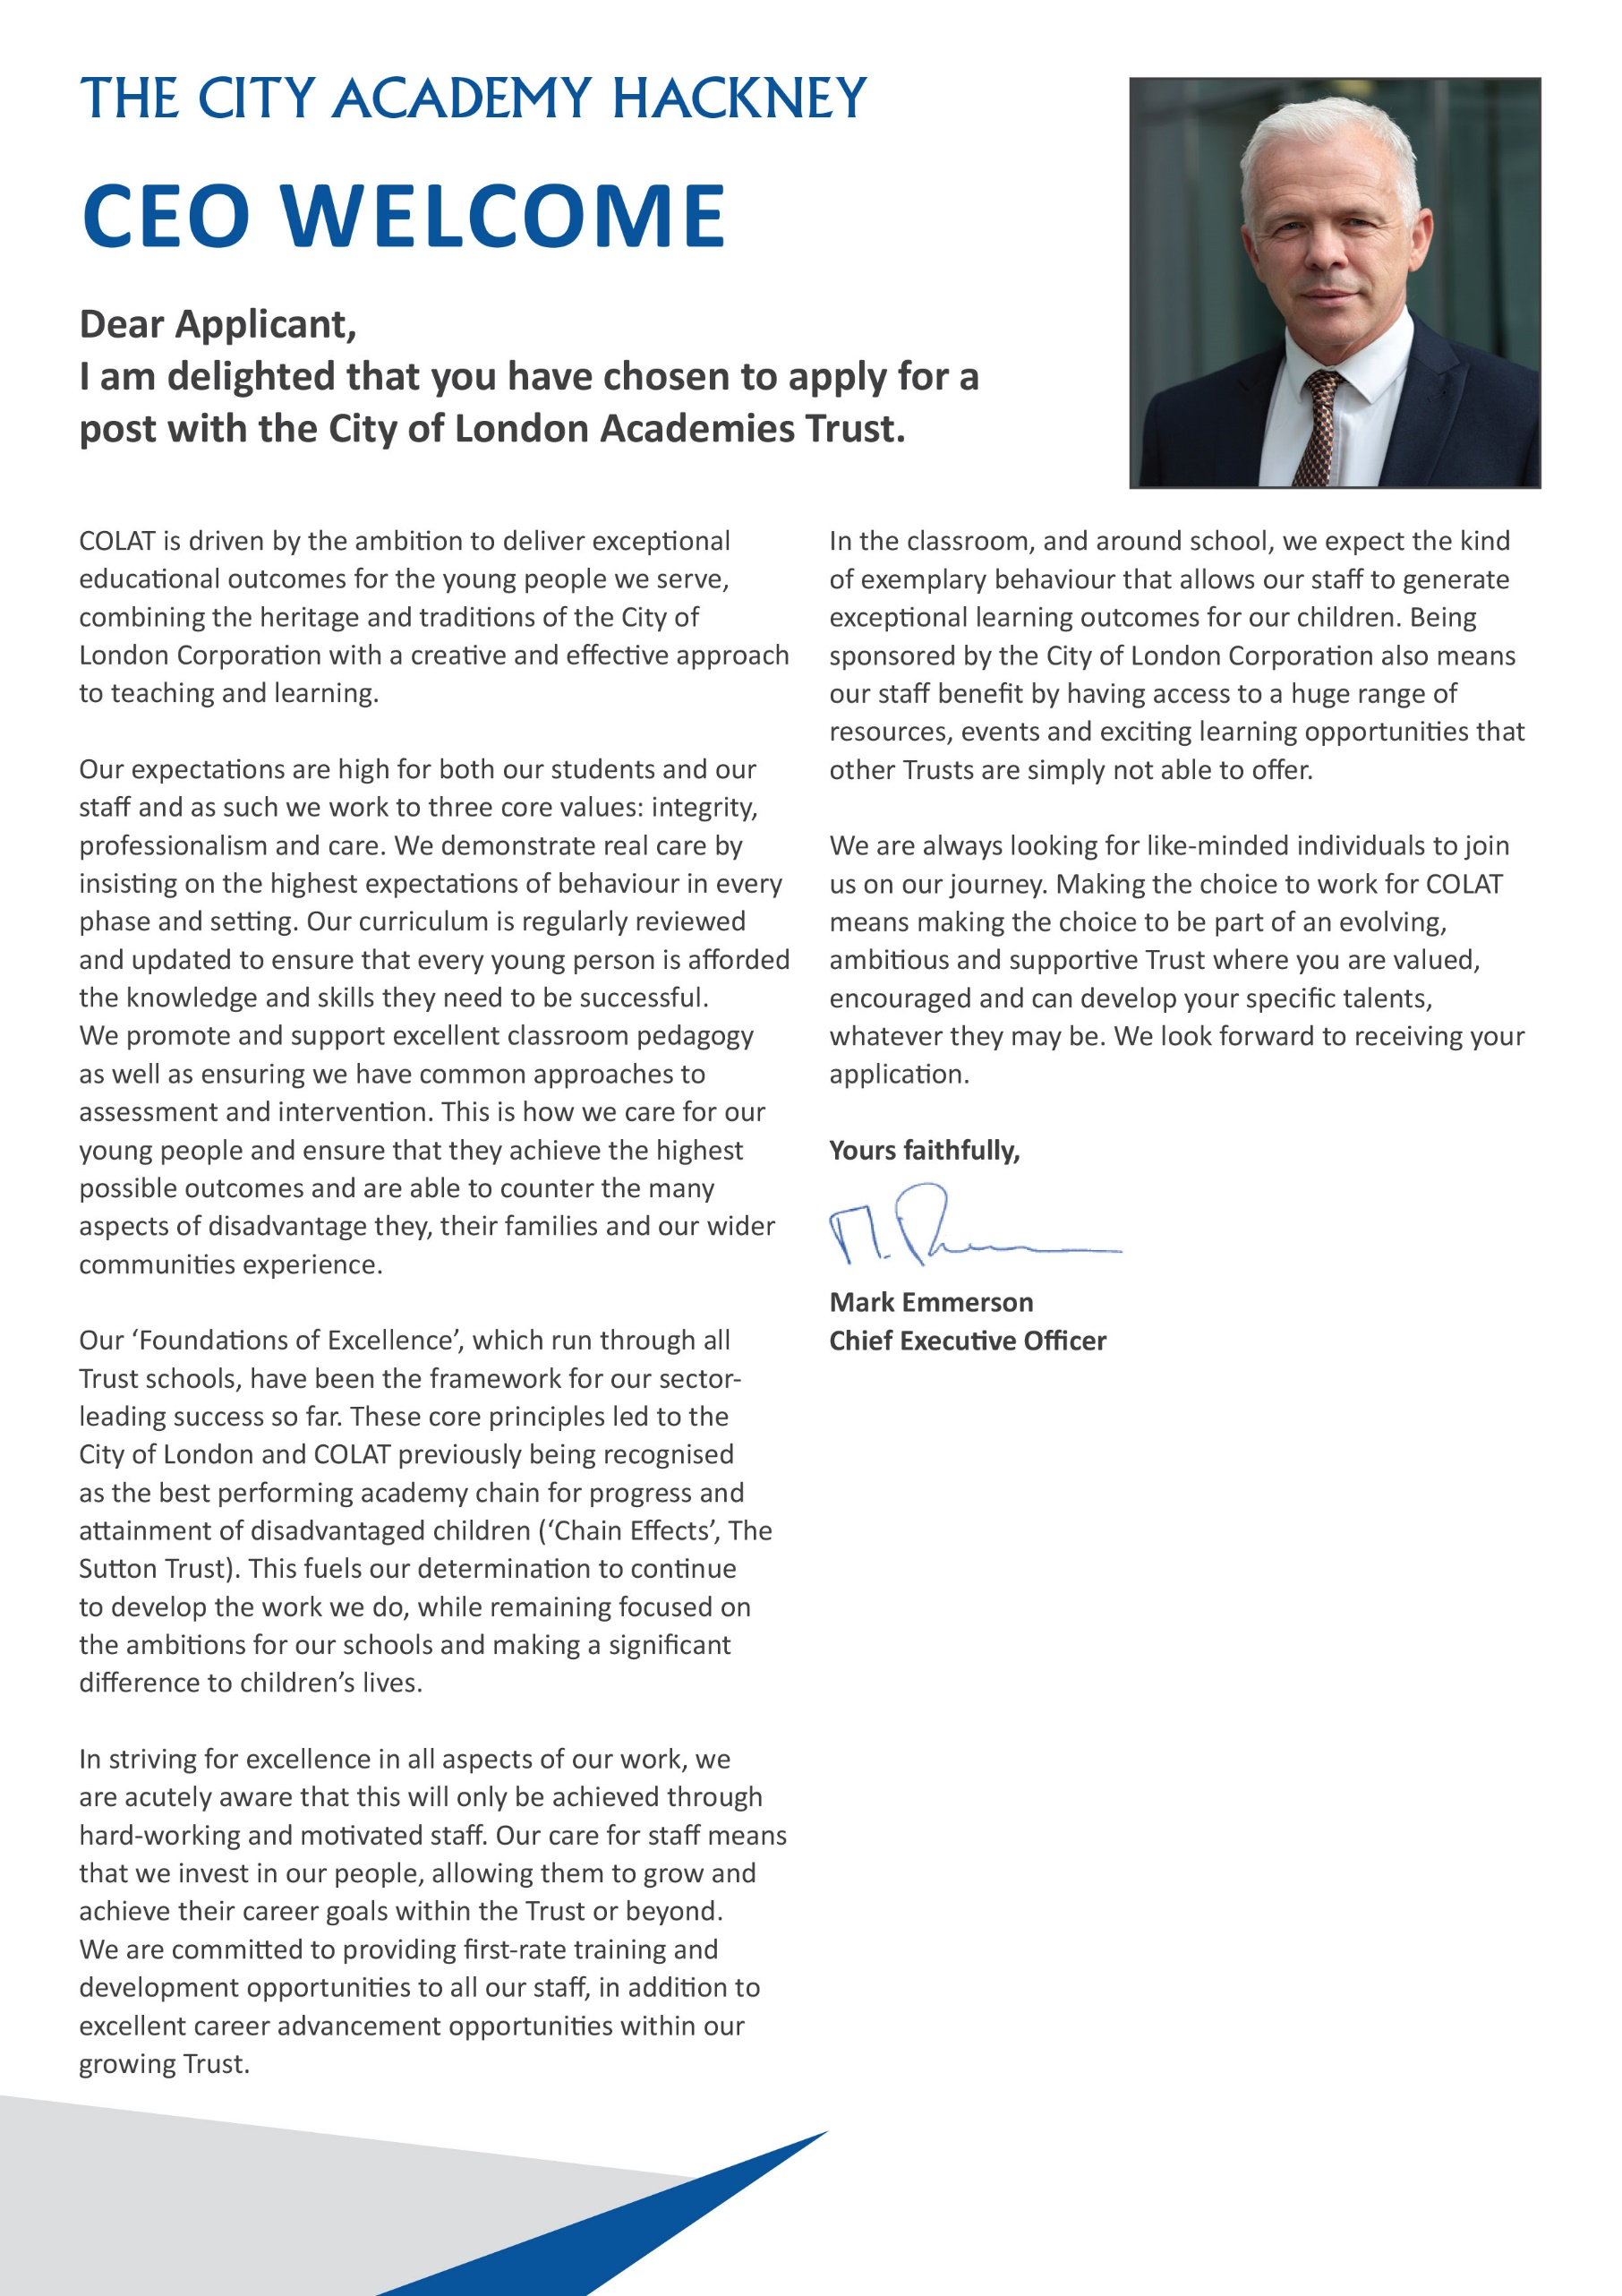

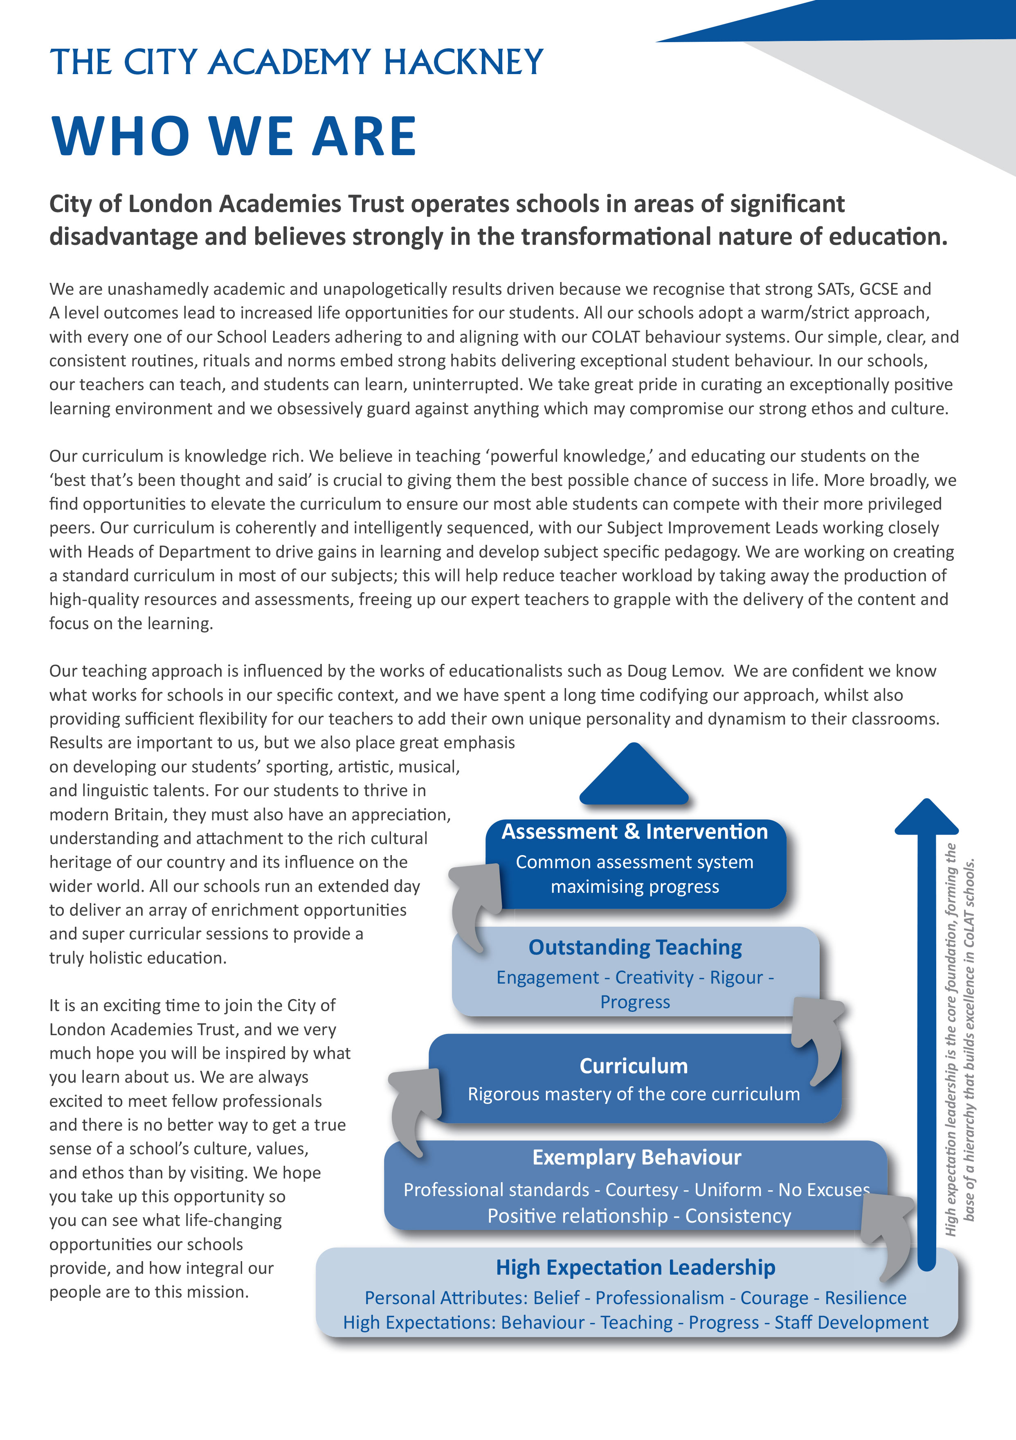

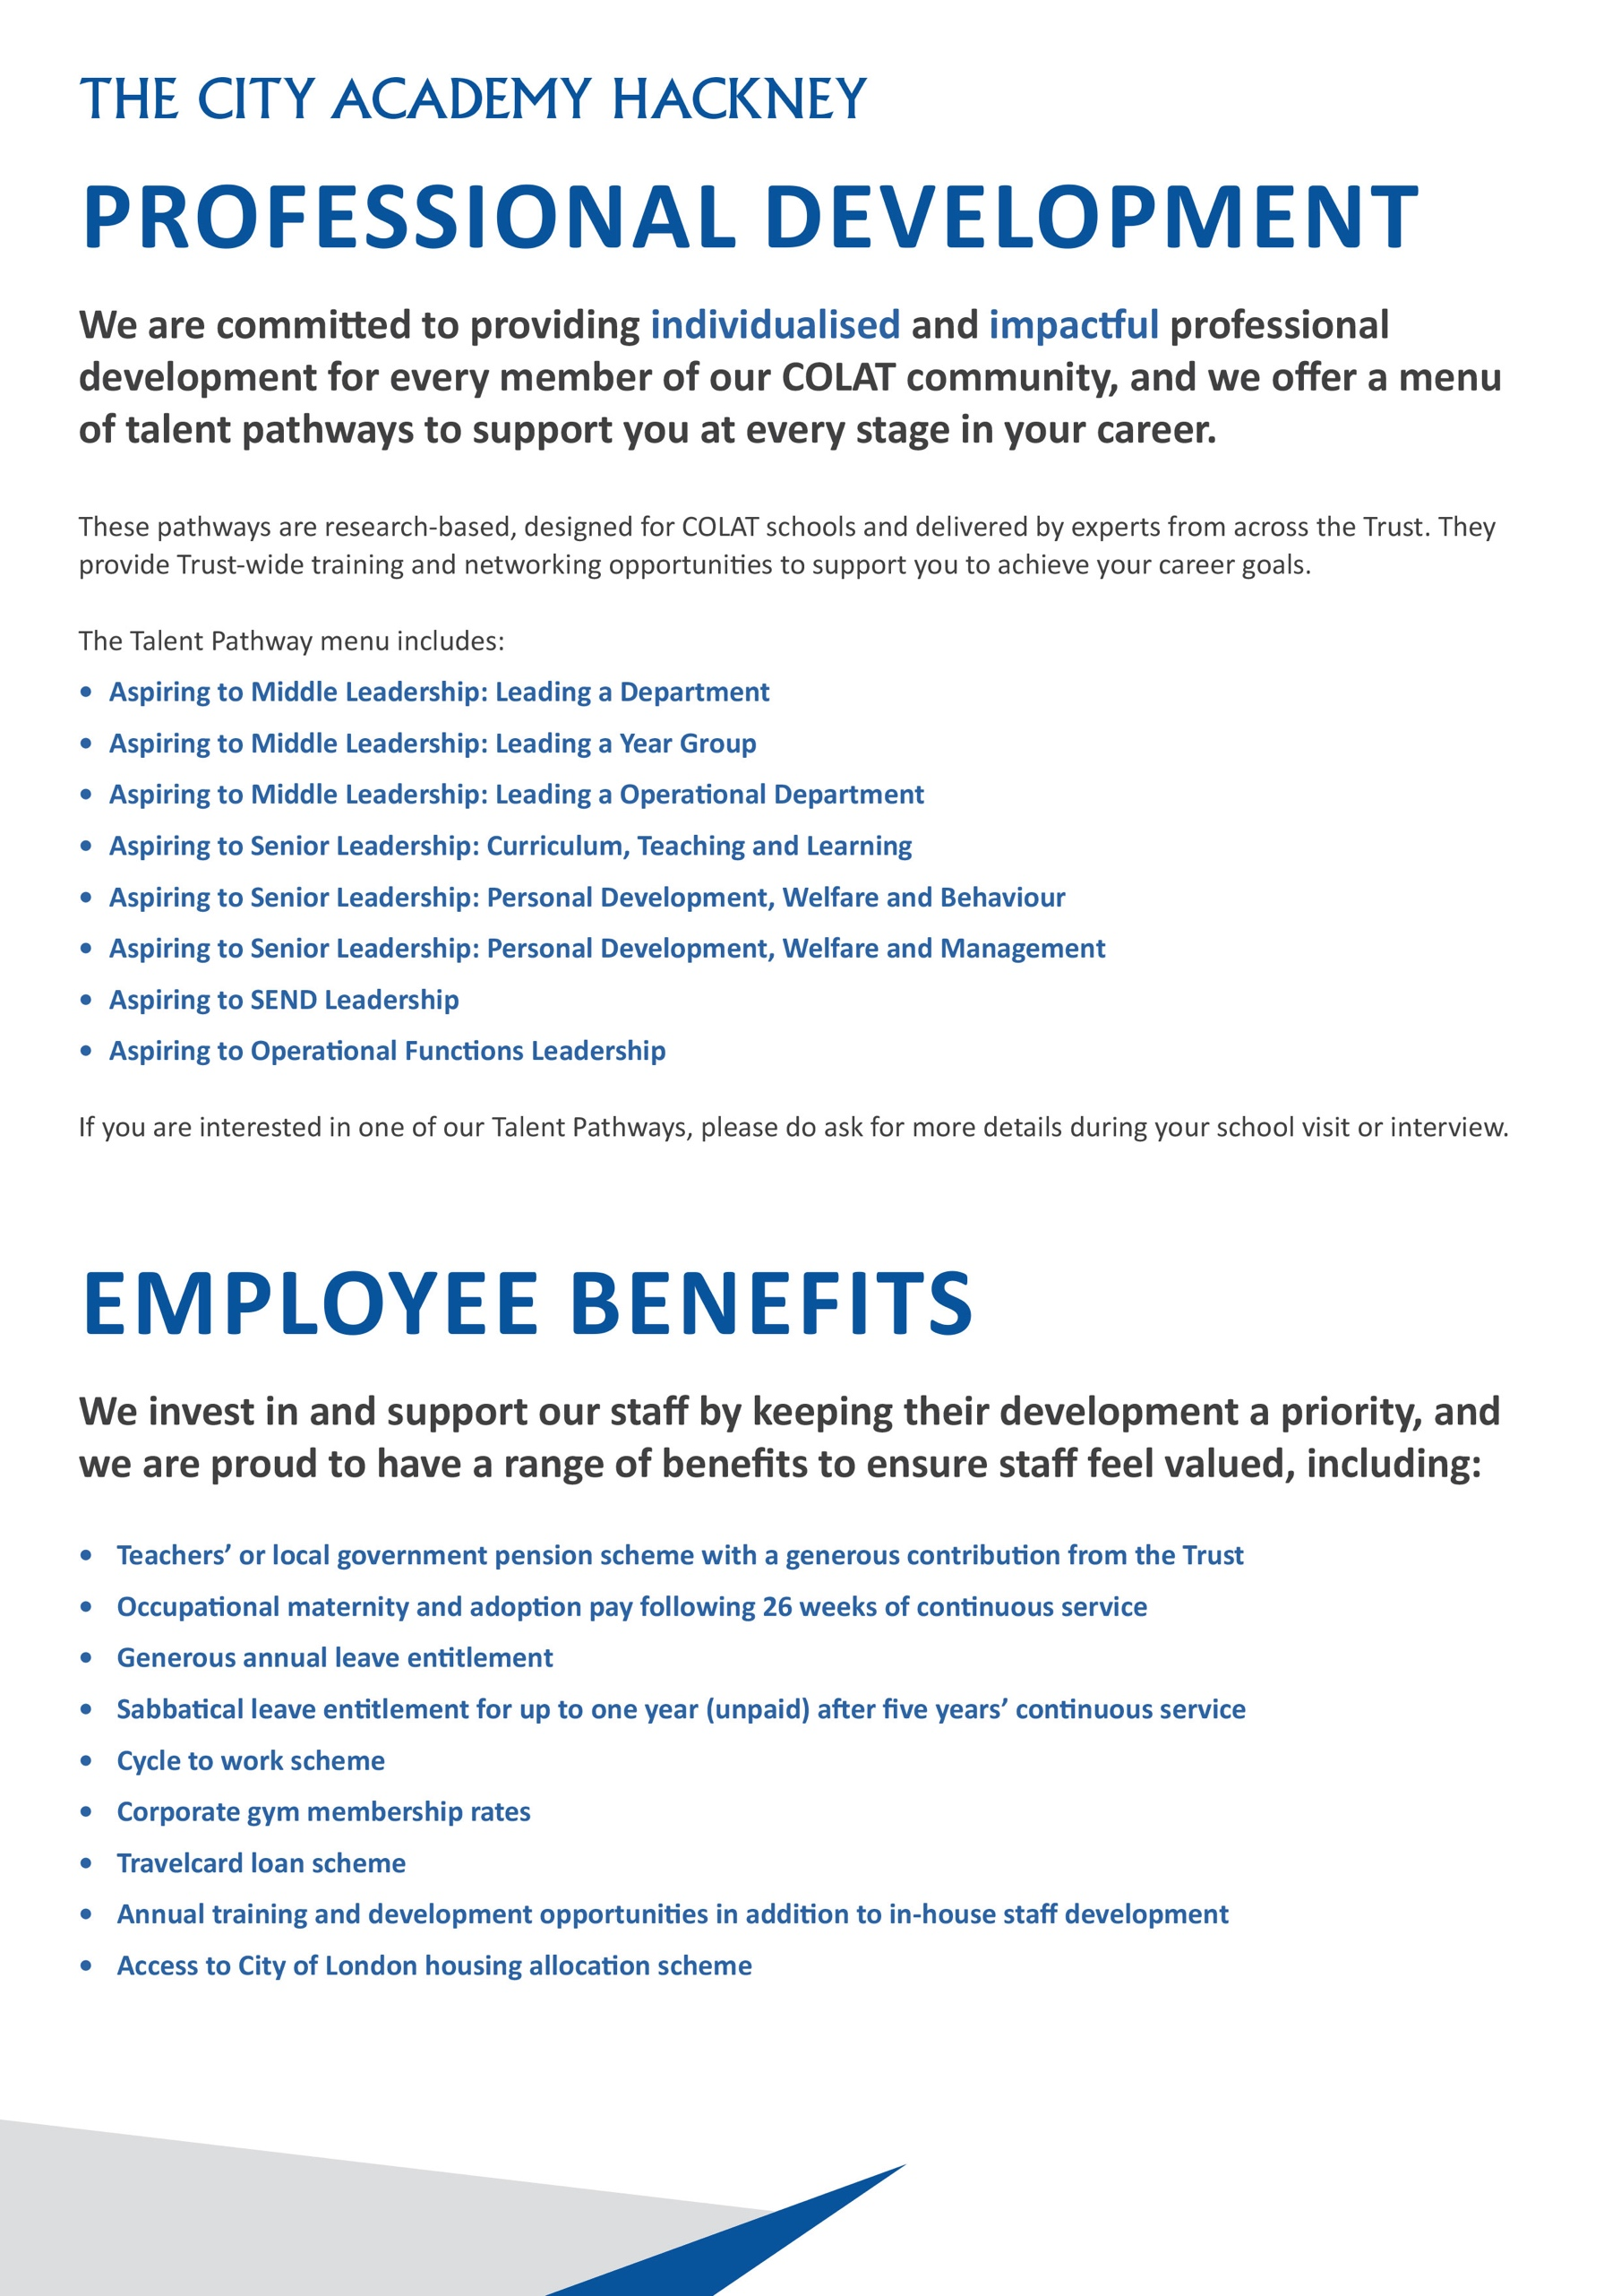
Headteachers Welcome

Dear Candidate,

Thank you for expressing an interest in the post of Behaviour Mentor at The City Academy, Hackney.

At The City Academy, Hackney, we are dedicated to providing all the students in our community with the best possible educational opportunities. We believe excellence is achieved through three key ingredients: clear structures, high expectations and strong relationships. Our outstanding curriculum is built around 'The City Experience' which places equal value on academic, creative, sporting, linguistic and personal development.
We pride ourselves on being a school which offers young people a warm and supportive environment, enabling them to meet our very high expectations. Our inspirational staff are skilled and committed and we are generously supported by The City of London Academies Trust. As a result of this, our students make exceptional progress.
We are looking for staff who are committed to working with students of all abilities, who constantly seek to learn and improve and who are ambitious for themselves as well as for their students. We expect hard work, skill and dedication, and in return will provide a supportive, flexible working environment, first class training opportunities and a comprehensive benefits package.

If you have the experience and passion to join our team and inspire the next generation, we look forward to hearing from you. Please apply via our website: https://www.thecityacademyhackney.org/

If you have any questions or would like to arrange a visit to the academy please contact our HR team at hr@thecityacademy.org. I look forward to reading your application.

Yours sincerely,

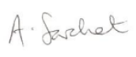

Anna Sarchet
Principal

Behaviour Mentor - Job Description

Accountable to: Behaviour Manager

Grade Scale Point Range: Local Government Pay Scale, Scale 4, Points 7-10

Salary Range: £30,987 - £32,346 pro rata (2024/25)
Actual salary £30,967 - £32,326 per annum, including overtime

Working Pattern: Full time, 35 hours per week, plus 5 hours per week contractual overtime
Term time only (39 weeks) per annum

Location: Hackney

Disclosure level: Enhanced

Responsible for: N/A

Main Purpose: Behaviour management and improvement systems, and a specialist area of focus

Key Accountabilities

- Participate in all aspects of the management and improvement of student behaviour and the prevention of poor behaviour.
- Implement and monitor the Behaviour Improvement Path, in line with academy policy.
- Work collaboratively in a team of Behaviour Mentors and a Year Group.
- Be a mentor to students.
- Liaise with the Behaviour Manager and Deputy Lead Behaviour Mentor to operate, monitor and evaluate behaviour systems.
- Participate in the supervision of Reflection Room activities and register.
- Participate in Active Classroom Support and Reflection Room duties as well as other duties required such as breakfast club, playground, break/lunch.
- Manage and administer the detention system as required.
- Co-run the one hour detention sessions.
- Keep parents/carers informed of their child’s behaviour and build positive relationships with parents/carers.
- Help to maintain files and data used within the behaviour administration systems.
- Produce reports, documents and correspondence, including confidential material for the Behaviour Manager and SLT.
- Liaise with Hackney Learning Trust and Governors as and when required.
- Liaise with staff and external bodies as appropriate.
- Lead on a specialist area of focus.
- Ensure all school safeguarding procedures are followed in line with school policy

The postholder will also:

- Establish constructive relationships with parents/carers exchanging information, facilitating support for their child’s attendance, behaviour and learning.
- Reward good behaviour and challenge/take action on poor behaviour.
- With the Behaviour Manager, support training and/or induction for staff on behaviour management.
- Support teaching and support staff in maintaining discipline and following up incidents.
- Monitor students’ behaviour and with the Behaviour Manager and Director of Engagement, decide on a range of appropriate interventions and support to improve behaviour.
- Decide on the best course of action, referring to the Behaviour Manager, Director of Engagement and other members of SLT if required.
- Maintain a high degree of confidentiality with regards to student issues.
- Collate supporting material and documentation when required for reintegration and exclusion meetings, as directed by the Behaviour Manager.
- Be responsible for investigating behaviour incidents for a year group or other incidents, where requested.
- Be responsible for taking key students to external events/activities, i.e. A&E, Court, CAMHS, New Regents, home visits or appointments with mentees.

Key Organisational Objectives
The postholder will contribute to the academy’s objectives in service delivery by:
- Following Health and Safety requirements and initiatives as directed.
- The academy is committed to safeguarding and promoting the welfare of children and young people and we expect all staff to share this commitment.
- Ensuring compliance with Data Protection legislation.
- At all times operating within the school’s Equalities policies, demonstrating commitment and contribution to improving standards of attainment.
- Adopting Customer Care and Quality initiatives.
- Fulfilling the role of Student Personal Adviser and/or mentor if required.
- Contributing to the maintenance of a caring and stimulating environment for young people.

Safeguarding Children
COLAT is committed to safeguarding and promoting the welfare of children and young people. We expect all staff to share this commitment and to undergo appropriate checks, including enhanced DBS checks.

The above responsibilities are subject to the general duties and responsibilities contained in the Statement of Conditions of Employment. The duties of this post may vary from time to time without changing the general character of the post or level of responsibility entailed.

The person undertaking this role is expected to work within the policies, ethos and aims of the Trust and to carry out such other duties as may reasonably be assigned. The post holder will be expected to have an agreed flexible working pattern to ensure that all relevant functions are fulfilled through direct dialogue with employees, contractors and community members.

Special Conditions of Service
Because of the nature of the post, candidates are not entitled to withhold information regarding convictions by virtue of the Rehabilitation of Offenders Act 1974 (Exemptions) Order 1975 as amended. Candidates are required to give details of any convictions and are expected to disclose such information at the appointment interview.

Because this post allows substantial access to children, candidates are required to comply with departmental procedures in relation to Police checks. If candidates are successful in their application, prior to taking up post they will be required to give written permission to the Department to ascertain details from the Metropolitan Police regarding any convictions against them and, as appropriate the nature of such convictions.

English Duty
This role is covered under part 7 of the Immigration Act 2016 and therefore the ability to speak fluent spoken English is an essential requirement for this role.

The duties outlined in this job description are in addition to those covered by the Local Government Terms and Conditions Document. It may be modified by the Principal, with your agreement, to reflect or anticipate changes in the job, commensurate with the salary and job title.

Behaviour Mentor – Person Specification

Our Values and Vision
The City of London Academies Trust, sponsored by the City of London Corporation, aims to provide high-quality education for students and pioneer educational innovation. We are driven by the ambition to provide world-class experiences and deliver exceptional educational outcomes for the young people we serve.
All City of London academies draw upon the traditions, institutions, heritage and historical successes of London to furnish each of their diverse communities with life-transforming learning experiences. In doing so, we believe that the young people we serve develop into successful, compassionate young adults, who make a positive contribution to their local, national and global communities.

Our schools are characterised by a common understanding of what makes outstanding schools, based on five key principles which are known as our 'Foundations of Excellence'​.

Our Staff
Our staff have high expectations, are consistent and driven to provide the best teaching and opportunities for our students. Teachers work in a well-disciplined environment where they are able to teach creative and engaging lessons, and all staff are given exciting opportunities to develop and learn from exceptional practitioners.

Equal Opportunities
The postholder will be expected to carry out all duties in the context of and in compliance with the COLAT Equalities policies.
 | Essential | Desirable
Qualifications
Educated to degree level or equivalent
Experience, Skills and Knowledge
Experience of using Microsoft Office suite, email and internet
Word processing and typing skills
Experience of using SIMS or similar database
Excellent admin skills and experience of using and maintaining recording and reporting systems
Familiarity with desk top publishing
A background working with students of all abilities
Experience of liaising with parents/carers, external agencies, etc
Experience of delivering a mentoring service and intervention programme
Experience of multi-agency working
Knowledge of Safeguarding and Child protection policies and procedures
Problem solving skills
Attention to detail in communication and planning
Excellent oral and written skills, and the ability to communicate effectively with staff, students, parents/carers and agencies/statutory bodies
Good interpersonal skills with the ability to build positive working relationships at all levels
Ability to train and develop staff
Ability to develop a bank of resources
Personal Qualities
Ability to form and maintain appropriate relationships and personal boundaries with children and young people
Ability to motivate young people
Ability to work hard under pressure while maintaining a positive, professional attitude
Ability to organise and prioritise workload and work on own initiative
Ability to work well as part of a team
Ability to accurately input information onto a database
Flexibility and willingness to contribute to the success of the team
An understanding of Every Child Matters
Other
Commitment to safeguarding and promoting the welfare of children and young people
Willingness to undergo appropriate checks, including enhanced DBS Checks
Ability to work some evenings, such as Parent Evenings

