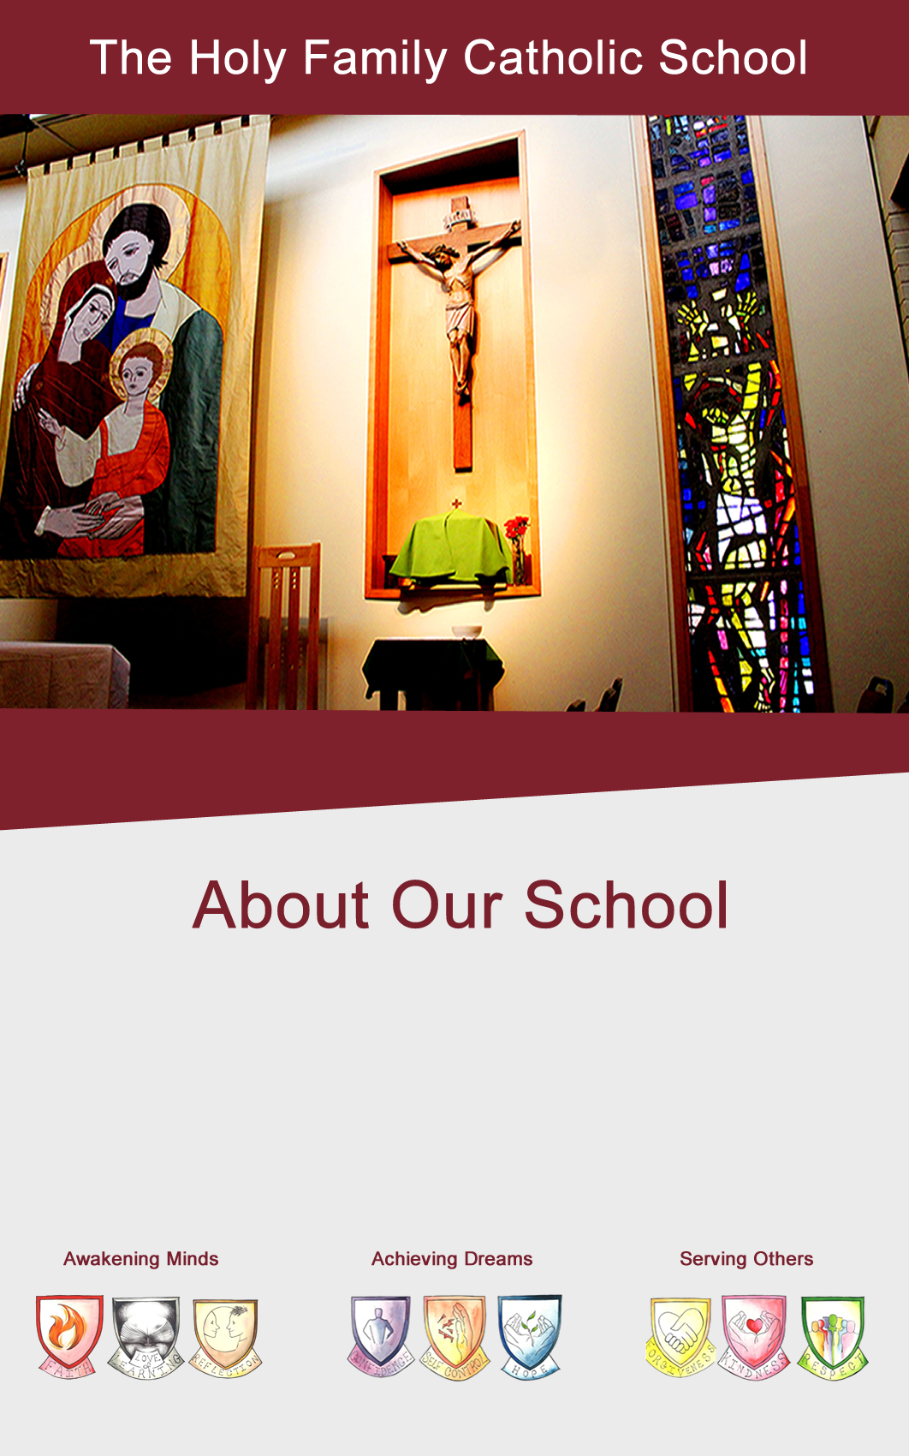

The Holy Family
Catholic School



Our Ref: JFA/MC

Dear Candidate

The Holy Family is a Catholic school, and all that we do derives from our Catholic vision which is encapsulated in our three-part mission statement: ‘awakening minds’, ‘achieving dreams’, ‘serving others’.

Thank you very much for your interest in this position in our school. Please find enclosed the requested information relating to the post.

I hope this gives you a flavour of the direction in which Holy Family is moving and I look forward to receiving your completed application.
.

Yours sincerely

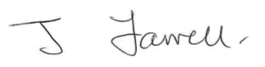

J Farrell
Chair of Governors

Headteacher: Ms S Mather The Holy Family Catholic School, Spring Gardens Lane, Keighley, West Yorkshire, BD20 6LH Tel: 01535 210212 Email: office@holyfamilyschool.uk Web: www.holyfamilyschool.uk

Our Ethos
The Holy Family Catholic School exists to provide a contemporary education rooted in traditional gospel values where we believe that Christ is at the heart of all our endeavours inspiring us to excellence, where justice, compassion, a commitment to service and moral responsibility pervade everything that we do. We aim to awaken students to the largeness of the world around them, give them a dream of human achievement and an active concern for the human predicament here and now and in doing so reveal the truth about God, Christ and Spirit.

Awakening Minds
Our faith, the teachings of Christ, is at our heart. We devote ourselves fully to our spiritual growth, striving for excellence in all that we do each day. 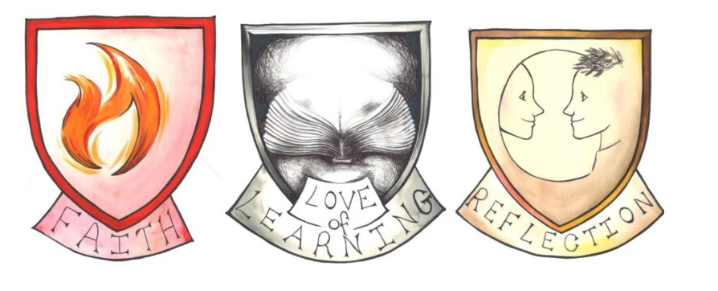

Achieving Dreams
Our work blends inspirational teaching and confident study in a stimulating environment. We learn wholeheartedly, turning our ambitions into reality with every opportunity.
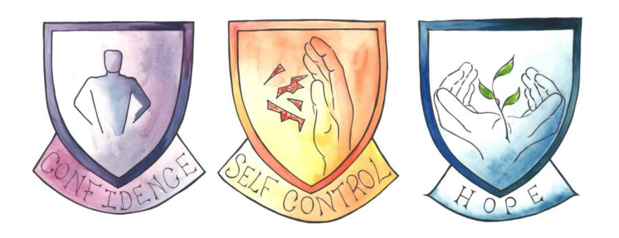
Serving Others
Our spirit leads us to take a positive role in our community. We show love, care and respect for one another and for everyone in our world today. 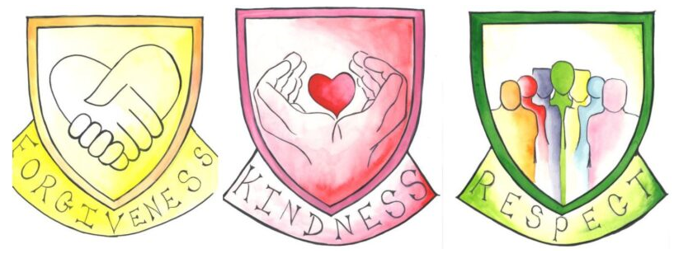

The Holy Family Catholic School is a Voluntary Aided 11-19 Catholic Comprehensive school, where the Governors are the employers, under the trusteeship of the Diocese of Leeds. There is a six form entry in each year group with approximately 900+ students on roll, including approximately 150 in Years 12 and 13.

We are a school on a rapid improvement journey. Welcome change is taking place within the school, about which we are all very excited. We have recently appointed a new Headteacher and the structure of the Senior Leadership Team has changed. They are working rapidly and effectively with the wider staff team to move the school to a ‘Good’ Ofsted judgement and beyond.

Holy Family is a very inclusive, multicultural school. Our catchment is also characterised by significant economic, social and cultural disadvantage. Our Catholicity is instrumental in our response to this. Inspired by the example of Jesus, we work hard to improve the life of every student who studies with us, regardless of their background. We have a strong focus on our relationship with the local community, from meeting regularly with the local MP and councillors, to running a foodbank throughout the Covid 19 pandemic.

The Holy Family is soon to join the Blessed Christopher Wharton Catholic Academy Trust which will comprise all the Catholic Primary and Secondary schools in Bradford and Keighley and as such be one of the largest education providers in the area. We already have strong associations with the three Catholic Primary schools in Keighley who are under one executive Headteacher and look forward to enhancing students’ transition to our school by further growing our relationship with the primary pupils and their families.

The teachings of Jesus are at the heart of our school community. The Sacraments, the Word of God, our behaviour towards each other, our care and friendship are all central to daily life in school. Students and staff have opportunities to continue their individual faith journey through prayer and liturgy. We pray together each day; and the significant events in the Church year are all celebrated. Our Christian faith is seen in action through the wide variety of events, groups and charitable activities with which our students can get involved, including pilgrimages to Lourdes and nationally.

The school was built in the 1960s but has benefitted from further development and refurbishment. Well equipped, the campus is a large site with open grounds around it. The school is situated in a pleasant location on the outskirts of Keighley with stunning views across the Aire Valley. It is on the edge of the Bronte countryside and close to Skipton, the gateway to the Dales. It has a prominent and well-established place in the local Catholic and wider community. There are particularly strong links with the local parishes and the feeder schools in Keighley. Keighley has good bus and rail links and, as well as its close proximity to beautiful countryside, it is within travelling distance of several cultural, social and commercial centres such as Leeds, Harrogate and Manchester. There are many attractive places to live within a short distance of the school.

For further information, do look at our website: https://www.holyfamilyschool.uk
Our Curriculum

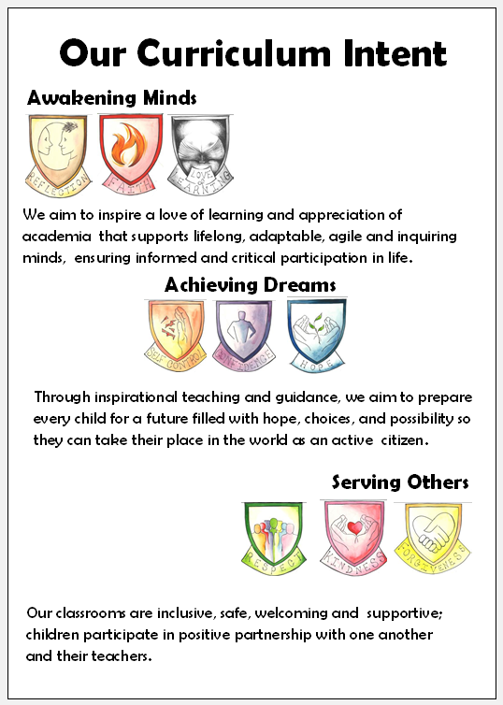
In September 2021, after having been a year in the planning, we launched our new curriculum which is built around the idea of mapping subject concepts in years 7-11 to create and deliver both a coherent and connected curriculum. Our new Quality of Education team leads on curriculum across the school with a single and clear mission to deliver the best possible experience for our children in the classroom and beyond. This is articulated in our curriculum statement of intent. We are focussed on developing a curriculum which will be consistent across all subjects and will deliver both academic excellence and excellence in a students’ personal development.

We recognise that change like this takes time and we are making rapid strides towards realising this vision- we are a school on the move towards excellence. Our curriculum vision is rooted in research and staff are coming on board quickly as they benefit from good, sustainable, and bespoke CPD. This is allowing staff, many of whom are already first-class practitioners, to further improve their practice as we shift our mindset to the idea of continual improvement in the classroom.

We launched this year’s CPD and our new curriculum with a bespoke session from Dylan Wiliam as we now embark upon a three-year plan to embed formative assessment in every classroom in our school. At the very heart of this is the creation of our Teacher Learner Communities (TLC). These small cross faculty TLC meet regularly throughout the year as we work with SSAT through their Embedding Format Assessment Workshops and Dylan Wiliam’s LSI led Book Study Groups. Our curriculum is a joined up coherent part of the school; planning, assessment, CPD and how we measure our impact are all tightly synchronised to make us more effective as a school.

Many of our students choose to stay with us for study A level courses, the list overleaf shares a selection of the leavers from 2021.

What people say about our school

‘I was so impressed with all the hard work the school did during the pandemic. The weekly welfare calls were so much appreciated. The work set was high quality and Class Charts is a fantastic tool. I don’t know what I would have done without the school whilst I was working from home.’ Year 11 parent

‘The Bridge has been an “absolute rock” for not only my child but me also. It is reassuring that she has someone to talk to and support her in a way sometimes I feel I can’t help. The support from The Bridge is second to none’ Parent of a student receiving SEN support

Section 48 Inspection 2018
A well-established triangle between school, home and the community supports all the school is doing to provide a contemporary education alongside a commitment to service and moral responsibility.

A strength of the school is its pastoral system. Praised by pupils and parents it affords pupils the opportunity to develop a reflective style. It is a well understood system and pupils know who to ask for help. Junior leaders spoke of their pride in helping with liturgies and Masses.
The school is highly inclusive, often taking pupils rejected by other schools.
Governors are frequent visitors to the school and are fully involved

Jonathan – Science teacher
As this is my 30th year of teaching in the area, I have seen the good, the bad and the downright ugly of many Yorkshire schools. So what makes schools successful? To start you need a clear, unhesitant vision from the top. Some SLT at The Holy Family may be relatively new to post but are not new to the school. They know what the school needs and how to get there and carry the support of the staff. The next thing you need is behaviour for learning. On the few occasions I have used it, I have been astonished at the speed and efficiency of the “on call” system at The Holy Family, responding in perhaps two minutes on average. With the vast majority of students showing excellent behaviour, this is all you need to be able to do your job! If you have ever felt frustrated at the school rather than the students, The Holy Family is the school for you.

Misty – English teacher
After taking a few years off to emigrate to England and get my family settled, I felt like I was missing something. Having been a teacher in the United States, I decided to start as a teaching assistant, so I could orient myself to the new school systems. Holy Family Catholic school was the perfect opportunity at the perfect time. My daughter attended here, so I was familiar with the school. After being hired in the Resource Provision, I instantly felt at home again. The staff were warm and welcoming along with being such genuinely caring and supportive mentors, and friends. As the year was wrapping up, I saw there was an open position in the English department and without hesitation, I applied. The entire faculty have been so supportive in my new role and I feel like everyone here wants teachers, but most importantly, each student to succeed in their education and have a bright future. I love the enthusiasm of all the heads and faculty leaders and the environment here is one of growth and the promise of a bright future.

Frances – Senior Leader
My link with Holy Family started way back in 2003, when I joined as a member of the Leadership team. I immediately found the ethos of the school fitted the name, it is truly a family. I left the school after 10 happy years here for a promotion. When I was offered the chance to come back here for a 6 month secondment, I jumped at the chance and was excited about the vision that the new head has for the school. I feel incredibly lucky that when a permanent position came up, that I was successfully appointed and can contribute to the improvement journey the school is on. I encourage anyone looking for an exciting challenge with strong staff support to apply here, you will not be disappointed.

Ruth – PSHE Lead
When I joined Holy Family as an NQT, in the peak of COVID, I was given an immediate friendly welcome by all. Each member of staff was always there to support me, whether that was simply by a friendly smile, or taking time out of their day to offer advice/help when needed. The whole feel of the school is warm, and like its name, a family. Throughout my NQT year I was given support from all departments, all well as my own. This, in turn, gave me the courage to apply and be appointed for a new position of Subject Lead for PSHE. Within the school, the time given to CPD and the high focus on quality teaching, is giving me the chance to continue developing as a professional, as well as giving me a positive environment, which I enjoy coming to work to, each day.

Helen – Health & Social Care Lead
I came to Holy Family school as a newly qualified science teacher in 2019. Prior to this I had worked in the NHS as a nurse, midwife and health visitor for almost 20 years! Right from interview I knew that HFCS was the type of environment I would love to work in. From the outset I have felt valued and experienced a sense of belonging, the senior leadership team have readily recognised my previous skills and experience and have offered me many opportunities to flourish and develop. I have developed so much personally and professionally with expert guidance from SLT and staff members. I have always felt very well supported and in 2020 was delighted to take subject leader responsibility for Health and Social care at KS4 and KS5. I enjoy the autonomy that the subject lead post has given me and feel very blessed to utilise my extensive knowledge, skills and enthusiasm to educate eager students.

The changes I have observed in this academic year are phenomenal and positive. The drive for improvement is evident in all aspects of school life and the communication between SLT and staff is always informative, timely and respectful. The SLT have the courage and commitment to recognise opportunities for development and invest in quality training and resources to enable this.

When it has been ‘tough’ (as teaching invariably is sometimes) the support I have received from senior leaders has been outstanding. I genuinely feel that staff welfare is a priority in this school, the importance of establishing and maintaining positive relationships is paramount. Mutually respectful relationships flourish between staff and students and we embrace an ethos of actively seeking opportunities to celebrate individual and collective success.

Ofsted – March 2022

‘Pupils… said they feel safe. They know that staff in the school are there to support them and they know they can speak to anyone if they have concerns or worries’

‘The school has high ambitions for all pupils’

‘Pupils… feel staff at the The Holy Family Catholic School care.’

