

HOW TO APPLY

- If you would like to apply for this role, please download the application form from the school website.

Our Guidance Notes for Applications can also be found on the website.

See below!!!

- Your application form should be completed in full and returned to : Admin@claremont-high.org.uk by Monday, 5th March 2018 (noon). Please note that we are unable to accept applications unless they are made on our own application form. Due to the large number of applications the school receives, please be aware that only shortlisted candidates will be contacted to be invited to interview.

- Should you require any further assistance, please contact us via email admin@claremont-high.org.uk.

- Claremont High School Academy Trust and its staff are committed to safeguarding the welfare of students. The school is registered with the DBS and successful applicants will be required to complete successfully the Disclosure procedure at the Enhanced level. It is an offence for any person barred from working with children to apply for this post.

- Claremont High School Academy is committed to Equal Opportunities and welcomes applications from all sections of the community.

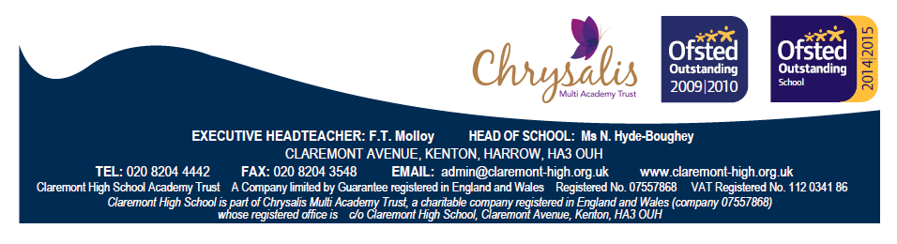

GUIDANCE FOR APPLICANTS WITH DISABILITIES

Information is requested on this job application form about disability/medical conditions you may have. If you are shortlisted, you will also be asked to provide further information on an Employment Health Questionnaire form.

This means:
- It is important that you tell us whether you require adjustments to any part of the selection procedure including arrangements for interview. The application form allows you to provide this information.
- If you are offered the job, any adjustments to the working conditions or environment that may be required to enable you to carry out the duties of the job will be considered in consultation with you.

Disability is defined as follows:-
- a person has a disability if he/she has a physical or mental impairment that has a substantial and long term adverse effect on his/her ability to carry out normal day-to-day activities where:
- a mental impairment is defined as an impairment resulting from or consisting of a mental illness only if the illness is a clinically well-recognised mental illness;
- long term, means the effect of the impairment has lasted at least 12 months or is likely to last for 12 months or is likely to last for the rest of a person's life;
- normal day-to-day activities are defined as: mobility; manual dexterity; physical co-ordination; continence; ability to lift, carry or otherwise move everyday objects; speech; hearing or eyesight; memory or ability to concentrate, learn or understand; perception of the risk of physical danger. NB Any disability which does not have a substantial and long term effect on one or more of them is not considered to be a disability.

Other conditions included within the definition of disability not already outlined above are:
- a recurring condition which has recurred over more than 12 months or is likely to recur over more than 12 months;
- a progressive condition, eg cancer, multiple sclerosis, muscular dystrophy or HIV which has, or has had, an effect on normal day-to-day activities;
- people with severe disfigurements, although some with deliberately acquired disfigurements will not be covered;
- people registered as disabled under the Disabled Persons (Employment) Act 1944 on 12 January 1995 and on the date the employment right comes into force, who will be deemed to be covered. People with a history of disability will also have protection, even if they do not now have a disability.

Your Application
There is no legal requirement for you to provide information about your disability on this form. However you are encouraged to do so, particularly where you believe that the information may be relevant to the job application. Please contact the Headteacher's Secretary if you require any further information on any aspect of your application.

