
Job Title: Library Assistant (part-time)

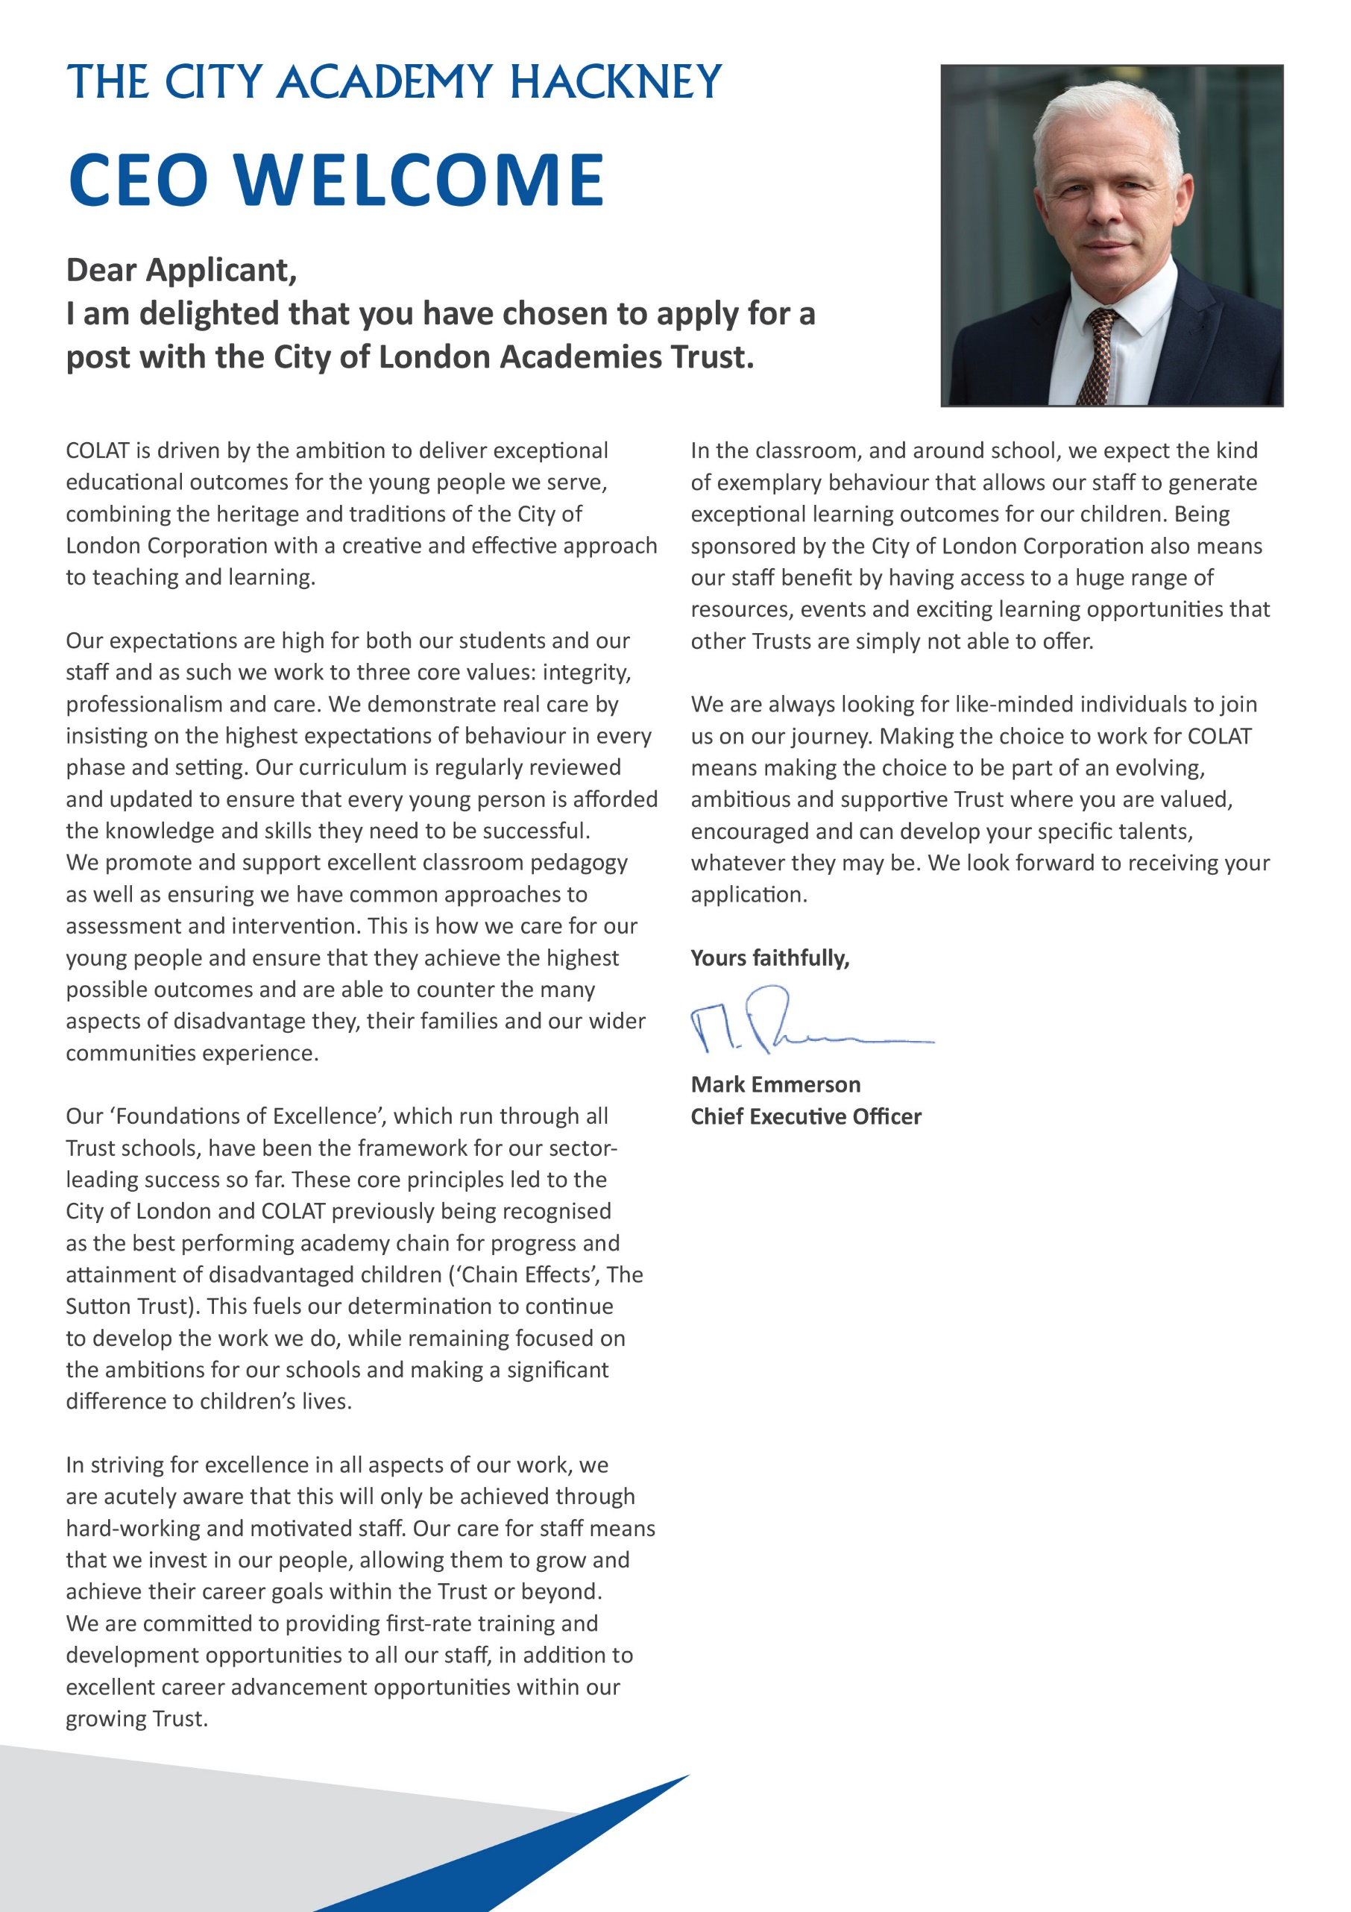

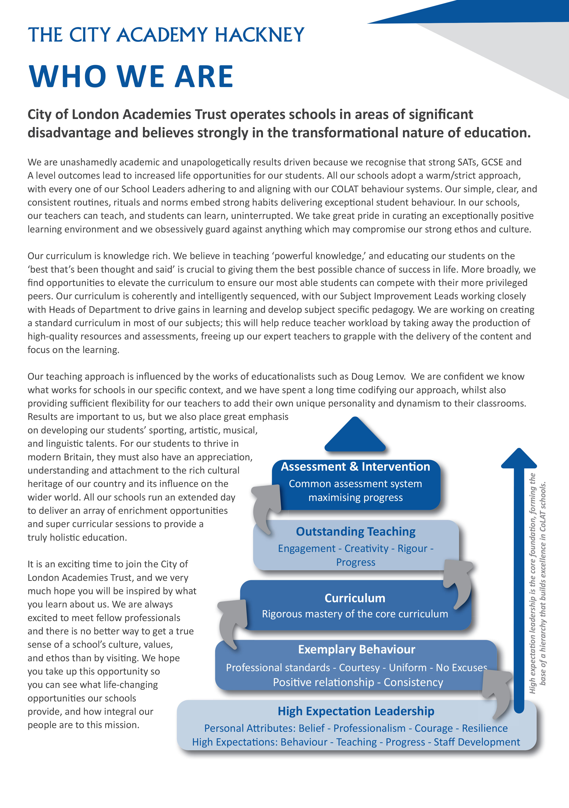

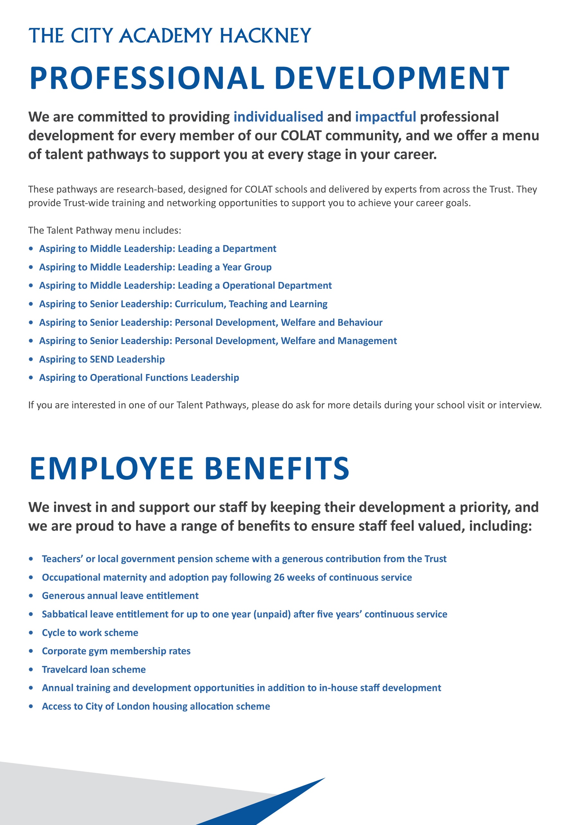
Headteachers Welcome

Dear Candidate,

Thank you for expressing an interest in the post of Library Assistant (part-time) at The City Academy, Hackney.

At The City Academy, Hackney, we are dedicated to providing all the students in our community with the best possible educational opportunities. We believe excellence is achieved through three key ingredients: clear structures, high expectations and strong relationships. Our outstanding curriculum is built around 'The City Experience' which places equal value on academic, creative, sporting, linguistic and personal development.
We pride ourselves on being a school which offers young people a warm and supportive environment, enabling them to meet our very high expectations. Our inspirational staff are skilled and committed and we are generously supported by The City of London Academies Trust. As a result of this, our students make exceptional progress.
We are looking for staff who are committed to working with students of all abilities, who constantly seek to learn and improve and who are ambitious for themselves as well as for their students. We expect hard work, skill and dedication, and in return will provide a supportive, flexible working environment, first class training opportunities and a comprehensive benefits package.

If you have the experience and passion to join our team and inspire the next generation, we look forward to hearing from you. Please apply via our website: https://www.thecityacademyhackney.org/

If you have any questions or would like to arrange a visit to the academy please contact our HR team at hr@thecityacademy.org. I look forward to reading your application.

Yours sincerely,



Anna Sarchet
Principal

Library Assistant - Job Description

Post: LIBRARY ASSISTANT

Accountable to: Learning Resources Manager

Grade/Range: Scale 3, spine points 5-6 on the Local Government Pay Scale

Salary: £30,120 - £30,552 fte, pro rata; Actual Salary £15,802 - £16,029 per annum (2024/5)

Working Pattern: Part-time 21 hrs per week, 1.30pm - 5.30pm plus 1 hr; term time only, 39 weeks per year

Location: City of London Academy Hackney

Disclosure level: Enhanced

Responsible for: Assisting the Learning Resources Manager in the operation of the Academy’s libraries.

Key Accountabilities

The duties outlined in this job description are in addition to those covered by the Local Government Terms and Conditions Document. It may be modified by the Principal, with your agreement, to reflect or anticipate changes in the job, commensurate with the salary and job title.

1. Duties and Responsibilities
- Supervising students in the libraries and maintaining a quiet learning atmosphere. This will involve solo supervision of students after school.
- Working with the Learning Resources Manager to ensure that all library opening times (7.30am – 5.30pm) are covered.
- Supporting students’ learning in the libraries, using library resources and computers
- Promoting the library and its resources to students and staff
- Using the library management system to issue and return stock and to catalogue new stock
- Supporting KS3 library lessons
- Assisting with the maintenance of a tidy environment in the libraries
- Dealing with enquiries from staff and students
- Other duties as directed by the Learning Resources Manager

- Additional Responsibilities
- Act as a personal adviser to a small number of students. This entails being a positive role model for students, giving them pastoral support, setting academic goals, and encouraging them to get involved with all aspects of Academy life. For some students, regular contact with parents may be necessary.
- Behaviour management in corridors and anywhere else on or off the Academy site, ensuring that students are behaving professionally both inside the Academy and outside when in Academy uniform.
- Participate in CPD as required, including school INSET and the Performance Management process.
- Other duties in the libraries as directed by the Learning Resources Manager

Key Organisational Objectives
The postholder will contribute to the academy’s objectives in service delivery by:
- Following Health and Safety requirements and initiatives as directed.
- The academy is committed to safeguarding and promoting the welfare of children and young people and we expect all staff to share this commitment.
- Ensuring compliance with Data Protection legislation.
- At all times operating within the school’s Equalities policies, demonstrating commitment and contribution to improving standards of attainment.
- Adopting Customer Care and Quality initiatives.
- Fulfilling the role of Student Personal Adviser and/or mentor if required.
- Contributing to the maintenance of a caring and stimulating environment for young people.

Conditions of Service
Governed by the National Agreement on Pay and Conditions of Service, supplemented by local conditions as agreed by the Trust.

Special Conditions of Service
Because of the nature of the post, candidates are not entitled to withhold information regarding convictions by virtue of the Rehabilitation of Offenders Act 1974 (Exemptions) Order 1975 as amended. Candidates are required to give details of any convictions and are expected to disclose such information at the appointment interview.

Because this post allows substantial access to children, candidates are required to comply with departmental procedures in relation to Police checks. If candidates are successful in their application, prior to taking up post they will be required to give written permission to the Department to ascertain details from the Metropolitan Police regarding any convictions against them and, as appropriate the nature of such convictions.

Safeguarding Children
COLAT is committed to safeguarding and promoting the welfare of children and young people. We expect all staff to share this commitment and to undergo appropriate checks, including enhanced DBS checks.

The above responsibilities are subject to the general duties and responsibilities contained in the Statement of Conditions of Employment. The duties of this post may vary from time to time without changing the general character of the post or level of responsibility entailed.

The person undertaking this role is expected to work within the policies, ethos and aims of the Trust and to carry out such other duties as may reasonably be assigned. The post holder will be expected to have an agreed flexible working pattern to ensure that all relevant functions are fulfilled through direct dialogue with employees, contractors and community members.

English Duty
This role is covered under part 7 of the Immigration Act 2016 and therefore the ability to speak fluent spoken English is an essential requirement for this role.

Library Assistant – Person Specification

Our Values and Vision
The City of London Academies Trust, sponsored by the City of London Corporation, aims to provide high-quality education for students and pioneer educational innovation. We are driven by the ambition to provide world-class experiences and deliver exceptional educational outcomes for the young people we serve.

All City of London schools and academies draw upon the traditions, institutions, heritage and historical successes of London to furnish each of their diverse communities with life-transforming learning experiences. In doing so, we believe that the young people we serve develop into successful, compassionate young adults, who make a positive contribution to their local, national and global communities.

Our schools are characterised by a common understanding of what makes outstanding schools, based on five key principles which are known as our 'Foundations of Excellence'​.

Our Staff
Our staff have high expectations, are consistent and driven to provide the best teaching and opportunities for our students. Teachers work in a well-disciplined environment where they are able to teach creative and engaging lessons, and all staff are given exciting opportunities to develop and learn from exceptional practitioners.

Equal Opportunities
The postholder will be expected to carry out all duties in the context of and in compliance with the academy Equalities policies.
 | Essential | Desirable
Qualifications
Educated to degree level or equivalent |  | √
Experience, Skills and Knowledge
Ability to use ICT effectively | √
Ability to use ICT to raise achievement |  | √
Administrative experience |  | √
Previous Library experience |  | √
Previous experience of working with children |  | √
Commitment to high quality outcomes | √
Awareness of developments in the National Curriculum |  | √
Personal Qualities
Excellent communication skills and organisational skills | √
Ability to work hard under pressure while maintaining a positive, professional attitude | √
Ability to organise and prioritise workload and work on own initiative | √
Ability to work as part of a team | √
Commitment to personal career development | √
Ability to develop good relations with staff, students and the wider Academy community | √

Other
Commitment to safeguarding and promoting the welfare of children and young people | √
Willingness to undergo appropriate checks, including enhanced DBS Checks | √
Knowledge of and interest in literature for children and young adults | √
An understanding of, and commitment to, Equal Opportunities, and the ability to apply this to strategic work and day-to-day situations | √
Understanding of different social backgrounds of students |  | √
Understanding the needs of students and the appropriate strategies to support them |  | √
Understanding the needs of bilingual students |  | √

