

Duke of Kent School Application Pack
TEACHER OF MODERN FOREIGN LANGUAGES (MFL)
MATERNITY CONTRACT
FULL-TIME Fixed-Term Maternity Leave Contract. Applications for part-time will be considered.
To Commence 30th October 2023.

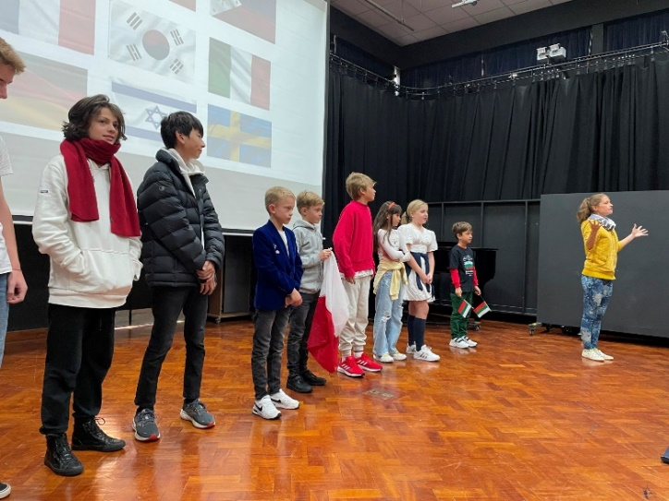
Contents:
- Advertisement
- School Information
- Job Description and Person Specification

Duke of Kent School is committed to safeguarding and promoting the welfare of children and expects all employees and volunteers to share this commitment. Applicants must be willing to undergo child protection screening appropriate to the post, including checks with past employers and the Disclosure and Barring Service. All teaching staff are required to submit a self-declaration form confirming their suitability to work with children across our age range. Appointment will be subject to satisfactory references and pre-employment checks as detailed in our Recruitment Policy.

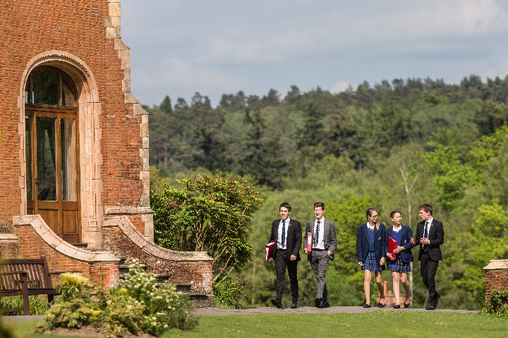
1. Advertisement: Teacher of Modern Foreign Languages (MFL), Maternity Contract
Duke of Kent School is a co-educational day school with 320 pupils from Nursery to Year 11. The School is organised into three sections: Pre-Prep (Nursery to Year 2); Prep (Year 3 to Year 6) and Senior (Year 7 to Year 11).
We seek to appoint a Teacher of Modern Foreign Languages (MFL) to join Duke of Kent School to cover Maternity Leave on a fixed-term basis, to commence 30th October 2023. This is a full-time position, but applications for part-time will be considered.
The successful candidate:
- Will teach French Years 3 to 9, and Spanish Years 7 to 9.

Conditions
- Working in a small, friendly School in a stunning rural location,
- A competitive salary, which is commensurate with experience and paid in accordance with the Duke of Kent School Teachers’ Salary scale
- Teachers are invited to join the Teachers’ Pension Scheme (TPS)
- All staff are entitled to a 30% fee remission for children who join the School, pro-rata for part-time staff
- Use of the School facilities: tennis courts, fitness suite & swimming pool when not in use by pupils
- Breakfast, lunch & tea, as well as refreshments, provided during term-time
- Extremely supportive staff Common Room

How to Apply
Application is by School Application Form only. Forms can be downloaded from the School website under vacancies. www.dukeofkentschool.org.uk/private-prep-surrey-england/job-vacancies
We cannot accept CVs unless accompanied by a completed Application Form. Further information about the school is available on our website. www.dukeofkentschool.org.uk
Applications will be reviewed on receipt.
The contact for this recruitment campaign is Rachel Harris, Head of HR & Deputy Bursar, 01483 277313 or rharris@dokschool.org

2. School Information
Duke of Kent School strives for excellence, expects and celebrates effort, nurtures well-being and presents challenge. Our size allows each pupil to be known and cared for as an individual.
The School has undergone considerable change in the past 13 years, transforming itself from a Prep to a through school, and growing quickly to its current roll of 320 pupils. Key entry points are Nursery, Year 3 and Year 7. Pupils leave at the end of Year 11 to a wide range of local colleges and sixth forms in the independent and maintained sectors.
Our teaching team is made up of experienced, well qualified and highly motivated teachers who have chosen to join our small community where they have a big impact. A dedicated and comprehensive operations staff team supports the teaching team. Across both support and teaching areas, the School currently employs approximately 100 staff (both full-time and part-time). We are also complimented by a team of committed local Governors with broad expertise.
We have a growth mindset, operating on the principle that all learners can, when properly challenged and supported, achieve extraordinary progress. Our focus is on achieving personal best in every aspect of development. We expect, and celebrate effort.
Duke of Kent School works in partnership with parents to support and promote all aspects of pupils’ development. We prepare our pupils to play a positive role in their adult lives, as independent learners and thinkers, and to be responsible members of the local and global community.
We expect all members of the community to exercise tolerance, kindness, respect and empathy. We value diversity and pursue equal opportunities for all.
The greatest gift we give each child is a passion for learning and a real curiosity about the world around them. Here at Duke of Kent School near Guildford in Surrey, we all care deeply about educating the whole child. We are proud of the incredible teaching staff who recognise the individuality and strengths of each of our pupils and challenge them to be the best they can be, whilst allowing them the freedom to be exactly who they want to be.
As well as the best possible academic learning environment, the breadth of the music, drama, creative arts and sports opportunities set us apart. Our after school activities programme is also designed to give the students opportunities to develop new passions and talents.
We are a thriving co-ed independent school and our pupils leave our care as happy, independent, rounded, grounded individuals with many joyful memories, and a desire to go out into the world and make a difference.
The School has an inclusive ethos and we are proud of meeting the needs of pupils across a broad range of academic ability. We seek to enable each pupil to achieve his or her potential, to address challenges and to develop interests and aptitudes.

The Modern Foreign Languages (MFL) Department
The MFL department has three teaching staff and two Foreign Language Assistants involved in the delivery of both French and Spanish; French from Pre-prep to GCSE and Spanish from Year 7 to GCSE. We have native speakers working in the department, which is exceptionally well-resourced, with interactive language courses throughout. Pupils are encouraged to follow at least one language to GCSE, but this is no longer compulsory. Students have traditionally been offered trips to Meaux near Paris and Valencia. The Department hosts special events and assemblies, including European Day of Languages.
Students in Year 11 take the Pearson Edexcel GCSE examinations. We are extremely proud of our excellent examination results and the number of students who go on to study a language A Level.
The department is well resourced with specialist teaching rooms, various sets of textbooks, subscriptions to online platforms and innovative schemes of work. All students and staff have their own Chromebooks to use in lessons.

- Job Description
Role Title: | Teacher of Modern Foreign Languages – Fixed-Term Maternity Contract
Main Duties and Responsibilities:

1. Teaching and Learning
- remain conversant both with general developments in education research and debate relevant to the subject and key stage, undertaking any training necessary for the role and for professional development
- teach engaging and effective lessons to assigned classes (French Year 3 to 9, Spanish Year 7 to 9) that motivate, inspire and improve pupil attainment
- assist in the development, review and maintenance of appropriate syllabi, resources, schemes of work, marking policies and teaching strategies in the subject area
- create and maintain a stimulating teaching environment
- plan and organise lessons to support pupil engagement and progress
- establish high expectations of pupil behaviour, managing behaviour effectively to ensure a good and safe learning environment
- understand, and differentiate for, individual learning differences of pupils, adapting teaching to respond to the strengths and needs of all pupils, liaising with the Head of Learning Development as necessary
- be aspirational in approach, selecting challenges which are achievable for pupils but which stretch them and enable them to improve to the best of their potential
- integrate IT in teaching and learning
- manage learning resources within the classroom including issue and return
- monitor progress, set and review targets, making accurate and productive use of assessment
- set and mark homework in line with school and department policies
- have a thorough and up to date knowledge of the relevant examination specifications.
- monitor and evaluate the assessment and feedback to pupils in line with whole school and department policy.
- follow department and school monitoring and tracking systems relating to pupil’s attainment and progress.

2. Communications:
- establish effective and positive working relationships with colleagues and support staff
- attend Staff Meetings and INSET as required
- adopt a collaborative approach to teaching, sharing best practice formally and informally on a regular basis
- write pupil progress reports and attend parents’ meetings to review pupil progress and development
- liaise as necessary with Form Tutors who act as first point of contact with parents in social or academic matters, communicating concerns and celebrating achievements
- contribute to home-school partnership in support of pupil progress
- liaise with pupils and parents at Parents’ Evenings throughout the school year
- be a Form Tutor, if required, promoting the general well-being of individual pupils and of the tutor group as a whole.
- take an active role in helping to organise and lead some of the extracurricular activities or trips offered by the department.

3. Professional Practice:
- be aware of and have a proper and professional regard for the School’s policies and procedures, including the Staff Code of Conduct
- provide reasonable cover in the event of colleague absence
- participate in the annual appraisal process
- attend and support School events and functions, involving evening and occasional weekend attendance, including Open Mornings and Parents’ Day
- undertake (on a rota basis) lunchtime, break-time and after school duties, as required
- participate in the School Activity Programme, as required
- model at all times the high standards of behaviour, courtesy and respect required from our pupils
- make a positive contribution to the life of the community, working to maintain the kind, caring and supportive ethos of the School
- promote diversity, equality and inclusion of all members of the community
- undertake any other reasonable duties as requested by the Head

Person Specification:
Assessment  Area | Essential | Desirable | Assessment Method
Safeguarding | Commitment to safeguarding and promoting the welfare of children and young people | Qualification in Safeguarding | Application Form, Interview, References
Academic Qualifications/  Professional Status | Bilingual or qualified to degree level in French or Spanish, with the ability to speak both  Completed a recognised postgraduate teaching qualification | QTS  Qualification in secondary language | Application Form, Interview, References
Professional Skills | Excellent classroom practitioner  Ability to plan and teach inspiring and engaging lessons  Ability to communicate love of learning, to establish classroom routines and develop habits of excellence  Commitment to supporting pupils to achieve individual ‘personal bests’  Ability to work to deadlines  Effective communicator with pupils, parents and  colleagues  Keen to contribute to extra-curricular programme  Dedication to achievement of highest possible academic and personal outcomes for all pupils  Passionate about the development and use of new technologies | Experience of innovation in education; | Application Form, Interview, References, Lesson Observation
Personal Qualities | Collaborative approach  Flexible and resilient  Empathetic and imaginative  Highly organised  Capacity for initiative  Open to new ideas or approaches  Able to inspire pupils and communicate with colleagues, parents and fellow professionals |  | Application Form, Interview, References, Lesson Observation
Safeguarding and Personal & Professional Conduct
Duke of Kent School is committed to safeguarding and promoting the welfare of children and expects all employees and volunteers to share this commitment. Applicants must be willing to undergo child protection screening appropriate to the post, including checks with past employers and the Disclosure and Barring Service. All staff are required to submit a self-declaration form confirming their suitability to work with children across our age range. Appointment will be subject to satisfactory references and pre-employment checks as detailed in our Recruitment Policy.
In addition to a thorough understanding of safeguarding procedures, staff are expected to demonstrate consistently high standards of personal and professional conduct.

This role description identifies the key responsibilities attached to the post described, and is subject to amendment from time to time within the terms of conditions of employment, as the needs of the School may require, after consultation.

This role description stands in addition to the standard expectations of Duke of Kent School staff and to any contractual arrangements.

