WALTHAMSTOW SCHOOL FOR GIRLS
“Neglect not the gift that is in me”

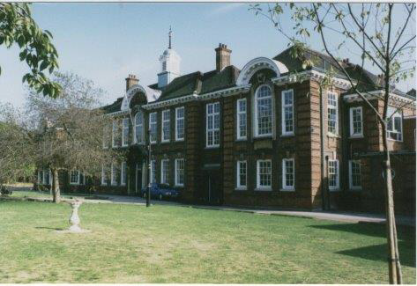

Information for applicants for the post of
Site Services and Lettings Officer
May 2017

May 2017
Dear Applicant
Thank you for requesting an application pack for the post of Site Services and Lettings Officer at Walthamstow School for Girls.
Walthamstow School for Girls is a high achieving, oversubscribed multi-cultural school which is regularly in the top 5% nationally for progress and the top 10% nationally for attainment. We have an ambition to become ‘world class’ and a commitment to work with other professionals both locally and nationally. In 2015 we won the national High Aspiration Award for the progress made by disadvantaged students and have won SSAT Achievement and Progress awards annually since 2014. Our students are ambitious and hard-working, they embrace the opportunities offered to them and this is highlighted by our exceptional examination results. They are a delight to work with.
We offer excellent facilities to both staff and students. Our acclaimed architect designed site is a pleasure to work in and is well served by transport connections, being just ten minutes’ walk away from Walthamstow Central tube and overground station and five minutes’ walk from the popular Walthamstow ‘village’, and creative and restaurant quarter. We pride ourselves on working hard to retain our role as an important part of the local community. Examples of this commitment can be seen in our weekly Greensheets. Our staff are inclusive and friendly, with social and wellbeing events organised on a regular basis. Other incentives for staff include membership of a child care voucher and cycle to work scheme.
We are committed to Safer Recruitment practices and procedures and shortlisted applicants will be questioned about their commitment to the safeguarding of young people. The successful candidate will be subject to an enhanced DBS clearance.
Thank you for taking an interest in this position. I do hope that having read more about the school you will decide to apply for the post. I look forward to receiving your application. Please note that it will not be possible to give feedback to unsuccessful applicants, other than those called for interview. Thank you for your understanding.

Ms Meryl Davies
Headteacher

The History of Walthamstow School for Girls
In January 1890, a circular stated that a “school for girls” was to be opened. Walthamstow was described as a pleasant suburb on the borders of Epping Forest. Hoe Street was almost a country road, with a few houses on either side and meadows in which were sheep, cattle, hawthorn and wild roses.
Miss Hewett was the first Headmistress, at the age of 27 until she retired in 1924. There were 49 girls, whose ages ranged from 7-16 years. At this time there were only five teachers, two of whom were graduates. The School’s original Staff Book gives details of the first one hundred teachers. Of them 30 remained at the school for ten years or more, 22 giving over twenty years’ service. Until 1944 all the teachers were women and not married.
The original building was in West Avenue Road and when the numbers grew the school moved to Church Hill House, where a church now stands. At this time there were also boys up to the age of 13 years at the school. It was in September 1913 that 243 girls came into the present building with the Greek Theatre being added in the 1920s. However in July 2008 the whole school moved off site for a period of four school terms to facilitate the building and refurbishment programme that has resulted in the unique blend of traditional and state of the art facilities found at the school today.
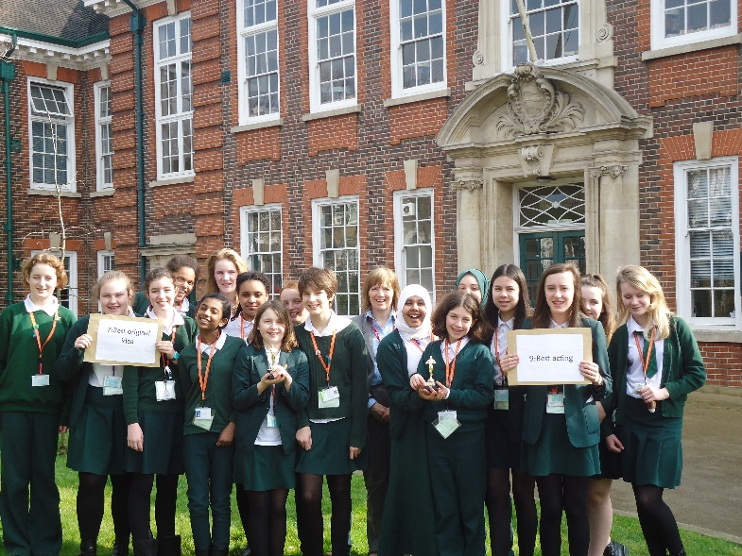
Walthamstow School for Girls is a place of high achievement. Effective teaching and learning are at the heart of our school. The school motto “Neglect not the gift that is in thee” underpins all the school’s work. Every girl is expected, encouraged and supported to achieve her very best academically and our pastoral system supports our students’ academic and social experiences.
Our role is to educate tomorrow’s women through a range of activities and opportunities to be confident, secure and happy individuals as they prepare for further education, careers and future lives.

WALTHAMSTOW SCHOOL FOR GIRLS
JOB DESCRIPTION
JOB TITLE: Site Services and Lettings Officer
GRADE: Scale 4 – 5 (36 hours per week, including weekend working, 52 weeks per year)
REPORTING TO: Site Services Manager
JOB PURPOSE
- Liaising daily with the Site Services Manager / Assistant Site Services Manager regarding site issues
- Ensure the security of the school premises at all times
- Help maintain the internal and external fabric of the school premises as a safe working environment
- Manage school lettings in partnership with the School’s Letting Agent and relevant school staff

Main Duties

Security
- Keyholding responsibilities for locking/unlocking school buildings and other areas
- Available on-call for out-of-hours alarm callouts and respond as necessary
- Assist with regular security checks
- Operate alarm systems where appropriate
- Cover lettings during evenings and weekends as necessary
- Monitor CCTV and surveillance equipment

Cleaning and Maintenance
- Assist with minor/simple repairs e.g. minor plumbing, changing light bulbs, unblocking drains, repairing door furniture
- Operation of heating plant, cooling and lighting systems
- Collect and assemble waste for collection
- Undertake cleaning duties including graffiti removal, litter-picking
- Undertake emergency cleaning duties
- Undertake routine tasks in connection with premises-related contractors, e.g. cleaning, grounds maintenance
- Provide emergency access to the school site
- Undertake activities to maintain safe and clean external environment e.g. gritting

Lettings
• To be responsible for the reception of visitors and lettees, ensuring they are welcomed in a polite, friendly and efficient manner.
• To be the key liaison for lettees, ensuring that their needs identified through the lettings booking are met
- Liaise with the Lettings Agent to plan and organise the necessary facilities and requirements for lettings to proceed smoothly
- Liaise with school staff to ensure rooms and facilities are booked out so that key school activities are not impacted upon and that the site is left in a state for teaching and learning to resume following the letting
- To organise the staffing required to cover lettings in partnership with the rest of the Site Team, the Lettings Agent and the School Business Manager
- To manage any complaints and issues regarding lettings and to escalate them to the Lettings Agent and/or School Business Manger as appropriate

General Tasks
  - Ensure the maintenance of a clean and orderly working environment
  - Timely & accurate preparation of routine equipment/resources/materials as set out in instructions
  - Undertake basic record keeping as directed
  - Refill and replace consumables e.g. soap & towels
  - Report faulty equipment & other maintenance requirements to appropriate person
  - Maintain the security of school premises by securing entrances/exits as appropriate and reporting potential security breaches to the Site Services Manager and School Business Manager
  - Ensure lights and other equipment are switched off as appropriate
- Escalate any staffing or hygine/safety concerns to line manager promptly
- Deputise for Assistant Site Services Manager
- Assist with the receipt, distribution, collection and despatch of goods
- Assist and participate in the organisation and movement of furniture within the building
- Maintain and arrange orderly and secure storage of supplies
- Operate everyday equipment in accordance with instructions
- Liaise with/supervise work of the cleaners by ensuring they carry out priority tasks and that rotas are adhered to
- Supervise contractors whilst on site
- Supervise work experience students
- To be available to cover lettings at short notice

Additional Responsibilities
- Be aware of and comply with policies and procedures relating to child protection, health, safety and security and confidentiality, reporting all concerns to an appropriate person
- Contribute to the overall ethos/work/aims of the school
- There is an expectation to attend all key school events out of hours as directed in the school calendar e.g. Opening Evenings, all Faculty and Staff Meetings and relevant twilight Inset sessions

- Present a positive personal image, contributing to a welcoming school environment which supports equal opportunities for all. To treat all users of the school with courtesy and consideration
- Promote and ensure the health and safety of pupils, staff & visitor (in accordance with appropriate health & safety legislation) at all times
- The above mentioned duties are neither exclusive nor exhaustive and the post holder may be required to be flexible and carry out other relevant and/or reasonable duties as directed by their Head Teacher/Line Manager commensurate with the skills, abilities and grade of the post

May 2017

WALTHAMSTOW SCHOOL FOR GIRLS
PERSON SPECICIFICATION
Site Services and Lettings Officer

- Experience

- Handyperson experience
- Supervisory experience

2. Qualifications
- Willingness to undertake induction training

3. Knowledge, Skills and Abilities
- Ability to relate well to children and adults
- Willingness to gain knowledge of basic plumbing, electrical and decorating repair procedures
- Willingness to gain knowledge of health and safety procedures and precautions
- Willingness to gain awareness of COSHH regulations
- Awareness of health and hygiene procedures
- Knowledge of moving and handling procedures
- Ability to work as part of a team
- Willingness to use relevant equipment
- Ability to relate well to children and adults
- Willingness to gain knowledge of cleaning procedures required to meet specified cleaning standards

May 2017

The diversity of all the students and accepting all religions, cultures and traditions.
It is welcoming, my daughter quickly settled into school life. It has high expectations of students but these are adapted for each individual so each is encouraged to do the best they can.

The value placed on education for young women, standards of behaviour expected, opportunities for activities which extend my daughter's understanding and interests, diverse community.

That the school provides opportunities for each girl to feel confident to strive to push beyond their current capabilities to achieve through hard endeavour and a belief that anything is possible.

What do you value most
about our school?
A sample of responses from a survey of parents (February 2016)
The sense of community; the high standards and expectations set by the school; the holistic approach to learning for the girls; the extra curriculum activities which supports learning and the fact that the staff team is a good diverse one.

High-quality learning environment and culture: comprising motivated, well-behaved pupils, strong and inspiring teachers and good resources.

The professionalism and reputation over such a long number of years.

