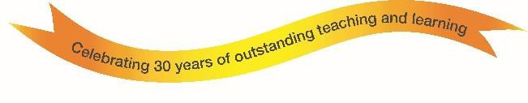
An Overview of Our School

The Cotswold School is based in the stunning village of Bourton-on-the-Water, Gloucestershire and has an outstanding reputation, as a highly popular, happy and successful 11-18 comprehensive school.

Set in over 30 acres of beautiful surroundings between Cheltenham and Oxford, the School has an incredible group of staff and governors who go that extra mile to provide students with an inspiring education - fully equipping them for their future lives. Our values of “friendship and knowledge”, symbolised on our badge, underpin all our activities across a broad spectrum of subjects and extra curricula offerings. Our mission - ‘the pursuit of academic excellence and individual achievement within a caring community’ is evident the minute you walk through our door.

The excellence of teaching and support has led to the School’s many awards, accolades and achievements, recognised both locally and nationally as:

Ofsted Outstanding School 2014/2015
In 2019, the examination results achieved by students at The Cotswold School were once again Outstanding
At A Level 42% of all grades awarded at A* or A, and two-thirds of all A Level grades awarded at A*, A, or B. Thirty Cotswold School students (25% of the cohort) achieved an impressive three or more A* or A grades.
At GCSE Level 81% of students achieved the benchmark of five or more 9-4 grades, 8% of students received 9-7 grades
in all their subjects, 35% of grades are 9-7. In addition, 44% of students achieved the EBacc Award.
The Sunday Times Comprehensive School 2015-2016 based on A*/A grades at GCSE and A*-B at A Level
19 Cotswold School students have gone to Oxbridge in the past 5 years
A new bespoke Sixth Form Building was officially opened in March 2018
The Cotswold School is a National Teaching School designated by National College for Teaching & Leadership

The School prides itself on the multitude of trips, excursions and expeditions, from Morocco to Iceland to China as well as offering a focused foreign language exchange programme to Spain, Germany and France. The international standing of the School is acknowledged through its partnerships with schools in France, Zambia and China, presenting the chance for pupils to experience different teaching approaches and countries.

The School holds a broad range of Careers Events throughout the year with a variety of visiting speakers from the world of business and finance, science and technology, performing arts, law, medicine and health care…..to name just a few!

Our Senior Leadership Team (SLT) is the backbone of the School. The SLT report to the Principal and the Governing Body and are responsible for the day-to-day management of the School. They work collaboratively with their colleagues to ensure cohesion across the different departments and Key Stages.

Our Governing Body bring a wealth of experience. With backgrounds in business and community activity, they make a significant contribution to the direction of the School. Our Chair and Vice Chairs of Governors are further supported by committees wi th separate responsibilities, including teaching and learning, finance and audit, personnel, premises, community use and health
and safety.

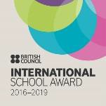
The Cotswold School is known for its highly successful preparation for University education, curriculum enrichment programme and flourishing facilities. Our results across a wide-range of subjects clearly demonstrate the commitment and professionalism of all the teaching staff. All our staff, both teaching and administrative, are extremely able and enthusiastic, responding well to both praise and challenge. We aim to continually move the School forward but, at the same time, we concentrate on the fundamentals of this job – teaching quality, pastoral care and upholding the unique ethos of The Cotswold School.

The Cotswold School Academy Trust is a company incorporated in England and Wales operating as a charity and limited by guarantee with registered Company
Number 7338767. Registered Office: The Avenue, Bourton-on-the-Water, Cheltenham, Glos. GL54 2BD

