

JOB DESCRIPTION

JOB TITLE: Senior Systems Administrator

REPORTS TO: IT Infrastructure Manager

AREA: ICT Services

GRADE/SALARY: Support Staff SO2, points 33 to 35, £34,952 to £36,681 per annum

POST NO: SS507

CLOSING DATE: Thursday 23rd May 2024

DBS: Enhanced DBS check with children’s barred list check
___________________________________________________________________

PURPOSE:

To support and develop College IT systems with key responsibilities for administration of authentication/security systems (Active Directory/Entra ID/Microsoft 365), Security systems (Sophos, Microsoft Defender, Barracuda), file sharing systems (SharePoint etc), groupware (O365) and collaboration (Outlook/Teams)

Based at Blossomfield Campus with an expectation to work across all three sites.

PRINCIPAL DUTIES:

- To administer the College’s Office365 tenancy and ensure and develop disaster recovery arrangements/business continuity arrangements.

- To be able to present IT problems, solutions and concepts to the wider college management team including deputising for the Infrastructure Manager where required.

- Ensure Business Systems version and patch releases levels are pro-actively maintained, working closely with wider colleagues and stakeholders to coordinate the application of upgrades and patches as appropriate.

- To develop and document the use of any custom scripts or procedures required to maintain College systems.

- To take a pro-active role in contributing to continual service improvement activities identifying new technological developments for potential use within the College.

- Liaise with relevant Colleagues to ensure College IT Systems and Services are fit for purpose and meet the needs of the College.

- To be responsible for changes and maintenance of College servers including those hosting key management information systems and Active directory

- To provide first and second-line support to our diverse customer base where required.

- To act as a mentor and trainer for new and existing technical staff to ensure effective infrastructure and other technical support.

- To line manage and appraise technical staff in order to achieve agreed goals.

- To adhere to policies, procedures and values of Solihull College & University Centre.

- To undertake all mandatory training in a timely manner as required e.g. Safeguarding, Prevent.

- To actively promote equality, diversity & inclusion and to champion anti-racist practice.

- To support the college to become a Sustainable Net Zero organisation by 2030 and support the delivery of its Sustainability Strategy.

- To undertake necessary Health and Safety responsibilities, duties and training as required by this post.

- To undertake any necessary Data Protection responsibilities, duties and training as required by the post.

- Such other duties as required which are broadly consistent with the general functions and grading of this position.

NATURE AND SCOPE:

This post provides back-office support to the various College systems to ensure cyber security and correct operation of College IT systems.

This involves working closely with College staff and stakeholders as well as with other members of the ICT Services team. It is important that the post holder is able to work as part of a team as well as on their own initiative and has excellent customer service skills.

EQUAL OPPORTUNITIES:

Solihull College & University Centre is committed to a comprehensive policy of Equal Opportunities. All employees are required to abide by this policy and ensure its compliance throughout the College.

SAFEGUARDING:

Solihull College & University Centre is committed to ensuring a safe environment for all students and expects all staff to engage fully with this commitment.

CORE VALUES:
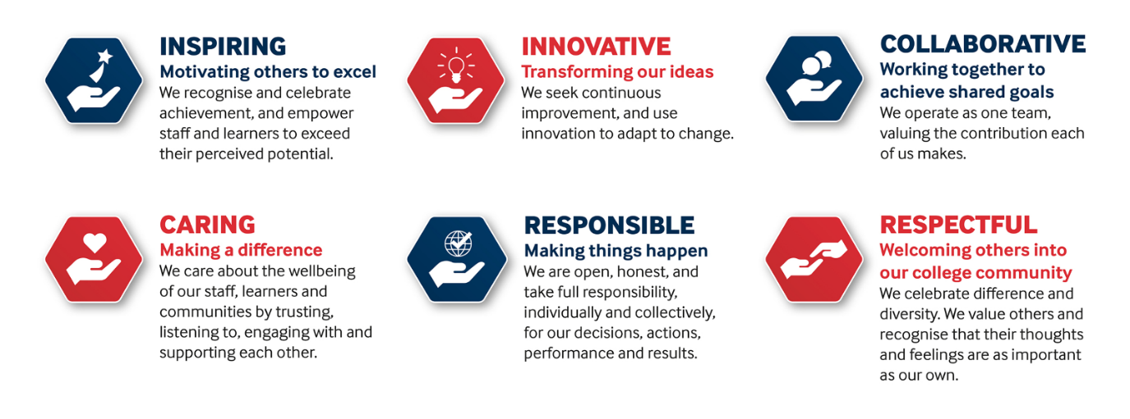

SOLIHULL COLLEGE & UNIVERSITY CENTRE
PERSON SPECIFICATION

JOB TITLE: Senior Systems Administrator

GRADE: Support Staff SO2, points 33 to 35, £34,952 to £36,681 per annum

POST NO: SS507

SPECIFICATION | ESSENTIAL | DESIRABLE
EDUCATION/  TRAINING | An Advanced Level or professional IT qualification or willing to work towards | Full MCSE or CNE qualification
RELEVANT EXPERIENCE | Extensive in-depth working knowledge of Entra ID and group policy preferences  Experience of migrating, supporting administering Office365  Thorough working knowledge of desktop/server/network operating systems and administration tools, including Windows Server and Linux  Effectively managing a technical team using service desk software  Thorough understanding of IT security concepts including firewalls, patching and vulnerability scanning | Knowledge of:  - SQL Server  - Exchange Server  - Powershell
SKILLS /  APTITUDES | Ability to research and develop own skills without direct supervision  Ability to share best practice  Ability to work independently or as part of a team  Work calmly under pressure  Ability to communicate clearly with others of similar and less technical experience  An awareness of sustainability and climate change and how it applies to Further Education
OTHER REQUIREMENTS | Ability and willingness to travel between College Campuses as necessary  Willingness and flexibility to work out of hours, and sometimes at short notice, when necessary  Strong commitment to Equal Opportunities  A commitment to the Safeguarding of Young People and Vulnerable Adults and an awareness of the Government ‘Prevent’ strategy  Commitment to the College’s Values

