KENT COLLEGE

______________________________________________________
INDEPENDENT DAY AND BOARDING SCHOOL FOR GIRLS 3-18

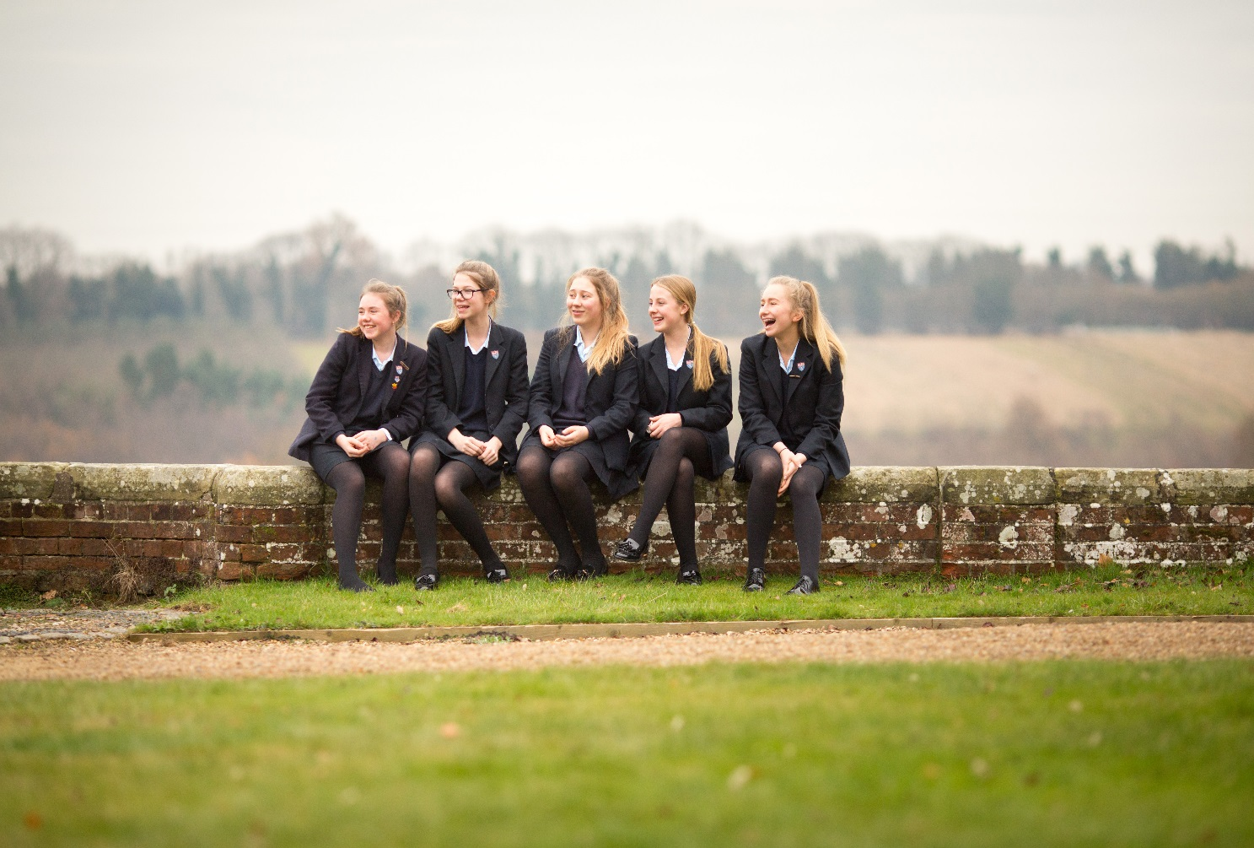

KENT COLLEGE PEMBURY

Teacher in charge of Sociology

Substantial Part time or full time would be considered for the right candidate

September 2020

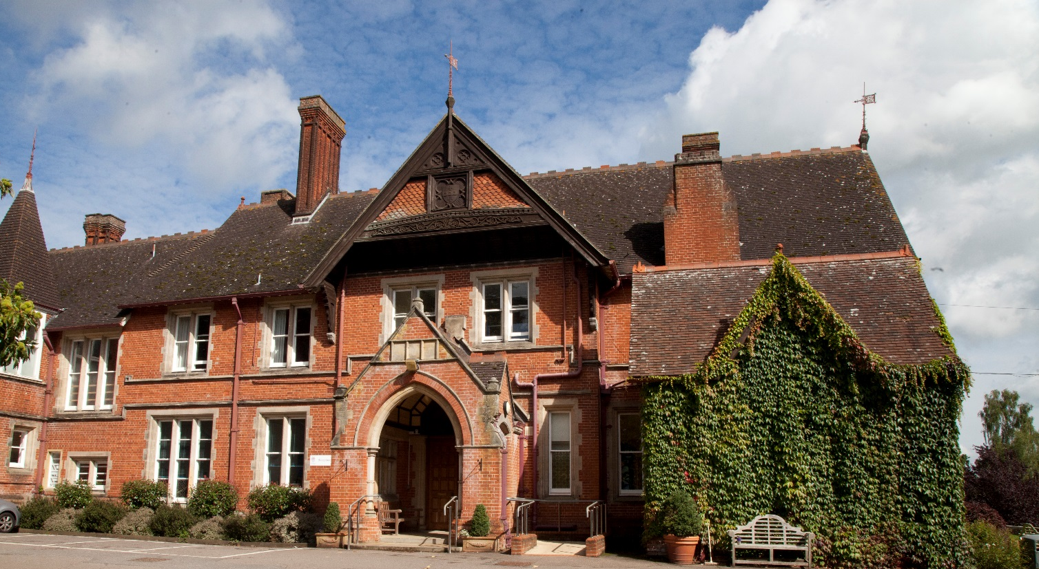

Background
Founded in Folkestone in 1886, Kent College is an independent day and boarding school for girls, with a Senior School (ages 11-18) and Preparatory School (ages 3-11) sharing the same site, facilities and some specialist staff. The school is one of a group of ten schools under the control of the Methodist Independent Schools Trust. The school has a resident Chaplain who leads the Christian worship in the school.

Since 1939, Kent College has been located on 75 acres of beautiful countryside in Pembury, near Tunbridge Wells. The school campus comprises an elegant Victorian manor house and purpose-built modern facilities, including boarding houses, a music centre, science building, sports hall, A level study centre, and an indoor, heated swimming pool. The school is committed to a continuous programme of development and the resources are excellent. IT provision is first-rate, including the number of interactive white boards, laptops and data projectors. In 2008 a new science wing was opened, providing inspirational science laboratories, and recent boarding refurbishment includes an extension of ICT facilities to individual study areas. The Countess of Wessex Theatre reopened in 2012 following extensive refurbishment and an iconic Library and Arts Centre opened in spring 2013. Our additional Sports Hall is now complete and was opened in October 2015.

The Senior School
The current roll in the Senior School is approximately 400 and attracts girls from all over the world. Entry at eleven and thirteen is by the GL CAT4 test and the school accepts quite a wide range of academic ability, with approximately half of our KS3 intake within the top 25% of the national ability range.

Kent College offers a choice of over 26 GCSE subjects, with group sizes usually between three and eighteen. Most girls complete 10 GCSEs or IGCSEs, but there is the opportunity to take more or less depending on interest or need. In summer 2019, 62% of GCSE grades awarded were 9-7 and the school’s value added, based on predictions at KS3 baseline data, was among the best in the country. Excellence was seen in core subjects such as English, Languages and Science, with 93% of all English grades being 7-9. The school is in a highly competitive area with girls’ grammar schools, strong comprehensives and many independent schools locally.

Students are also accepted for entry at 16+ and there are approximately 100 girls studying for A-level courses. In 2019, at A-level there were 72% A*-B grades and 37% A*-A Grades. We offer around 27 subjects: A-levels in most subjects and BTECs in PE and Drama. Class sizes at 16+ normally range between three and 12. Scholarships to the Senior School are offered at 11+, 13+, 16+ and means-tested bursaries are available.

The Prep School
In 1939, the School moved to its current site in Pembury, near Tunbridge Wells. In 1945, a Prep School was opened in the centre of Tunbridge Wells and in 1989; it was moved to the Senior School site in Pembury into architect-designed purpose built accommodation. The move also enabled the Prep School to benefit from a range of excellent facilities, which now include an indoor heated swimming pool, sports hall, theatre and dining hall.

The Prep School is a friendly, caring and happy school with a current roll of approximately 150 girls aged 3 to 11 (Nursery – Year 6). The majority are day pupils with a small number of boarders. In addition to the core subjects of English, Maths and Science, all of the girls in Key Stage 2 study Geography, History, Art, DT and RE, ICT Taught from Year 1 upwards. Specialist teachers in Music, French, Drama, PE and Swimming work with girls throughout the school, ICT is taught from Year 1 upwards and Mandarin is now also taught in Year 6. Class sizes in KS1 and KS2 are a maximum of 18. Each year, a number of girls apply for and are awarded scholarships to the Senior School.

Extra-curricular Activities (ECAs)
Kent College places a strong emphasis on extra-curricular activities and has a flexible and innovative lunchtime and evening programme of prep and activity sessions. Boarders can choose when they do their prep and day girls choose whether to do homework at home or at school. All girls participate in extra-curricular activities and are encouraged to plan the use of their time so that they follow a balanced programme of academic work and extra-curricular activities. The pastoral care in the school is very strong and all staff are highly involved in PSHCE and general pastoral matters. All teaching staff are required to be involved in at least one ECA and most do more than this, as both subject and general ECA are available.

Inspection
The school underwent a full integrated inspection by the Independent Schools Inspectorate in December 2015 and was found to be excellent in all areas. The report together with other information about Kent College can be found on our website at www.kent-college.co.uk

Benefits
Kent College Pembury employs over 200 people in both academic and support staff positions. Highly skilled, dedicated and passionate staff are the driving force behind our ‘Excellent’ school.

We are delighted to welcome applications from candidates who share our core values and who are able to contribute to our continued future success. We recruit staff of the highest calibre who will inspire, support and challenge the girls, and fellow colleagues, to achieve their full potential. Whatever your role, you will benefit from a being part of a large staff community with opportunities for professional development.

We believe in rewarding our staff and offer a complete range of employee benefits including:

- Reduced school fees
- Free meals during working hours
- Free eye tests
- On site Flu Vaccinations
- Free onsite parking
- On-going training and development
- Use of swimming pool and fitness suite (at allocated times)

Sociology Departments
There are close links between our Sociology and Psychology departments, both of which are popular and enjoy high levels of success in a school that is noted for its pastoral ethos and outstanding value-added factor in its results. Teachers at Kent College are well supported with access to a rich variety of teaching materials, including good ICT resources and a library well stocked with subject-specific works.

The School
Kent College for Girls is a happy and thriving school, offering a broad education aimed at developing character, inter personal skills and all-round wellbeing. This is reflected particularly in our Growth Mindset and Sport and Wellbeing programmes. It is hoped therefore teachers joining the school would share the same sense of openness and enthusiasm that we aim to cultivate in our students.

The Post
We are seeking a well-qualified and inspiring A-Level Sociology teacher with excellent subject knowledge. The ability to teach a second subject, especially Psychology, would be an advantage.

Salary
Kent College’s salary structure is based on the national Teachers’ Pay Scale according to experience, albeit with enhancement, together with the school’s own management and responsibility points. Kent College also offers the staff the opportunity of moving to the upper pay range of teachers’ pay, including progression from U1 to U2, on KC criteria; existing threshold achievement to U2 will be honoured. The post holder will be eligible to join the Teachers’ Pension Scheme operated by the Teachers' Pensions Agency.

Application process
The completed application form, including the names and addresses of two referees, cv and a letter of application should be sent to Headmistress, Ms Julie Lodrick, Kent College Pembury, Old Church Road, Pembury, Tunbridge Wells, Kent TN2 4AX by letter, fax (01892 820232) or email (hr@kentcollege.kent.sch.uk)

Closing date: Monday 27 January 2020 by Midday

Candidates are encouraged to apply well before the deadline. We reserve the right to interview candidates before the closing date.

References will be taken up prior to interview. One of the referees should normally be the applicant’s current or most recent employer. The post requires the highest level of clearance through the Disclosure and Barring Service (DBS).

Kent College is committed to safeguarding and promoting the welfare of children. Appointees must be prepared to undergo child protection screening. Child Protection and welfare are taken very seriously at Kent College, with guidelines on confidentiality and staff-pupil relationship procedures well-publicised to staff.

All gaps of employment are to be accounted for and will be rigorously investigated. Referees are contacted to ensure the validity of the reference. Testimonials are not acceptable in place of confidential references.

