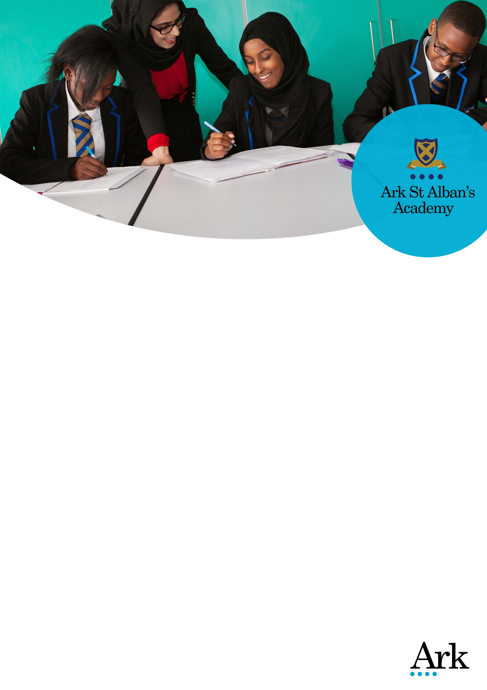

Teacher of Design & Technology (Maternity cover)
Join a school where staff are given the freedom and support to innovate and collaborate
Start date: January 2018
Salary: Ark MPS (£23,486 - £34, 328) Outside London, depending on experience
Location: Highgate, Birmingham
Deadline: 11am, Monday 16th October 2017
Ofsted: Outstanding (2011)

Visits to our school are encouraged; to arrange, please contact Katie Roberts on 0121 446 1300 or email katie.roberts@stalbansacademy.org

With an outstanding rating from Ofsted, the best EBacc results in Birmingham and some of the best value-added results in the country, we promote an ambitious and aspirational culture to students and staff alike.

We are looking to recruit an outstanding Teacher of Design and Technology to join the school. You will be responsible for planning and delivering the highest-quality lessons and achieving excellent results for their students, instilling in them a love for the subject and a desire to learn.

Our ideal candidate will:
- be passionate about design technology;
- help the transition from Resistant Materials to Product Design;
- have the ability to teach KS5;
- possess highly developed ICT competencies is desirable

We offer you the best training and support at every stage of your career. You will receive regular coaching sessions, 3 hours of timetabled CPD per week, as well as staff collaboration across the network. Our teachers also provided with nine free periods per week and are encouraged to use creative approaches to teaching.

Our clear behaviour management system across the school allows our staff to concentrate on what they do best and students to focus on learning.

As a teacher at Ark St Albans Academy, you will be part of Ark, an international charity and one of the UK's most successful multi-academy trusts, with a network of 35 schools in 4 locations across the country. Benefits of being part of the Ark network include:
- A salary 2.5% higher than the main scale teacher salaries
- Twice as many training days as standard and network-wide events with Ark colleagues, held by the best minds in education
Click here to find out more about the benefits of work for Ark St Albans Academy.

Visit our website for more information on the school. For an informal, confidential discussion, please contact the school and speak with Katie Roberts.

For technical queries, please contact the central Recruitment team on recruitment@arkonline.org or 0203 116 6345.

Please submit your application online by visiting https://goo.gl/kR4E6p . The deadline for applications is 11am, Monday 16th October 2017. Applications will be reviewed on an ongoing basis so early applications are encouraged.

Ark is committed to safeguarding children; successful candidates will be subject to an enhanced Disclosure and Barring Service check.

Job Description: Teacher of Design & Technology

Reports to: Head of Department
Start date: January 2018
Salary: Ark MPS (£23,486 - £34, 328) Outside London, depending on experience
Contract: One-year Maternity Cover

The Role
To deliver outstanding teaching and learning and achieve excellent results for students.

Key responsibilities
- Plan, resource and deliver lessons to a high standard.
- Ensure that students make good progress.
- Provide a nurturing classroom environment that helps students to develop as learners.

Teaching and Learning
In the classroom
- Plan and deliver objective-led lesson plans and schemes of work.
- Teach engaging and effective lessons that motivate, inspire and improve student attainment.
- Use regular assessments to monitor progress and set targets.
- Use assessment data to inform intervention and future planning.
- Engage in a professional dialogue informed by lesson observation.
- Participate in the development and delivery of high quality teaching of literacy and numeracy.
- Attend to the learning needs of students who speak English as an additional language.
- Provide quality support for students with special needs.
- Provide for Gifted and Talented students in line with department policy.
- Teach personal, social, moral and spiritual aspects.
- Implement department and school behaviour policies in lessons.
- Ensure that all students achieve at chronological age level or, if well below level, make significant and continuing progress towards achieving at level.
- Maintain regular and productive communication with parents, regarding progress and associated issues.

In the department/school
- Engage in a thorough process of monitoring and evaluating the quality of teaching and learning in the subject area in the context of the school’s self review framework.
- Engage in collaborative planning and development with department and whole school teams (e.g. School Improvement Group).
- Use all available relevant data to inform planning, target setting and raising achievement.
- Deliver work related learning in line with department policy.
- Contribute to the development of ICT to support learning in the subject and deliver the school’s plans for ICT across the curriculum.
- Carry out assigned tasks and responsibilities within the department.
- Help to formulate the Department Raising Attainment Plan.
- Carry out assigned tasks and responsibilities as identified in the Department Raising Attainment Plan.
- Meet deadlines for the submission of data, information, reports and other returns as required.
- Participate in the development of appropriate syllabuses, resources, schemes of work, marking policies, assessment and teaching strategies.
- Engage in networking activity with partner schools.

Academy Culture
- Have high expectations of what students will achieve.
- Have high expectations of colleagues.
- Challenge every individual to make the most of their God given talents.
- Focus efforts on maximizing student achievement.
- Be pro-active in implementing whole academy policies and raising attainment plans.
- Promote the Christian ethos of the academy.
- Be vigilant and respond to breaches of the Academy behaviour policy whenever and wherever encountered.
- Be an active participant in a learning community and work towards personal professional development targets.
- Help create a strong academy community, characterised by consistent orderly behaviour and caring respectful relationships.
- Help develop a small school/department culture and ethos that is utterly committed to achievement.
- Participate in consultation and marketing events for parents and the wider community.

Other
- Carry out tasks on own initiative or as directed in response to unexpected circumstances (e.g. medical emergency, health and safety issue, disorderly incident).
- Lead at least one weekly after school session e.g. extra lesson or club.
- Undertake other various responsibilities as directed by the Head of Department or Principal.

Personal Specification: Teacher of Design & Technology

Qualification Criteria
- Qualified to degree level or above.
- Qualified to teach in the UK.
- Right to work in the UK.

Experience
- Experience of raising attainment in a challenging classroom environment.
- Evidence of continually improving the teaching and learning of their subject though schemes of work and extra-curricular activities.

Behaviours
Leadership
- Actively sympathetic to the Church of England ethos of the school which aims to nurture and encourage the faith of all students whatever their religion.
- Effective team worker and leader.
- High expectations for accountability and consistency.
- Vision aligned with Ark’s high aspirations, high expectations of self and others.
- Genuine passion and a belief in the potential of every student.
- Motivation to continually improve standards and achieve excellence.
- Commitment to the safeguarding and welfare of all pupils.

Teaching and Learning
- Excellent classroom teacher.
- Effective and systematic behaviour management, with clear boundaries, sanctions, praise and rewards.
- Good communication, planning and organisational skills.
- Demonstrates resilience, motivation and commitment to driving up standards of achievement.
- Acts as a role model to staff and students.
- Commitment to regular and on-going professional development and training to establish outstanding classroom practice.

Other
- This post is subject to an enhanced DBS disclosure.

Ark is committed to safeguarding and promoting the welfare of children and young people in our academies. In order to meet this responsibility, we follow a rigorous selection process. This process is outlined here, but can be provided in more detail if requested. All successful candidates will be subject to an enhanced Disclosure and Barring Service check.

