Diocese of Northampton - Duns Scotus Trust
A registered charitable Company limited by guarantee (number 10435919)
Address: St. Joseph’s Catholic High School, Shaggy Calf Lane, Slough, Berkshire, SL2 5HW

St. Ethelbert’s Catholic
Primary School and Nursery
‘Learning, achieving and growing together with Jesus’
Headteacher: Mrs F.Maynard

Wexham Road, Slough, Berkshire SL2 5QR
Telephone: 01753 522048 Fax: 01753 552613
post@stethelberts.slough.sch.uk

Dear Applicant
Do you want to work in a school where standards are high and pupils are eager to learn?
Would you like to access personalised professional development and support?
Then St. Ethelbert’s is the school for you!
Thank you for your interest in the role of class teacher at St. Ethelbert’s Catholic Primary School and Nursery. Our school is a popular, friendly and welcoming community with wonderful children whose positive approach to learning and excellent behaviour make them a real pleasure to teach.
Our most recent Ofsted inspection (January 2015) confirmed that we are a good school. Some of the many strengths noted in the report include:
- Pupils make good progress because the school has an exciting and challenging curriculum which is well taught.
- The behaviour of pupils in class is very impressive. Across the school, pupils work hard to complete the tasks they are given.
- Pupils enjoy their work and demonstrate a real resilience when tackling difficult, new subject matter.
- Leaders are skilled at supporting and improving the quality of teaching…Teachers are very positive about the level and effectiveness of the support and professional development they receive.
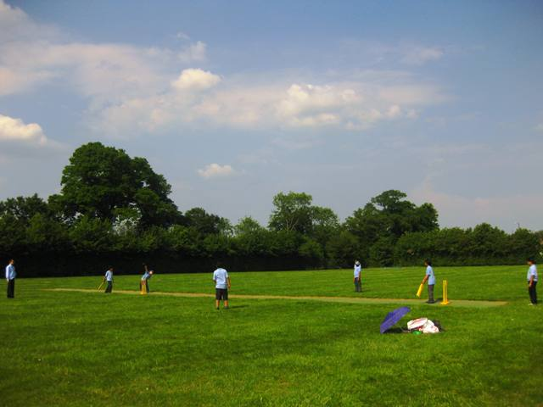
As a Catholic school, we strive towards providing a curriculum and learning environment that ensures every child achieves and makes the most of their talents given to them by God. We have high expectations for every child and believe strongly that the unique achievements and contribution of every child should be celebrated and valued. Our mission statement – “Learning, achieving and growing together with Jesus” – underpins everything we do and we are looking for teachers who are supportive of this ethos. We are looking for teachers with high expectations and a positive approach, who see and value the potential in each child. In return we will offer you the support you need to develop your career within a warm and friendly environment where each member of our team is valued for the

contribution they are making. Most importantly, we have a school full of wonderful children who are waiting to welcome you to our team. Applicants of all faiths or of no faith are more than welcome to apply; our staff reflect the diversity of the local area.
Our staff are a committed and hard-working team who will provide a welcome to new colleagues. The systems and structures of the school are firmly embedded and we provide an excellent induction programme for all new staff.
I hope that you are excited by the prospect of working at our school. If you have any questions or wish to discuss your application further, then please do not hesitate to contact me. Visits to the school are also warmly welcomed so you can see for yourself how fantastic our pupils are.
Yours faithfully
Mrs Fiona Maynard
Headteacher

