Deputy Learning Support Co-ordinator (Part-time)
Job Description

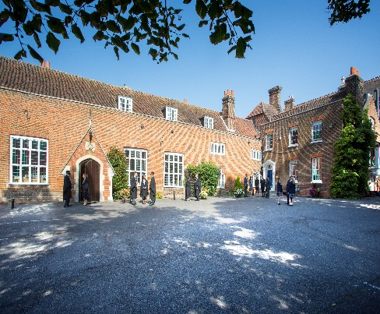

Introduction
We are seeking to recruit an enthusiastic and motivated Deputy Learning Support Co-ordinator. This is a new and exciting opportunity for a teacher with the relevant experience who is committed to supporting teaching and learning to meet the needs of the students and the School. The successful candidate will work closely with the Head of Learning Support in the provision of the learning support function in the School. The Learning Support department is key to ensuring pupils fulfil their full potential and is highly significant both pastorally and academically across the School.

Background
Founded in 1629 by Samuel Harsnett, the son of a Colchester baker who went on to become Archbishop of York, Chigwell School stands on it original site with the original school building still in use. However, whilst Chigwell of today is conscious of its long-standing history, it is a forward-looking, ambitious, co-educational independent school of 930 pupils aged four to eighteen. It enjoys excellent facilities, a dedicated staff, bright and hardworking pupils, and a site of 100 acres.

Chigwell School is located in the picturesque village of Chigwell just over ten miles from central London and on the Central Line. The extensive, beautiful grounds are close to the edge of Epping Forest and it is rare for a school to have so much space and yet be so close to the centre of the Capital. Most pupils are day pupils but in the Sixth Form, there is a small community of international boarders, roughly thirty from sixteen countries, and these live in four small boarding houses.



As well as being an academic school, Chigwell has the reputation for providing a rich and full education, with plenty of opportunities for all pupils who are enthusiastic, co-operative and able. Chigwell is a caring and friendly school, with a close sense of community, not least between colleagues. As the 2015 Good Schools Guide reports: Academically, pupils are put through their paces but it all seems to be done in such a civilised and pleasant manner that you are more likely to hear pupils talk about opportunities and prospects than pressure and stress. “Anyone who wants to do well here, will do well” said one student, and I can’t think of a nicer place to succeed.”

The School Development Programme
Over recent years, the School’s facilities have been extensively developed in order to enhance the educational experience that pupils receive. The development programme has included the following additions:
- 2008 Wilson Building teaching block
- 2008 Floodlit AstroTurf pitch
- 2009 Junior School library extension
- 2010 Complete redevelopment of catering facilities
- 2010 Sixth Form coffee shop
- 2010 Harsnett’s and Church House converted into boys’ boarding houses
- 2012 The Old Chigwellian Club and land was incorporated into the school estate
- 2013 Pre Prep School built and opened
- 2013 Two new science labs created
- 2014 Drama Centre balcony extended to provide additional music and drama rehearsal space
- 2016 The Risham Sarao Sixth Form Centre was completed

In the future we plan to:
- Renovate the Chapel
- Extend the Dining Hall
- Develop the Sports Centre
- Expand our music facilities
- Further expand our provision of bursaries

The School
Some pupils join in Reception and there are two classes in each of the three Pre Prep year groups. A small number of other children join the Junior School at 7+ (Year 3) and there are two or three classes in each of the KS2 year groups. At 11+ (Year 7), there is a further entry with four classes making up Years 7 to 11. Again, there is a small entry into the Sixth Form. Entry at each stage is selective and although there are three main sections to the School (Pre Prep, Junior School and Senior School) these sections work closely together and there is a common ethos running throughout.

There are over a hundred teachers and together with the support staff, there is a friendly, mutually-supportive atmosphere. All teaching staff contribute to the extra-curricular programme.

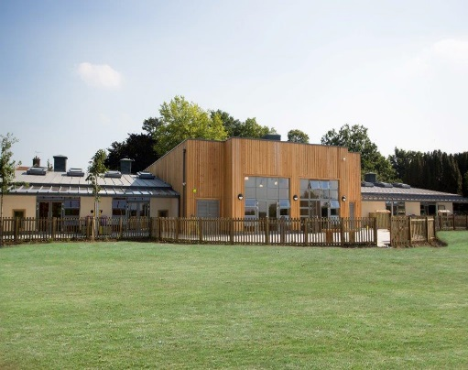

The Role

We are seeking to recruit a Deputy Learning Support Co-ordinator. The Learning Support department is highly significant both pastorally and academically, and it is key to ensuring that pupils fulfil their full potential across the Junior and Senior Schools. There is a team of teaching assistants who work with the Learning Support Co-ordinator to provide help to both individuals and groups. Chigwell pupils are selected on the basis of academic ability but there are a number on the learning support register. The intervention of the department helps both them and their teachers to work more effectively. We anticipate that the successful candidate will want to work with parents to help guide their support of their children; guide pupils with learning difficulties to work in the way that best suits them; and promote an understanding of the needs of individuals on the learning support register with teaching colleagues.

Key Responsibilities

Working closely with the Head of Learning Support, the postholder will assist the running of the Learning Support department to ensure the successful teaching and learning and development of the Department take place.

The postholder will:

- Support the Head of Learning Support with providing and strategic vision for the department

- Support the Head of Learning Support to ensure that the School’s Learning Support Policy is up to date, compliant and implemented throughout the School.

- Assist the Head of Learning Support with the identification, assessment and provision for all children with SEN or to deputise for the Head of Learning Support if required.

- Support the Head of Learning Support to ensure high standards of learning and teaching in the department

- Working with the Head of learning and support evaluate and develop the courses offered to pupils and the teaching strategies used and contributing to other aspects of the general on-going development of the SEN report.

- Advise staff with developing a broad, balanced and inclusive curriculum to help SEND learners succeed

- Liaise with Learning Support staff, Heads of Department, class teachers and Heads of House about students with SEN and, where necessary, refer students to the appropriate external agencies for further support.

- Engage in liaison meetings with appropriate outside agencies, under direction of the Head of Learning Support e.g. Ed Psych, Speech and Language service, ASC service, EWO; LEA etc.

- Ensure that appropriate schemes of work, including related SEND assessment processes, are in place and regularly reviewed

- Monitor students to ensure that appropriate intervention strategies that raise overall standards are implemented

- Managing and deploying available resources including, under direction from the Head of Learning Support and assist staff working within the department.

- To keep up to date with national developments in the departmental area, and to remain informed of recommended teaching practice and methodology

- Plan and deliver, in consultation with the Head of Learning Support, suitable programmes of work and in-class support strategies for students with SEND.

- Arrange in-class support as appropriate. Advise TA’s of the needs of students with learning inclusion issues and of suitable methods and strategies to remediate these needs. This may include the modelling of good practice or support with planning and review.

- To assist with staff development and INSET training with regard to SEND where appropriate.

- To work with the Head of Learning Support to ensure that students are awarded appropriate examination concessions in respect of their needs and trained in their usage. To deploy support staff to assist with such concessions as appropriate.

- To report termly to Head of Learning Support on departmental intervention performance and resultant student progress so that interventions can be refocused as appropriate

- Keep detailed records of the progress of key students receiving Learning Support, including writing and reviewing IEP’s and Annual Reviews

- To play a full part in the life of the school community, to support its ethos and to encourage staff and students to follow this example

- Attend appropriate training courses as relevant and attend meetings with local counterparts

- Attend staff meetings, assemblies and functions as appropriate.

- Participate in the School's system of performance management.

- Be aware of and comply with policies and procedures relating to child protection, equal opportunities, health and safety, confidentiality and data protection.

- Contribute to the overall ethos of the School

- Undertake any other reasonable and relevant duties in accordance with the changing needs of the School.
This job description is not exhaustive and will be subject to periodic review.

The Person

This is a challenging and exciting position. We are seeking an energetic and confident teacher with relevant experience. He or she will be an advocate for the needs of those pupils with learning difficulties, who will also be capable of working with teaching colleagues to help them bring out the very best in all pupils.

Person Specification

 | Essential | Desirable
Qualifications/Education | - University graduate and qualified teacher with the ability to teach KS2 pupils or KS3 to KS5  - Hold a post graduate (Level 5) qualification ins SpLD | - Hold a Head of Learning Support qualification  - Hold a post graduate (level 7) qualification in SpLD which includes at least 100 hours relating to individual specialist assessment, or the willingness to undertake the training for this qualification
Experience | - Experienced teacher at Junior and/or Senior School level.  - Experience of working alongside other teachers in development and learning  - Experience on access arrangements for exams (in school and external) for pupils who qualify according to JCQ guidelines | - Evidence of continuing professional development  - Evidence of an active contribution to the successful development of students with SEND related issues or other significant vulnerabilities
Skills and attributes | - Proven understanding of SEND and best practice in its support and remediation.  - Sensitivity to the aspirations, needs and self-steem of others  - Commitment to team working  - Willingness to address challenging issues  - Ability to motivate, lead and support staff and students | - Confident in the use of information and communication technology  - Good negotiating skills.
Personal Attributes | - Dynamic nature with a passion for teaching and learning  - Excellent communication, organisational and management skills  - Excellent interpersonal skills  - Self-motivated and able to use own initiative  - Flexibility, able to take on a new challenge

Remuneration
Competitive and commensurate with experience. The children of teaching staff receive a 50% fee remission for children in Years 3 to 6, and 66% fee remission thereafter, subject to satisfying the normal admission criteria.

Other benefits of working at Chigwell School include:

- Access to the School Pension Scheme  - Free lunch and refreshments during term time  - Childcare Vouchers  - Personal Accident Cover  - Employee Assistance Support Programme  - On site parking and cycle racks  - Use of School Library | - Medical Centre on site  - Free use of School’s sports facilities outside of the School day  - Commitment to professional development  - A vibrant and supportive community of highly motivated students and staff  - A beautiful working environment- 100 acres site beautifully landscaped with a number of listed buildings

Applications

Applicants should complete the teaching staff application form which can be accessed directly from our website: www.chigwell-school.org (Vacancies) and sent to the Headmaster’s P.A.: hmpa@chigwell-school.org by Monday 25th September 2017. The Headmaster, Mr Michael Punt, will be happy to answer any questions; he can be contacted at the School by telephone 020 8501 5701 or by e-mail to mpunt@chigwell-school.org

Chigwell is committed to safeguarding and promoting the welfare of children and young people and expects all staff and volunteers to share this commitment. Applicants must be willing to undergo child protection screening including checks with past employers, prohibition orders and enhanced DBS.



