
Introduction
Gosford Hill School

This popular and successful school is on an attractive site located in the ‘village’ of Kidlington on the northern edge of Oxford. It was founded in 1932 as a co-educational ‘National’ school, became a mixed community comprehensive in the 1960s, and now has Academy Status from 2012. It serves students from 11 to 18 across the whole ability range for a wide area of Oxfordshire – Kidlington, North Oxford, Bicester and surrounding villages such as Islip and the ‘seven villages of Otmoor’; contract buses bring students into school each day.

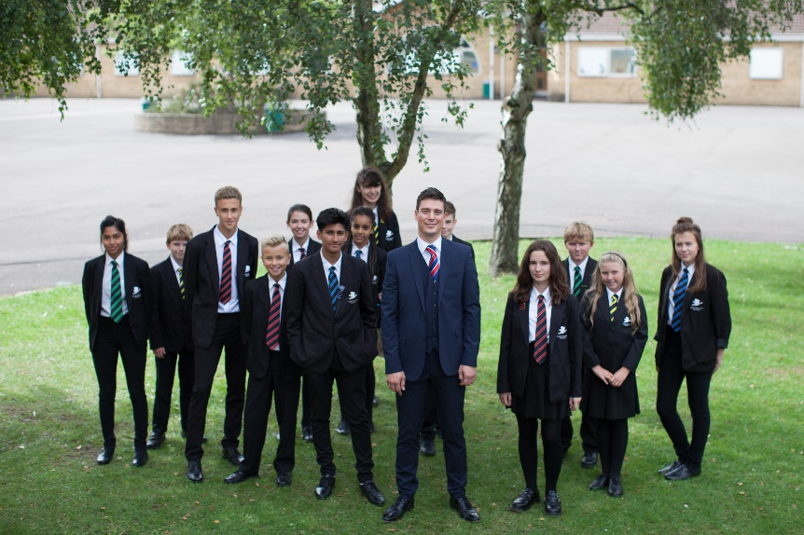

There are 903 students (including our Sixth Form) and a staff of 62 teachers and 48 support staff.

The vision for the School underpins everything we do. Gosford Hill School aims:

To be an outstanding school, recognised both locally and nationally, that provides an outstanding, creative education for all its students and prepares them for life after Gosford Hill as responsible members of society.

To develop an environment that will help all our students exceed in achieving their goals and aspirations by:

- Creating a supportive, collaborative and nurturing community for both students and staff;
- Enabling our staff to deliver teaching and learning excellence, which is both challenging and inspiring to all;
- Providing outstanding pastoral care and developing all of our students’ individual qualities;
- Ensuring that all stakeholders are valued and contribute to the success and sustainability of the School; and
- Embedding a passion for learning which will change lives and last a lifetime.

The school is accommodated in a range of buildings of various dates, including a superb joint school/community use Leisure Centre (with sports hall, swimming pool, flood lit all weather astro turf pitches and squash courts), a new nine laboratory Science block; three new Design and Technology rooms; six Information Technology rooms; a large staff room, faculty staff learning areas, training and conference rooms.

The School Development Plan is tightly focused on raising standards of student achievement and behaviour for learning, and there have been significant improvements in examination results, at GCSE and A level, over recent years. We are a specialist school in Mathematics and Computing. In 2017, the school achieved 61% 5A*-C (including English and Maths).

School Hours

There are 5 lessons each day of I hour each, over a timetable cycle of two weeks.

08.50 - 09.00 | Assembly / tutor time
09.00 - 11.00 | Lessons 1 & 2
11.00 - 11.20 | Morning break
11.20 - 13.20 | Lessons 3 & 4
13.20 - 14.05 | Lunch break
14.05 - 15.05 | Lesson 5
15.05 - 15.20 | Assembly / tutor time

The Curriculum

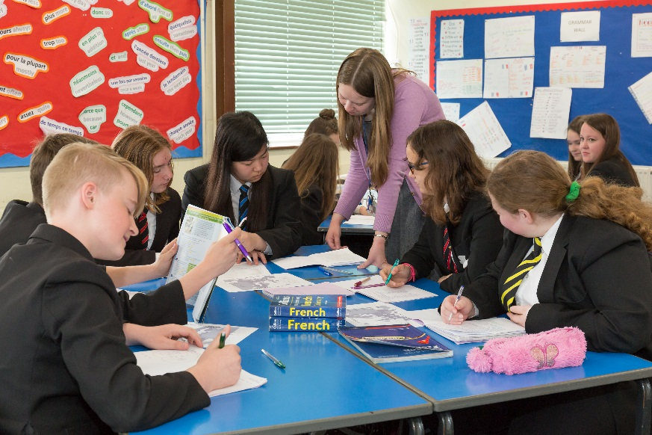
Each student has a broad and balanced curriculum covering the national curriculum subjects plus a Personal, Social, Health and Citizenship Education (PSHCE) course, which are incorporated into Religious and Personal Education (RPE) lessons at Gosford Hill.

After some smaller cohort years due to local demographics, the school has increased its intake to around 160-175 students per year group, and is appealing to parents from a wider area. We attract 160-175 students In Key Stage 3 (Years 7-8) most students follow a common course, including both French and German as foreign languages. Lessons are taught to mixed ability groups in Year 7 and 8, except for Mathematics which has broad setting.


Students with special needs are helped in the classroom by a team of Teaching Assistants and may also be withdrawn to attend ‘catch-up’ lessons in Literacy and Numeracy, ‘Booster’ classes and individual learning programmes in the Intervention Faculty.

The current curriculum at Key Stage 4 (Years 9-11) is broad and balanced. Students follow a curriculum of English, Mathematics, Triple or Double Award Science, Physical Education (PE) and Religious and Personal Education (RPE) in the ‘core’, plus a choice of four GCSEs from a mixed option of subjects including a full GCSE in PE, Languages, Humanities, Business, Health & Social Care, Performing and Creative Arts, ICT and Design & Technology. For most students this leads to between nine to eleven GCSE examinations (or their equivalent).

A small number of students follow a Study Support option.

The curriculum is currently being reviewed in response to the 14-19 agenda and discussions are taking place regarding the structure of the school day and the number of options to be studied at KS4. There is also a feeling within the school that there needs to be some greater flexibility at Key Stage 5 in particular.



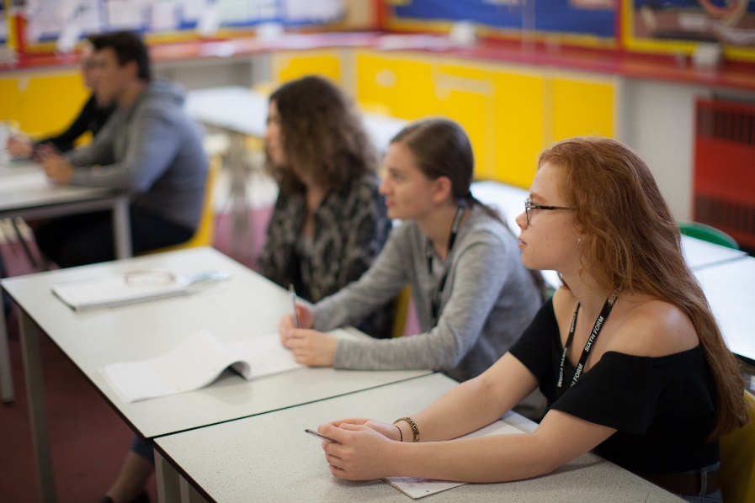
Our well-established Sixth Form offers a wide choice of three or four A levels from a list of 22 different subjects. Students are also given the opportunity to resit GCSEs in English and Maths, if required. Results have been very good with the school achieving a high place in the league tables for average A level points score. We take students from other schools who transfer here at 16+. Whilst our Sixth Form numbers are relatively small it allows for a very personalised curriculum with students being well supported and achieving highly. Most students achieve their first or second choice University place, many are Russell group establishments and we regularly have students applying to and attending Oxbridge, medical and veterinary schools.

Pastoral care

A distinctive feature of Gosford Hill School is the strength of the pastoral system and the school's commitment to each individual. All teaching staff are tutors and we work hard to ensure that students are supported throughout their time at Gosford Hill School both academically and pastorally.

Students join a vertical tutor group of about 24, assigned to one of four Houses, and all tutor groups have one main tutor and a House Leader who share the responsibility of pastoral care and monitoring academic progress. Students are also supported on a day to day basis by Student Managers.

The PSHCE programme is delivered by specialist teams in Years 7-11 through RPE lessons. It covers all aspects of personal development including study skills, personal relationships, moral and social awareness, citizenship, careers, sex and health education and social issues. In Years 10 and 11 those students wishing to sit an additional GCSE in Religious Education are taught separately by specialist staff.




The school offers a challenging range of visits, residential experiences, foreign exchanges and, in Year 10, work experience. The willingness of staff to contribute to extra-curricular activities is widely evident and greatly appreciated.

Student progress is assessed at least three times per year. A Progress Report is sent to parents twice a year for Years 7-11 and Year 13, and three times a year for Year 12, indicating current progress and highlighting any issues. There is also an annual Parent Consultation Evening (PCE) for each year group. A system of House Points and rewards operates for outstanding work and service and there are the usual sanctions for poor behaviour or effort.

The Staff

Two particular strengths of this school are the excellence of administrative support and the close collaboration and good working relationship between the teaching and support staff. The school is committed to the professional development of all staff and every member of staff is encouraged to determine the nature of their individual CPD programme and develop their own CPD portfolio.

House Leaders, chaired by the Assistant Headteacher – Student Support, meet to discuss all matters relating to student welfare and development. Faculty Leaders, chaired by the Deputy Headteacher, is the forum for discussion of all curriculum matters. Joint meetings of the two groups are held as appropriate and are one of the main decision making groups in the school. Regular Faculty and tutor team meetings take place during each month. Staff are consulted regarding the school priorities and goals. These are outlined in the annual School Development Plan and are shared throughout the school.

Each Faculty and House Leader takes part in an annual review of progress towards targets set in school and team development plans. All staff are fully involved in the planning and decision making process, and regular meetings of the support staff are held. Each Faculty has a link with a member of the Strategic Leadership Team and with a school governor.

The present contact ratios for staff are as follows:
Career Stage | Teaching Load out of 50 periods per fortnight
Standard Scale | 45
Faculty Leader | 39-41 (dependent on size of faculty)
House Leader | 40
Assistant Headteacher | 25
Deputy Headteacher | 14
Headteacher | 4

For New Appointments to Gosford Hill School we offer:

- Training specifically tailored to meet your CPD needs
- A mentor, suitably qualified and experienced to offer you support.
- A warm welcome from a positive and committed staff who enjoy working together
- Career progression opportunities – we train our own, and other staff, as part of the Outstanding Teacher Programme and utilise various leadership programmes

The Future

This is an exciting time to be joining the school. Since the arrival of our ‘new’ Headteacher, just over a year ago, there is a strong sense of the school being ‘on the up’ amongst staff, students, parents and the local community. Pupil attainment has improved and student progress at Key Stage 2-4 has been strong. Results at 14+, 16+ and 18+ are good and getting better.

Our Ofsted report of 2016 was full of praise for the accomplishments of students and the supportive nature of staff in all aspects of student learning and development. The report also acknowledged how the leadership team have correctly identified the key foci for Gosford Hill School as it continues to rise to the educational challenges that lie ahead.



Gosford Hill School is an equal opportunities employer and is committed to safeguarding and promoting the welfare of children and young people. We expect all staff and volunteers to share this commitment. Due to this post having access to children and/or vulnerable adults, candidates will be required to undertake a Disclosure and Barring Service check. The possession of a criminal record will not necessarily prevent an applicant from obtaining this post, as all cases are judged individually according to the nature of the role and information provided.

