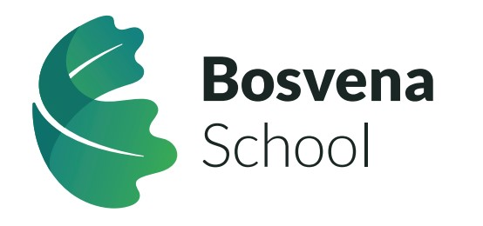

Job Title: Teacher
Closing Date: 21st March 2025 – 12.00pm
Shortlisting: 25th March 2025
Interview: 3rd April 2025
Start Date: May/June 2025
Salary: MPS/UPS3 plus SEN
Hours: Full time – in accordance with STPCD
Location: Bosvena School, Bodmin
Contract type: Permanent

About Bosvena School
Bosvena is part of the Special Partnership Trust, an extraordinary education Trust who are redefining Special Educational Needs in the Southwest. Our mission is clear: to be a force for good in SEN and make a positive difference to people's lives. We challenge conventions, pioneer excellence, and work tirelessly to create better tomorrows for our young people and their families.
The Special Partnership Trust’s intent is to provide an outstanding special school for pupils with SEMH needs; a school which celebrates neurodiversity by accepting, respecting, recognising and responding to developmental differences and thereby shaping the pupil’s educational offer to inform and improve their outcomes.
Bosvena School will be research focussed, innovative and aspirational in its practice where the development of pupils’ SEMH skills are at the centre of our work.
The school will cater for 65 pupils who are aged 4 to 16 and will serve the community of Cornwall.
Bosvena is close to Bodmin with easy access to the A30/A38. The school is due to open in September 2025 and the building works are progressing well.

Are you a passionate, knowledgeable and skilful teacher looking to inspire and support pupils with Social, Emotional and Mental Heath (SEMH) needs and Autistic Spectrum Disorder (ASD)? Do you believe in creating a nurturing and structured environment where every child can thrive?
If so, we would love for you to join our team creating a new provision to transform the life opportunities of young people with Social, Emotional, and Mental Health (SEMH) needs. This school will be the only SEMH school within Cornwall providing a continuum of specialist provision and will provide the support to enable pupils to learn, thrive and succeed in their education.
The Special Partnership Trust is a great place for a career in SEND. You would be part of a supportive network of professionals, in a Trust who values its staff.
- Teachers’ pension
- Competitive salary
- Effective and supportive quality CPD
- Staff wellbeing focus – including – staff health care scheme and competitive benefits.

The Trust is an equitable partnership of special schools and area resource bases across Cornwall and Devon. This role will be primarily working with learners across Cornwall.
Trust settings provide for over 600 pupils aged 2 to 19 with complex needs, a highly tailored education. We are committed to providing an outstanding standard of education through effective partnership working which informs our teaching and learning approaches. All our schools have Good and Outstanding Ofsted Inspection outcomes.
Are you ready to make a lasting impact? Join us today.

Contact Us
If you would like to discuss the role in confidence please call Guy Chappell, CEO, on 07807 495402 or Ruth Zimmerman SEN Director 01872 613 115.

Please visit the Special Partnership website, www.specialpartnership.org for further information about our Trust and an application pack.

Completed applications should be returned to recruitment@specialpartnership.org at the Special Partnership Trust no later than 12pm on Friday 21st March 2025.
In addition to your application form, please click on the following link to complete the Equal Opportunities Monitoring form Equal Opportunities Monitoring Form

The Special Partnership Trust is committed to safeguarding and promoting the welfare of children and young people and expects all staff and volunteers to share this commitment. All positions will be subject to five years of satisfactory references and DBS checks.
Early applications are advised. We receive high numbers of applications for our roles and therefore have to close the vacancy prior to the closing date in order to review candidates' details against our job criteria before shortlisting or re-opening the vacancy.
Please note that only candidates shortlisted will be contacted.

