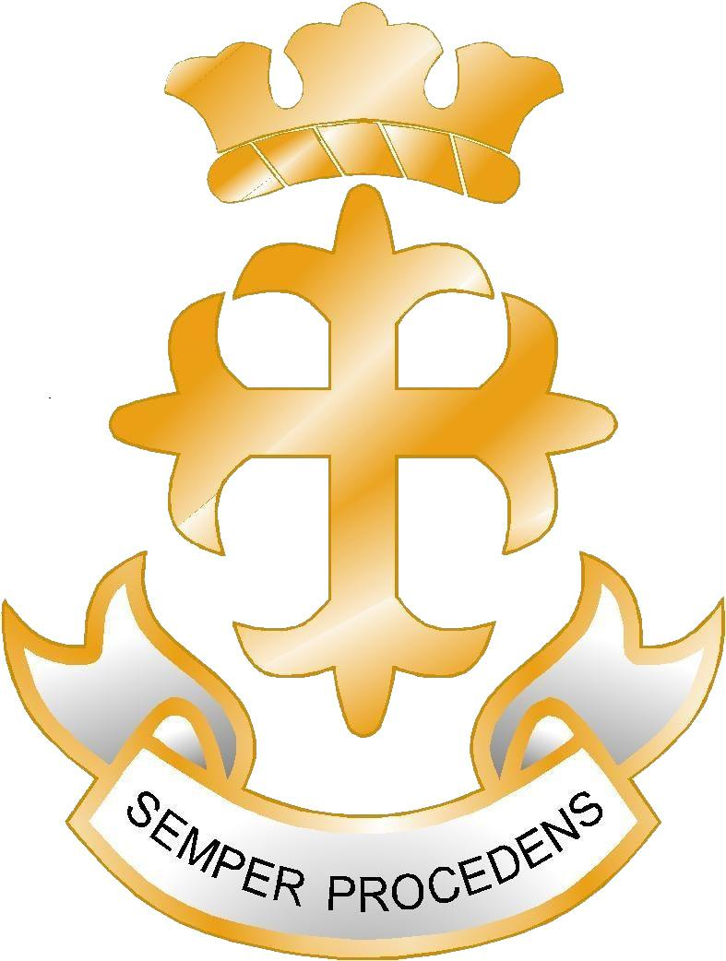
The Royal Liberty School

Job Profile

_____________________________________________________________

Job Title: Cleaner
Grade: APTC 1
School: Royal Liberty School
Reports to: Site Manager

Staff Managed – None
______________________________________________________________

Job Purpose and Context
A cleaner will normally be one of a team of cleaners, working under the day-to-day supervision of a cleaning supervisor or the school site manger or school keeper. Specific duties and designated areas of the premises are usually allocated depending upon the needs of the school and the cleaner is responsible for making sure those areas are clean, sanitary and safe for use.

The nature and intensity of the work required varies with the season and with whether the school is in session or not. During closures a school may carry out a programme of special cleaning and a cleaner may be expected to contribute to these programmes.

A cleaner may be expected to:
- Use cleaning products, chemicals and materials that require safe handling procedures
- Use a variety of machines used in school cleaning
- Clean up body fluids using agreed safe handling procedures
- Respond to the results of emergencies and accidents – for example, flooding
- Lift, carry and move school furniture and equipment.

Responsibilities
- To remove loose dust and debris from floors, surfaces, plant and equipment by hand and/or using machines provided
- To clean floors, potentially of a wide variety of different surface materials, by hand and/or machine and using a variety of cleaning products and chemicals
- To clean furniture, fittings, soft furnishings and equipment
- To clean toilets/bathrooms/showers/washrooms and the fixtures and fittings in these areas
- To clean and remove body fluids using safe handling procedures
- To refill and replace relevant consumables, for example, toilet tissue, hand towels, and so forth.
- To clean vertical surfaces, including walls, doors, and partitions, which may include cleaning glass.
- To remove rubbish and waste. This may include:
- Removal of waste that requires safe handling procedures
- Waste separation to comply with re-use and re-cycling processes
- Removing waste classified as unsanitary, hazardous and/or dangerous.

- To use the relevant procedures of the school to record work carried out
- To note breakages, repairs, or maintenance required and inform the relevant supervisor
- To operate a variety of machines used for cleaning, reporting faults to supervisors where relevant.
- To be responsible for safety, security and appropriate energy conservation within the areas of the school designated for cleaning (in accordance with the procedures of the school)
- To take appropriate action to identify, evaluate and minimise any risks to health, safety and security in the immediate working environment, reporting concerns to the supervisor where necessary
- To work, support and cooperate with others to make sure the responsibilities of the post are carried out.
- To work in accordance with the values, culture, ethos, equalities and inclusion policies of the school proactively promoting anti-racist, anti-sexist and anti-discriminatory behaviours in the day-to-day operation of the job.
- To complete school based induction and any subsequent training required to improve performance.
- To take part in the school performance management system, which may involve attending meetings.

Notes:

- The authority expects its employees to work flexibly within the framework of the duties and responsibilities specified above. This means that the postholder may be expected to carry out work that it not specified in the job description but which is within the remit of the duties and responsibilities.
- This is a new job description for a new post. It will be subject to review with the postholder after one year and may then be reviewed from time to time

Signed: .......................................................................... Date: ...................................

Signed: .......................................................................... Date: ...................................
(Head Teacher)

Royal Liberty School is committed to safeguarding and promoting the welfare of children and young people. All adults who work at the school must share this commitment to young people.

The Royal Liberty School

Cleaner

Person Specification

Skills and Abilities | Essential | Desirable | Assessed By
Ability to organise one’s own work, to prioritise tasks and keep to deadlines | √ |  | Application & interview
Ability to work independently and support the work of the team | √ |  | Application & interview
Ability to be flexible and respond effectively to the ‘unexpected’ | √ |  | Application & interview
Ability to communicate and interact effectively with adults | √ |  | Application & interview
Ability and willingness to carry out the instructions of supervisors and managers | √ |  | Interview
Knowledge
An understanding of basic health, safety and security issues in schools | √ |  | Interview
An understanding of the various cleaning methods and techniques | √ |  | Application & interview
An understanding of basic cleaning chemicals and products and their appropriate use in accordance with the COSHH regulations | √ |  | Application & interview
An understanding of quality and customer service as applied to work in schools | √ |  | Application & interview
Qualifications and Experience
Willingness to successfully complete the range of training relevant to the job | √ |  | Interview
GCSE at level A – C in English and mathematics or equivalent |  | √ | Application
Six months experience, on a voluntary or paid basis |  | √ | Application & interview
Willingness and motivation to develop own skills and work towards NVQ Level 1 Cleaning and Support Services (Cleaning Building Interiors) |  | √ | Interview

