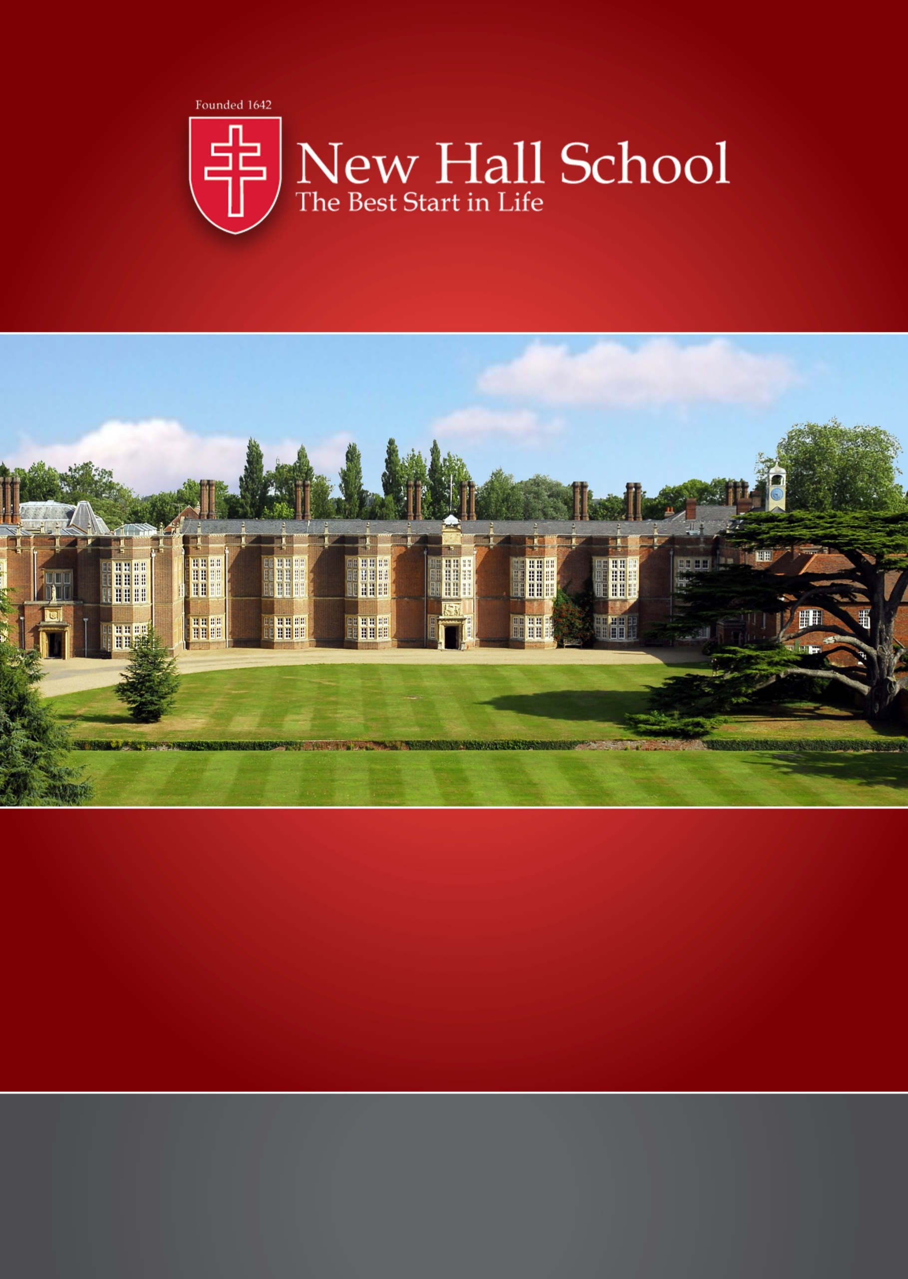
Appointment of
Casual Teacher of Russian

Independent School of the Year 2016

newhallschool.co.uk
New Hall School, The Avenue, Chelmsford, Essex CM3 3HS | 01245 467 588
A Catholic foundation and ethos, welcoming all

New Hall School
New Hall School is a leading HMC boarding and day school for girls and boys aged 1-18 and was awarded the TES ‘Overall Independent School of the Year’ for 2016-17. Founded in 1642, New Hall School is one of the oldest Catholic schools and the largest Catholic boarding & day school in the UK. New Hall is a strong and thriving community, set in a stunning location on the edge of the city of Chelmsford, just 20 minutes by train from London Stratford and 30 minutes from London Liverpool Street. There are also plans for Network Rail to open a new station at the foot of New Hall’s Avenue; this is due to be completed by 2023.

At New Hall, we operate the highly successful ‘diamond model’ structure, i.e. co-education in the Preparatory Divisions (ages 1-11), single-sex education in the Boys’ Division and Girls’ Division (11-16) and co-education in the Sixth Form (16-18). In this way, New Hall provides the best of both worlds: the benefits of a co-educational environment together with the advantages of girls and boys being taught separately throughout the 11-16 age range. The provision of single-sex education during the formative years enables students to grow in confidence, whilst enjoying an education that is specifically tailored and recognises the different ways in which girls and boys learn.

There is an exciting School Development Plan (SDP), which has the continued strengthening of the school’s academic standing as its priority. New facilities successfully delivered so far in the 2016-19 SDP include: investment in digital technologies; outdoors ‘Forest School’ provision; a second Astroturf, 3G pitch and new PE changing rooms; new recreational and hospitality facilities, and additional staff accommodation. Plans are currently underway for the expansion of the Preparatory Divisions to 3-form entry and for a new Science Centre.

Students aged 7-18 can board in one of four boarding Houses. High academic expectations and achievements, together with outstanding pastoral care and exceptional drama, music and sports facilities and provision, make New Hall a wonderful place to be educated.
The ethos at New Hall has been inspired by the founding Religious Community, the Canonesses of the Order of the Holy Sepulchre. New Hall has thriving Chaplaincy, RE and Theology teams and the community benefits from having a full time resident priest Chaplain. The School welcomes all who support its ethos.

New Hall’s Mission & Ethos Statement

New Hall, a Catholic boarding and day school, provides
the best start in life, enabling students
to meet confidently the challenges of the wider world.
Here academic excellence is achieved in surroundings
where relationships are based on
care, trust and respect.
We welcome students from many traditions,
building a Christian community that has at its heart
prayer and service to others.

Strategic Aims of the School

In all of these strategic aims, we seek to bear witness to our distinctive Catholic ethos, which is at the heart of everything we do:

- To promote the Catholic life of the School and to provide outstanding Religious Education
- To be an outstanding and caring educator of all students
- To recruit, support and develop outstanding staff
- To provide outstanding learning opportunities through the co-curriculum
- To promote New Hall’s reputation as a distinctive school of choice
- To share our ethos, grow and innovate
- To ensure the on-going security of the School’s financial future, and ensure affordability of fees, while continuing to invest in improving the quality of education

Accolades for the School

New Hall School was awarded Independent School of the Year for 2016 in the Times Education Supplement school awards, as well as Financial Initiative of the Year (2016), in relation to our Green Travel and Transport Strategy. The school has previously won the TES Award for ‘Outstanding Strategic Initiative’ (201l).

New Hall received the highest commendations in its most recent inspections:
- ‘Outstanding’ in the Denominational inspection, Diocese of Brentwood (2018)
- ‘Excellent’ (the highest category) in the whole school ISI inspection (2016)
- ‘Outstanding’ in the ISI boarding inspection (2014)

New Hall’s sponsored primary academy, Messing Primary School, received the highest commendation of ‘Outstanding’ in the following categories:
- Effectiveness of leadership and management
- Personal development, behaviour and welfare of pupils
- Early years provision
and ‘Good’ overall, in the Ofsted inspection (2018).

Independent School of the Year 2016

The Modern Languages Department
Our 5 comfortable classrooms are housed in Priory Court, a new and attractive purpose-built block overlooking the peaceful grounds to the sides and rear of the school. Each room is equipped with interactive whiteboards and audio equipment. French and Spanish are our main taught languages, however German, Chinese and Russian are also offered to native speakers or as an “extra” to non-native speakers. Language clubs are thriving, allowing students to experience languages and cultures as part of the co-curriculum. The Modern Languages Department at New Hall is a lovely place to work in all respects.

Staff and Students
We are a team of dedicated and passionate teachers and are supported by two enthusiastic Language Assistants. The Language Assistants work primarily with KS5 and KS4 students; however, when the opportunity arises, their work is also enjoyed by KS3 classes. All members of the Department participate in researching, creating and sharing new and exciting resources. We also work with the Preparatory Divisions to create a coherent, overarching programme of language progression.

Our students are a delight to teach; and you can truly “teach”, using your full repertoire of strategies to engage and challenge. They are charming and funny, but are at the same time focussed on achievement. New Hall has an international student intake, which creates an atmosphere of intercultural understanding and support for the study of other languages.

Languages beyond the Curriculum
Students at New Hall have many opportunities to practise their languages outside the classroom. Recent trips include Normandy, Paris, Madrid and Andalucía. Theatre trips to London are organised for Sixth Form students, and visiting theatre companies perform plays in French and Spanish, enhancing the GCSE and A Level curriculum.

Language Diplomas
We have also recently introduced the DELF and DELE language diplomas to provide regular, attainable and aspirational points of achievement for our students. By providing our students with access to the differentiated levels of these courses, we are preparing them for the use of language beyond the classroom and providing a pathway for students of all abilities to gain language qualifications.
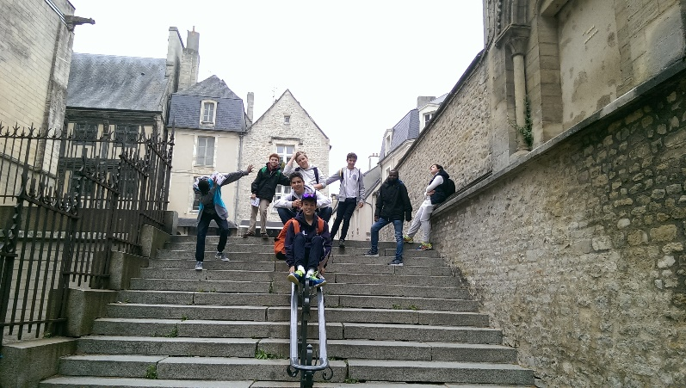

Teaching at New Hall School
As a teacher at New Hall School, you will enjoy working in a vibrant community with a strong sense of team work. Curriculum lessons take place Monday to Friday and there is a busy co-curricular and social programme of activities at the weekend.
New Hall is a busy, fast-paced environment. Staff benefit from the long school holidays, polite and enthusiastic students, tranquil surroundings, generous salary scales.

What Staff Say
“Every child has a right to shine; it is our job to discover that talent and polish it”
“We advocate encouragement rather than pressure”
“At New Hall, children are encouraged to care and to treat others as they would like to be treated”
“We don’t have ‘colleagues’ - at New Hall you’re part of a family!”
“At New Hall we work together, sharing the same passion”
“The sense of community is built up through staff clubs such as staff choir, book club and dance classes, as well as staff vs Sixth Form sports fixtures”
“I love working in a place where I can be creative and make a real difference”

Senior Divisions Teacher

All teachers are expected to uphold, support and realise the Catholic ethos of the School as outlined in the Mission and Ethos Statement and Aims of the School.

Key responsibilities:

- Within the Department
  - to support colleagues, to ensure good working relationships and to contribute to the work of the Department
  - to maintain and develop a sound knowledge of the subject area, including developments in the teaching of that subject; where a need for any further training or INSET is identified, it is the responsibility of the individual to bring this to the attention of their line manager
  - to ensure a purposeful, happy and safe working environment for students by good lesson management, giving due regard to published curriculum and schemes of work, by use of suitable resources and a variety of appropriate methods and by the delivery of stimulating lessons (this will necessitate good lesson preparation, appropriate setting of study and regular marking of work giving due attention to the different educational needs of the individual students)
  - to communicate clearly to students the requirements of the examination syllabus including coursework requirements (this will necessitate a thorough knowledge of the published syllabus, and careful attention to detail, on the part of the teacher)
  - to maintain high expectations of the students, both academically and in their behaviour
  - to monitor, assess and record students’ progress, using strategies in accordance with department and school policies (these will include formal reporting to parents once a year in a full written report, in half-termly grade sheets and orally at Parents' Meetings, normally once a year)
  - to work closely with other teachers to evaluate and develop the courses offered to students and the teaching strategies used, and to contribute to other aspects of the general on-going development of the Department (this will include taking responsibility for aspects of the Department Development Plan)
  - to carry out any specific tasks mutually agreed within the Department
  - to initiate and support cross-curricular links as appropriate
  - to take proper care of any School or Department resources including the areas of the School used by the particular teacher; this includes the creation, and maintenance of stimulating and informative displays both within classrooms and around the School site
  - to report any malfunctions or issues with equipment or rooms immediately to the ICT manager and/or estates staff
  - to co-operate fully, as appropriate, in parental contact
  - to be fully aware of, and observe the School’s Health & Safety Policy

- Within the School
  - to liaise and work with tutors, HoYs, HMs and the SLT, as appropriate
  - to ensure that work within the department is fully integrated with whole School policies
  - to contribute to discussion concerning whole School issues
  - to act as a tutor if required - working within a year and house team
  - to contribute on at least a weekly basis to the co-curricular programme or as otherwise arranged

  - to take a share in rotas for:
2.6.1 lesson cover (absent colleagues)
2.6.2 study period cover (as required)
2.6.3 evening study
2.6.4 weekend activities (currently one per term)
  - to attend full Chapel and Divisional assemblies and meetings and contribute towards them either as an individual or as a member of a particular group (e.g. department, year group or house team)
  - to attend school functions as arranged across the staff as a whole or within particular departments
  - to participate in the School's Performance Management scheme
  - to assist, wherever possible, in promoting the School

- Outside School
Whilst students are ‘in the care of the School’, teachers who accompany them beyond the school campus are expected:
  - to take proper care of them according to the circumstances
  - to familiarise themselves with the standards of behaviour and dress expected from the students
  - to be familiar with the Educational Visits Policy and to ensure that the safety and welfare of students is paramount

- Basic Competencies
It is expected that all teachers will achieve the following minimum standards:
  - to set regular study, in accordance to the study timetable issued by HoY and the School’s policy
  - to mark students’ work regularly and promptly to approved standards
  - to adhere to the School’s Assessment Policy
  - to monitor students’ progress regularly and to maintain an accurate markbook
  - to write full and accurate reports
  - to meet deadlines e.g. report deadlines
  - to begin and end lessons on time and to not leave classes unattended
  - to adhere to the School’s behaviour management policy in order to maintain a safe, purposeful classroom environment
  - to take responsibility for setting cover as required
  - to demonstrate confident use of ICT to enhance teaching and learning

All staff are responsible for promoting and safeguarding the welfare of students at New Hall School by ensuring compliance with the School’s Safeguarding & Child Protection Policy at all times. It is a requirement of all staff to report any actual or potential risks to the safety or welfare of students to the Designated Safeguarding Lead.

This document summarises the main responsibilities of the post. All staff are required to undertake whatever else may reasonably be requested by the Principal. All staff are expected to uphold, support and realise the Catholic ethos of the school, as outlined in the Mission Statement and Aim of the School. Job Descriptions are subject to annual review.

Person Specification
In addition to the below, all candidates should have a clear understanding of and a commitment to the aims of a Catholic independent school and be committed to the values and ethos at the heart of New Hall School as expressed in the Mission & Ethos Statement of the School.
 | Essential | Desirable
Education | University graduate and with an ability to teach Russian to both GCSE and A Level | Qualified Teacher Status or equivalent
Experience | Experienced or newly qualified teacher/tutor | Experience of independent and/or boarding education  Experience marking or moderating for public examination boards
Skills and Aptitudes | Excellent communication, IT, organisational and management skills
Disposition and personal qualities | Understanding of the importance of promoting and safeguarding the welfare of children  Initiative, drive and enthusiasm to develop students’ interest in the subject  Willingness to participate enthusiastically in aspects of boarding school life  Common sense and initiative  Ability to relate effectively to students  Flexibility to adjust to change and development

Salary & Benefits
Salary
The annual salary is £38,387 and per period, including holiday pay will be £32.81 (Sept 19 rates).

Sports teams
Contributions to the sporting life of the school by leading a team attracts a competitive remuneration package for weekend fixtures.

Pension
Teaching staff are able to join the national Teachers’ Pension Agency (TPA) pension scheme. Pension contribution rates are variable, currently between 7.4% per annum and 11.7% per annum, dependent on salary (employee), and 16.48% (employer).

Training
New Hall is committed to professional development of staff and will support further in-service training as required. There are generous INSET and Continuing Professional Development (CPD) budgets.

Sports membership
Staff are entitled to free membership of the School Fitness Suite, which comprises a range of cardiovascular equipment and free weights. We also offer staff a generously discounted rate of membership to the New Hall Sports Club, which includes use of our 25-metre, 6-lane indoor swimming pool & 10 floodlit tennis/netball courts.

Laptops
Teaching staff receive a New Hall laptop and iPad.

Your Application
The School can only accept applications made on the New Hall Application Form.

Completed Application Forms and your letter of application should be sent, via email, to hr@newhallschool.co.uk. The letter of application should be addressed to Mrs Jeffrey, Principal, and include:

- Your understanding of the distinctive nature of the school and this role
- How your skills and experience meet the requirements in our person specification and job description
- Why you wish to apply for this role and what particular contribution you would make

Alternatively, you can send your application by post to:
HR Department, New Hall School, The Avenue, Boreham, Chelmsford CM3 3HS.

Early applications are encouraged.

Closing Date for applications is: Midday on 10 June 2019

Interview Date: 14 June 2019

New Hall School is committed to safeguarding and promoting the welfare of children and young people and expects all staff and volunteers to share this commitment. Applicants must be willing to undergo child protection screening appropriate to the post, including checks with past employers and an enhanced check with the Disclosure and Barring Service (DBS).

Please do not hesitate to contact a member of the HR team on 01245 467588 should you have any queries.

