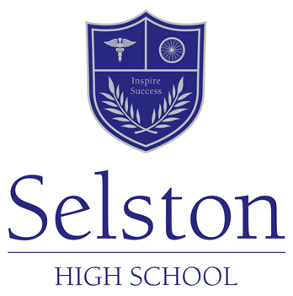

The Science Department

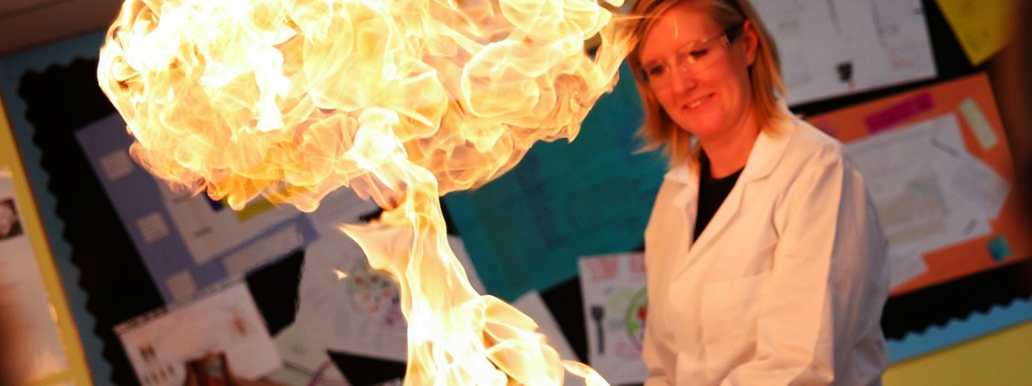

Science Department Mission Statement:

Inspiring students to explore and engage with the exciting world of science and its many applications.

Subject Leader - Miss S Keal (stkeals@selstonhigh.org.uk)

Background
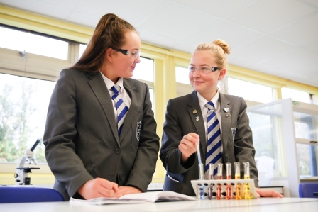
Science is one of the key subjects in our school that is popular with students and has a strong record of achieving good GCSE results. The department is housed in 7 purpose built and recently refurbished laboratories. The department is well equipped and supported by a dedicated Science Technician. The Science team currently consists of 7 specialist science teachers who each teach across the Science discipline areas throughout years 7 to 11. Our staff are committed to being at the leading edge of teaching and learning providing a first class experience for Selston students. The department is keen to further students interest in Science running a number of after school clubs, intervention classes and participating in the schools Enrichment Afternoon. The department has access to full class ICT facilities that are situated adjacent to the main suite of 6 laboratories. In line with the school’s mission statement we are committed to delivering outstanding CPD and career development for all of our staff.

Years 7, 8 and 9 Learning:
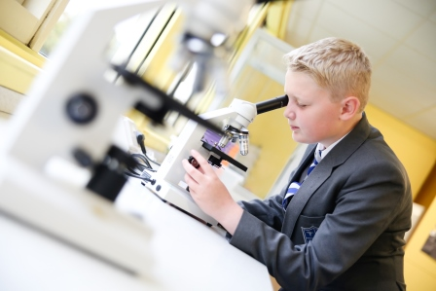
Pupils study all three Sciences at Key Stage 3. Year 7 groups are taught in their tutor groups; Years 8 and 9 are taught in set groups. Throughout the three years pupils study a wide variety of topics that cover Chemistry, Biology and Physics. Each topic is assessed through a variety of methods including written topic tests, levelled tasks and homework to assess knowledge, understanding and skills. Throughout the three years pupils undertake a wide variety of practical work and the development of these skills aims to support their understanding of how science works in the real world. Towards the end of Year 9 pupils start to build on their Key Stage 3 learning so that they are fully prepared to embark on their GCSE studies.

Yrs 10 and 11 Learning:
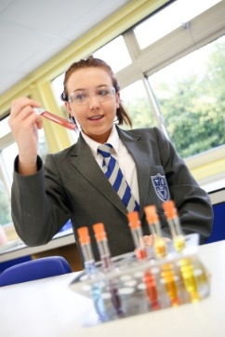
The majority of students in Key Stage 4 will study towards GCSE Combined Science. This qualification allows each student to gain two equal GCSE grades at the end of the course. The course consists of topics in Biology, Chemistry and Physics and at the end of Year 11, students will sit six written examinations. Amongst other practical work, students take part in a number of ‘Core Practical’s and they will be examined on various aspects of these activities.
At the end of Year 9 some pupils will be invited to opt to study for the separate GCSE Sciences in Biology, Chemistry and Physics.

