HEAD OF SCHOOL RECRUITMENT PACK
HOMEWOOD COLLEGE

Homewood College caters for children aged 11-16 who have social, emotional and mental health difficulties

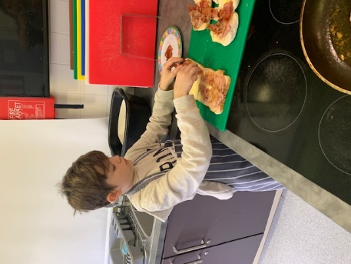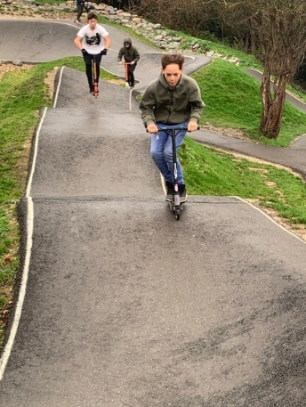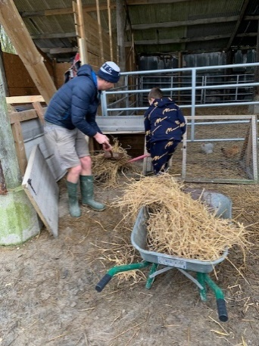

“A different kind of learning”
Our vision is to become a holistic hub where children are nurtured, inspired and engaged so that they can achieve to the best of their ability and lead happy and fulfilled lives.

Homewood College
Queensdown School Road Tel: 01273 604472
Brighton Email: HWC_admin@chb.org.uk
BN1 7LA Website: www.chb.org.uk

February 2021

Dear Applicant

The governing body of Homewood College along with Louise Cook, our Executive Headteacher, the staff team, our pupils and their families are delighted to be able to ask you to consider applying for the role of Head of School. We are at an exciting and inspiring point in our development and we seek to appoint a leader with a strong moral purpose, professional drive and energy, resilience, and determination to move the school and the provision we make forward.

Homewood College is an expanding school for students with social, emotional, and mental health (SEMH) needs. The College is a key element of Central Hub Brighton (CHB) under the leadership of our Executive Headteacher. Two other Heads of School lead the other CHB strands. The Connected PRU, a Pupil Referral Unit based on two sites, provides education to pupils across Keys Stage 2 to 4, including some full-time primary provision for children with EHCPs. The third strand is The Connected Hub, a Pupil Referral Unit making provision for a group of Year 11 students. The Senior Leadership Team for CHB comprises the Executive Headteacher, the three Heads of School and our Senior School Business Manager.

Our local authority, Brighton and Hove City Council, has identified significant funds to invest and improve our accommodation. It has just been confirmed that we will be moving site, and the new Head of School will be fully involved in shaping this capital development and ensuring physical provision and resources are created fit for an SEMH school in the 21st Century. The ability to work with us to design and create an engaging, innovative, and imaginative building and curriculum to engage our learners is a crucial requirement for the successful candidate.

Homewood is currently designated as ‘requiring improvement’. A significant budget deficit has been eradicated over the last two years. Our quality of learning and teaching has shown substantial improvement and we have worked very hard to improve student attendance and engagement. We are not complacent, and we understand that we still have further improvements to make and secure. We seek a leader who is uncompromising with high professional standards who can join us and work with us in leading this continuing journey.

Governance of CHB has been fragmented between a Governing Body (for Homewood College) and a Management Committee (for the two PRU strands) for some time. We are working with the local authority to bring these two groups together to work and support our Executive Headteacher and CHB more effectively. We will expect our new Head of School to work with this group, our Executive Headteacher, and other colleagues to further develop the cohesiveness and effectiveness of Central Hub Brighton.

We look forward to receiving your application and providing an opportunity to share and discuss our vision with you.

Bob Wall
Chair of Governors

Primary & KS4 Year 11 Hub KS3 Homewood School
Lynchet Close Tilbury House St Georges House Queensdown School Road
Brighton Florence Place 42 Dyke Road Brighton
BN1 7FP Brighton, BN1 7GU Brighton, BN1 3JA BN1 7LA
01273 542050 01273 291294 01273 327389 01273 604472

February 2021

Dear Candidate

Thank you for your interest in the role as Head of School at Homewood. It is an exciting time for the right person to take on this role following several changes in the senior leadership team.

You will be working with a caring and dedicated staff team who will benefit from an experienced leader to provide stability and a clear direction for the school. The successful candidate will be supported by the Executive Headteacher, the Heads of School at The Connected Hub and the PRU and a supportive Governing Body.

The school will have 49 students on roll in September, but is due to grow to 60 over the next few years. This is linked to our move to a new premises which will shortly be refurbished – you will have a major part in how this is planned and implemented so that it best meets the needs of our students. It is vital that we get the curriculum offer right both now and as we expand, and this will be a key part of the role.

Homewood was judged as ‘Requires Improvement’ in our last inspection, but the indicators were that we were very close to ‘Good’. Progress has been slower than expected due to Covid, but we are confident that we can move to ‘good’ at our next inspection with the right Head of School in place.

Many staff at Homewood have been here for a long time and describe it as their Homewood family. Relationships are key, and staff are skilled at developing these and helping students to feel included and wanted – Ofsted reported that “Pupils say they like the school because staff listen to them”. No two days are the same here and it is our passion to improve the lives of our students, and the variety of each day, that motivates us to come to work.

Homewood is a lively, often challenging, but rewarding place to work. Our students deserve the very best, and we are striving to improve as quickly as possible.

Brighton is a wonderful city to live and work in with the benefits of city, countryside and the sea on our doorstep.

I hope you decide to apply for this role and I look forward to meeting you at interview.

Yours faithfully

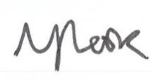

Louise Cook
Executive Headteacher

Primary & KS4 Year 11 Hub KS3 Homewood School
Lynchet Close Tilbury House St Georges House Queensdown School Road
Brighton Florence Place 42 Dyke Road Brighton
BN1 7FP Brighton, BN1 7GU Brighton, BN1 3JA BN1 7LA
01273 542050 01273 291294 01273 327389 01273 604472

Dear Applicant
Welcome to the Central Hub Brighton. We hope you will apply for the role of Head of School for Homewood.
You will be joining a dedicated and skilled staff team, some of whom have been here over 15 years and the reason we’re here is because of the students.
Homewood has been here in various guises since the early 1950’s and moving on to 2022, it will be a time of great change where the current site and Homewood College will close and we will all move to a different site in a new school. This is an exciting new opportunity for the Central Hub Brighton.
We want to continue to follow a nurturing ethos as an attachment aware school where we get to know the students - so that they trust us, with the aim that they relax and learn. We try to meet the individual needs of all students. The staff team use PACE (Playful, Accepting, Curious, Empathic) which is our way of thinking, feeling, communicating and behaving that aims to make students feel safe.
We are very proud of our Student Central space where students can check in with staff or talk through their anxieties.
We all look forward to meeting you at interview.

From the staff team

Primary & KS4 Year 11 Hub KS3 Homewood School
Lynchet Close Tilbury House St Georges House Queensdown School Road
Brighton Florence Place 42 Dyke Road Brighton
BN1 7FP Brighton, BN1 7GU Brighton, BN1 3JA BN1 7LA
01273 542050 01273 291294 01273 327389 01273 604472

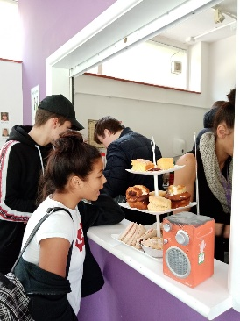

Important Information

School Visits
We warmly welcome potential applicants to visit the school. We would ask that you keep to our Covid requirements including wearing a face covering. To arrange a visit please contact a member of our school office team on 01273 916595 or email shelleydunbar@chb.org.uk

Closing dates for applications - Monday 8 March 2021
Please submit your application using the application form with a supporting letter of no more than two sides of A4 when typed. This should tell us how you satisfy the person specification. Please return your completed application form and supporting letter to : shelleydunbar@chb.org.uk

We are unable to accept applications via post.

Shortlisting of candidates
Letters will be sent to shortlisted candidates on Thursday 11 March and your referees will then be sent a reference request.

Interview process - 18 and 19 March 2021
If you are shortlisted at the end of Day 1, you will be invited to attend an interview on Day 2.

Salary
Deputy pay spine L15-19.

Safeguarding
The governing body of Homewood College is committed to safeguarding and promoting the welfare of children and young people. In order to ensure this, our recruitment and selection policy is in accordance with both local and national guidance.

Central Hub Brighton – Head of School (Homewood College)

Head of School Job Description
Job purpose
To lead the school to a sustained good or better judgement at Ofsted and gain excellent outcomes for students through excellent standards of learning and personal development. You will be responsible for the operational leadership of the school and shared strategic leadership of Central Hub Brighton.
Key responsibilities:
To be accountable to the Executive Head and Governing Body for:
● The learning, teaching, progress and outcomes for the pupils of the school
● The effective day to day leadership of the school
● The effective implementation of the Central Hub Brighton vision, principles and policies
● Innovating the curriculum and leading on this throughout CHB

Homewood College
Strategic direction and development of the school:
- Lead and manage the school in a strong and positive way, by building on its strengths, and ensuring the successful implementation of developmental, and sometimes radical, change.
- Ensure that high expectations of pupils’ achievement are established throughout the school and secured
- Ensure that the SEMH needs of students are at the heart of all we do
- Ensure that agreed clear lines of accountability work in practice to secure outcomes for all pupils
- Grow, develop and empower all staff in fulfilling their own responsibilities and contributing to the development of the school, to the best of their ability
- Ensure rigorous and effective implementation of systems of quality assurance, appraisal and effective professional development of teachers
- Build a learning community within the school, modelling and promoting a self-critical reflective approach
- Ensure open, searching professional self-evaluation of the school and supported evaluation with the SLT team and any relevant external groups
- Create and implement a whole school development plan which will secure continuous school improvement
- Be responsible for the health and safety management for the school (alongside the Business Manager and Executive Head)
- Ensure all safeguarding procedures are rigorously followed acting as DSL if needed
- Undertake any relevant professional duties delegated by the Executive Head.
- Establish a sensitive and inspiring relationship with parents and carers, developing a wide range of high quality provision to contribute to high aspirations and outcomes for children
- Ensure that the school’s governing body has accurate, timely and detailed information on which to base sound decisions about the school’s priorities
- Promote equality, diversity and inclusion

Leading Learning and Teaching

- Provide a curriculum for learning for learning that is rich, relevant, flexible and inspirational which meets the needs and expectations of all students, and is personalised as required to accommodate the full range of need and ability
- Ensure the quality of teaching and learning is secure and improving to at least good
- Ensure that the chosen system of assessment is implemented so that small steps of progress are tracked (and so plan accurately for individual need), and monitor standards of progress and achievement over time
- Monitor, evaluate and review classroom practice and promote improvement strategies
- Ensure that all children make optimal progress even when there are barriers to learning, through excellent systems and provision for all
- Establish and maintain an ethos and relationships in which children and staff develop their emotional literacy to create an emotionally healthy environment which optimises learning

To contribute (with other members of the Central Hub Senior Leadership Team) to:

- The securing of high quality aspirations, self-belief, outcomes, learning and progress for all pupils
- The establishment of CHB as a centre of excellence and innovation in education
- A rich partnership with families and community to build a learning community that strives for personal growth
- The development of strategies for positive transition into post 16 provision for children & parent/carers
- The vision and strategic direction of CHB
- The evaluation of outcomes and practices and consequent planning for improvement, for CHB
- The efficient and effective use of resources across CHB
- The promotion of CHB and developing strong productive relationships with a wide range of stakeholders

Safeguarding
Central Hub Brighton is committed to safeguarding and promoting the welfare of children and young persons at all times. The Head of School will be responsible for promoting and safeguarding the welfare of all children for whom he/she is responsible, or with whom he/she comes into contact, in accordance with our Safeguarding policy. The successful candidate will be required to undergo an Enhanced Disclosure from the Criminal Records Bureau.

Equal Opportunities
The Head of School will be responsible for ensuring compliance with Equalities Act 2010.
This job description may be amended at any time after consultation with the post holder and will be reviewed annually

Person Specification for the Post of Head of School, Homewood College

Section 1 – Qualifications

Criteria | Essential | Desirable
1.1 Qualified teacher status.
1.2 Evidence of further CPD or qualification in preparation for educational leadership.
1.3 Candidate must have either successfully completed, or be in the process of completing, the NPQH course and accreditation or equivalent experience.

Section 2 – Strategic Direction and Development

Criteria | Essential | Desirable
2.1 Ability to develop and articulate a clear and educational vision and provide purpose, direction and leadership in its implementation.
2.2 Ability to develop policy, practice and culture in support of school aims and in line with statutory responsibilities.
2.3 Evidence of a contribution to the development and implementation of an ambitious evidence based School Improvement Plan, using accurate self-evaluation information and student progress data.
2.4 An understanding and evidence of successful partnership with a Governing Body.

Section 3 – Professional Experience

Criteria | Essential | Desirable
3.1 Be a substantive senior leader at headship, deputy headship or non-class based assistant headship level in a special or mainstream school with a proven track record of driving whole-school improvement and success over a sustained period.
3.2 Have had experience working with secondary aged students with Social Emotional and Mental Health difficulties.
3.3 Have an excellent attitude to inclusion and equality of access, and direct experience of making a difference.
3.4 Experience of managing challenging behaviour through the consistent application of a whole school behaviour policy.
3.5 Have a demonstrable commitment to safeguarding and promoting the welfare of all students, through development of school policy, and collaboration with other service professionals.
3.6 Experience of effective working with vulnerable families and with multi-agency teams to develop integrated programmes of support for children with a range of barriers to their learning.
3.7 Have successfully managed significant change within an organisation in a constructive and sensitive manner.
3.8 Experience of successfully analysing data and drawing up improvement plans which are monitored and evaluated and result in measurable improvement.
3.9 Evidence of successful management of staff performance including supervision, target setting and capability and/or conduct management procedures.
3.10 Evidence of successful collaborative working and the development of partnerships with colleagues in other schools and key stakeholders e.g. colleague headteachers, LA Officers and the voluntary sector.

Section 4 – Leading Teaching and Learning

Criteria | Essential | Desirable
4.1 Able to implement strategies for developing effective teachers to ensure the entitlement of all pupils to effective teaching and learning.
4.2 A clear understanding of the components of good curriculum development for students with learning disabilities.
4.3 Use appropriate models and principles of effective learning and assessment for learning, informed by research.
4.4 Ensure choice and flexibility in learning to meet the personalised learning needs of every child.
4.5 Evidence of driving continual improvement in progress and attainment outcomes for all students.

Section 5 – Managing the Organisation

Criteria | Essential | Desirable
5.1 Knowledge of effective deployment of human and financial resources to develop and sustain an innovative and personalised curriculum.
5.2 Ability to wok under pressure, determine priorities and meet deadlines.
5.3 Ability to show respect and empathy at all times in order to work effectively in partnership with parents.
5.4 Ability to communicate and convey information for differing purposes, using a variety of media and IT to ensure positive audience engagement and understanding.
5.5 Ability to display a solution focussed, positive approach to challenges.
5.6 Ability to plan and manage projects for implementing change.
5.7 Able to successfully develop and lead a fair and open workplace with a pervading culture of trust and respect, and an ability to manage conflict positively.

Section 6 – Knowledge

Criteria | Essential | Desirable
6.1 An understanding of the impact of anxiety on behaviour and the need to address far of failure and personalise the implementation of a consistent whole school behaviour policy.
6.2 A sound knowledge and understanding of the barriers to learning and inclusion experienced by pupils with SEMH and of the range of improvement strategies which accelerate progress rates and close gaps for disadvantaged pupils.

Section 7 – Personal Attributes and Qualities

Criteria | Essential | Desirable
7.1 Use excellent interpersonal and communication skills to develop a culture of trust and respect, where everyone is valued for their contributions, strengths, and individual differences.
7.2 Be driven and have emotional intelligence, empathy, calmness and resilience that are displayed at all times.
7.3 Have a deep intrinsic advocacy for children with disabilities.
7.4 An inspirational personality with the ability to motivate and enthuse adults and students alike to aspire to excellence.
7.5 Able to use a range of leadership styles to suit different situations and individuals, especially when under pressure or duress.
7.6 Able to accurately reflect on one’s own practice, and welcoming of further personal and professional development opportunities.
7.7 Ability to create a positive learning environment and an enjoyable place to learn and work, where everyone is committed to trying their best.
7.8 Able to promote and maintain (as far as possible) a healthy work/life balance both for oneself and the staff team.

