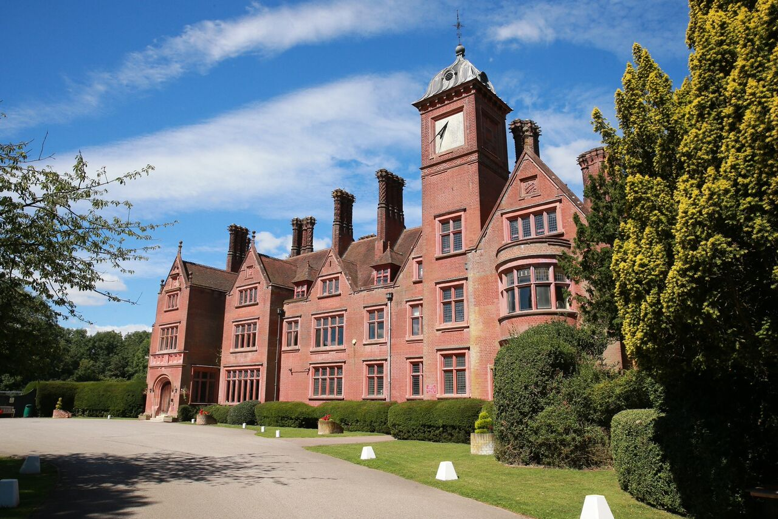
Finding a Business Manager for Akeley Wood School

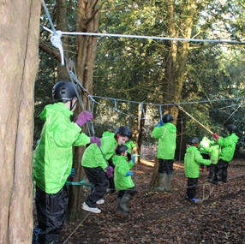
Contents

3 The Cognita Family

4 The School

5 Role Profile

6 About you

7 When and how to apply

The Cognita family

Akeley Wood School is part of the Cognita Family, global leaders in independent education. Founded in 2004, it is a growing family of 68 schools in eight countries in Europe, Latin America and South-East Asia, serving some 35,000 pupils. Although Cognita’s schools are very different, they share a commitment of ‘inspiring and empowering children to achieve more than they believe possible’.

A Cognita Education

• pursues academic excellence for every child

• develops character

• nurtures a global mindset

Underpinning a Cognita Education, is the Cognita Way, a simple way of operating based on energised leadership, innovation, personalised learning, people growth, community engagement and efficient systems.

You’re not alone

Cognita provides expert support for their schools. As the most diverse schools group in the world, they have education leaders and industry experts based in each region. Their role is to foster best practice across all Cognita schools and support centres and develop a peer to peer network of support and expertise.

As a valued member of the Cognita family, you will benefit from the exhaustive knowledge of these networks and will regularly be invited to attend events and workshops, giving you the opportunity to learn from and share with your peers and other leading practitioners.

The School

Akeley Wood School is an independent co-educational day school for pupils from the age of one to eighteen, nursery through to Sixth Form.
The School has a wonderful family feel and offers a happy caring environment for both pupils and staff alike.

The Senior School is located across two historic sites just a mile apart in the beautiful Buckinghamshire countryside, offering a tranquil yet stimulating work environment, whilst the Junior School is a thriving hub of learning and discovery in a beautiful, historic building on the rural Wicken Park site.

Role Profile

Operating as a key member of the Senior Leadership Team, you will be primarily responsible for providing commercial input to all aspects of the school operations. You will work with the Head and Cognita Executive team to develop the School strategy and build tactical working plans to implement change.

Key Responsibilities

Leadership & Strategy
- Contribute to the development of the school’s values and vision and communicate this clearly and enthusiastically to all staff and other stakeholders.
- Motivate, encourage and empower individuals to work innovatively and creatively to achieve and exceed targets.
- Ensure that all staff are briefed on allocated work, showing how it fits within the school’s vision and objectives.
- Monitor the progress and quality of direct and indirect reports and provide prompt and constructive feedback. Set C-SMART objectives and undertake performance management for all direct reports.

Business Development
- Business Development including strategic planning, new business generation, growth activities and management of organisational development.
- Business performance management including enrolment development and continual improvement in the efficiency and effectiveness of school processes and system.
- Production of business cases to support capital investment linked to school growth.

Financial & Commercial Management
- Responsible for the line management of the finance team.
- Ensure all receivables are recovered for all pupils in line with UK guidelines.
- Liaison with colleagues to agree appropriate reporting of pupil numbers for the school and identify opportunities for the admissions team to develop the pupil recruitment opportunities.
- Manage month end timetable to ensure delivery of group reporting requirement.
- Investment appraisal and project management and management of any capital investment and repair works within the school in conjunction with the group facilities management.
- Ensure parent contracts are in place for all parents and any / all discounts are managed in accordance with policy and optimising the schools commercial outcomes.
Human Resource Management
- Managing the probation and absence management process with the HR Business Partner.
- Human resources reporting.
- Responsible for staff briefings and the delivery of Health and Safety Training to school colleagues as necessary.
Facilities and Estate Management
- Overall responsibility for Facilities, Estate and Services, including Property and Asset Management, Maintenance, IT and Services Management (catering, cleaning and transport).
- Accountable for the line management of the Site team and Office administration team.
- Ensure an effective rolling maintenance programme is in place.
- Ensure core services provision in the areas of catering, cleaning, security and transport are delivered to the highest possible standard affordable.
- With the agreement of the Head, manage the letting of the school premises to outside organisations and school staff and the development of extended school activities with particular reference to the local community.
- Ownership of all governance related requirements including health and safety responsibilities and buildings management, risk assessments (with the support of Cognita group facilities).
- Responsible for facilitating out of hours school service programmes, including overseeing the effectiveness of the provision and monitoring on-going requirements.

About you

We need an effective communicator with excellent interpersonal skills who can motivate staff and engage with the school community and the wider public to create a credible reputation for the school.
You will have:

- Proven experience of operating at a strategic level.
- Strong influencing and negotiating skills that allows for a highly effective working relationship with the Headteachers and the Senior Leadership Team.
- The ability to both support and challenge.
- Significant gravitas and the ability to gain the respect of colleagues.
- Strong team management skills and experience including the ability to work cross functionally and in particular with Marketing & Admissions and the school teaching staff.

- A Health & Safety Qualification with previous experience of working within the requirements of H&S Policies and procedures.
- General management experience including strong financial and accounting skills, with experience of budget preparation and management. The preparation of basic accounts would be beneficial.
- Experience of using financial systems and MS Office products (word, excel, etc) and preferably a school's admission and pupil management solution.
- Experience of property management, human resources, cleaning, catering & transport.
- Good time management skills and the ability to multi-task and work to tight deadlines.

When

We would love to welcome you to our team early in 2018.

How

Applicants must submit a completed Cognita application form and a personal statement of no more than two sides of A4.

We are particularly keen to read in your application about who you are and how you will drive the financial and commercial aspects of The School forward. We are looking to appoint an individual who thinks for themselves and is a strong and authentic leader.

To succeed in the position you will have the intellect and people skills to know when and how to implement change and you will not condone mediocre practice.

Please send completed applications and a covering letter to susan.morgan@cognita.com. Applications must be received by 09:00 22 November 2017. Interviews will be held 29 November 2017.

