Dear Applicant,

Thank you for your interest in the position of Director of Global Understanding at Manchester Communication Academy.
MCA is a vibrant school that is at the heart of the community and is committed to improving educational outcomes for our students. MCA is proud to be a community hub and our outward facing work is exceptional. In our Ofsted inspection in 2019 we were recognised as a GOOD school and want to build on this by recruiting excellent practitioners that are driven by evidence informed practice. We are seeking to appoint an experienced and enthusiastic Director of Global Understanding. This faculty comprises of both the MfL and the humanities department and offers a range of qualifications at KS4. The successful candidate needs to be an engaging and forward thinking leader who will work to build excellence in our students and our staff.

To apply for the post please complete an application form via TES, this includes a supporting statement of no more than 2 sides of A4 (minimum font size 10) explaining, with examples, how you meet the requirements set out in the person specification.

The closing date for applications is Friday 26th February 2021. Interviews will be held soon after the closing date. Shortlisted candidates will be given full details of the selection process.
We look forward to hearing from you.
Yours sincerely

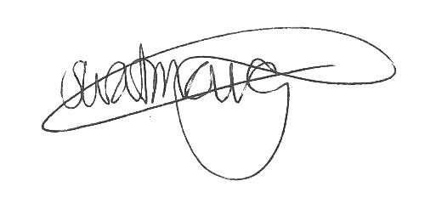
Susan Watmough
Headteacher

About Manchester Communication Academy
Great teaching starts with great teachers and at Manchester Communication Academy we’re serious about looking after our talent.
Our staff development programme ensures that all staff receive training and coaching that compliments their role and career plan. We have maintained this offer throughout the complexities of the pandemic. We’re committed to developing everyone through weekly training sessions, learning communities, coaching and leadership development at all levels. Our staff well-being programme is driven by teachers which works to address potential work load issues, signposts to supporting agencies and when we are open, includes a wide range of activities from yoga, relaxation and art therapy through to team sports and zumba.
Staff well-being and development is an absolute priority making sure that we look after those who work hard to care for our students and famililes:
- Every member of staff can take one 'flexi day' holiday per year.
- Teaching staff have planning sessions each week to collaboratively plan with colleagues during the school day.
- Teachers teach in both break out areas and flexible learning bases where they can learn from one another through team teaching, coaching and mentoring.
- We have a half day on a Friday with an hour's training from 1 to 2pm with a variety of teaching and learning communities to participate in.
- There are no after school meetings, these are all captured in the school day.
- Excellent career progression routes through a talent management strategy for those who are ambitious keen to develop.
- A staff well-being group who meet regularly to discuss work-load and work-life balance and organise wellbeing and social events.
Ken Robinson once said, “Most great learning happens in groups. Collaboration is the stuff of growth." And that's what we do. Our collaborative, flexible learning bases ensure teachers plan together and teach together, learning from one another in the process.

