Information for Applicants
LEAD PRACTITIONER - HISTORY
Salary L4-L8 (£45,434p.a. -£50,151p.a.)

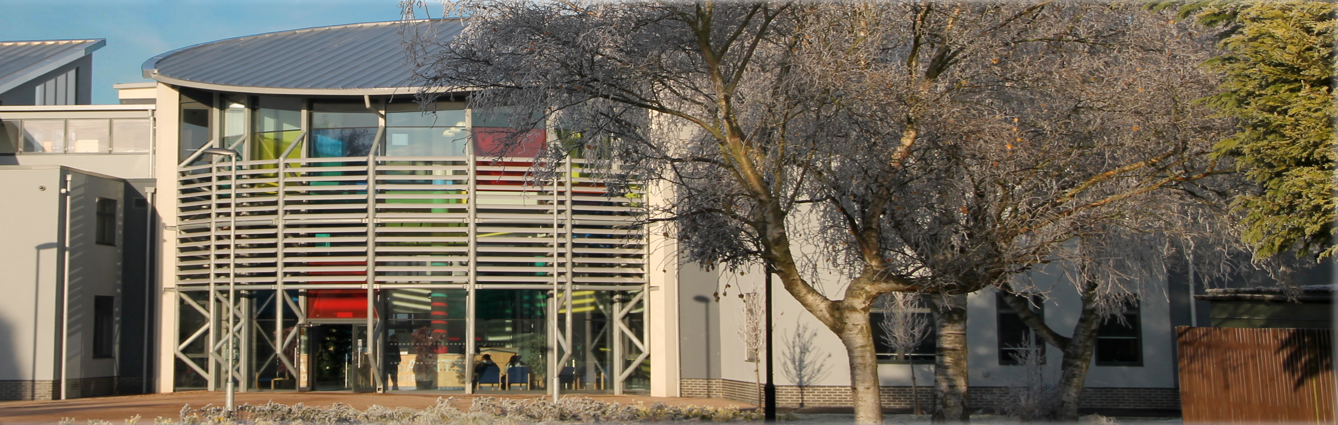

Dear Candidate

Welcome to All Saints Academy Dunstable.

I feel extremely proud to be the Principal of All Saints Academy and I intend to work alongside the students and staff to create a school that all can feel proud to attend. Last year’s Ofsted result was again an improvement on our journey to Outstanding.

At the Academy it is important to us that all children make the best progress possible regardless of their academic starting point. We understand that the best progress is only achieved when teachers know their students well and plan lessons with expertise, ensuring all students make progress. We are highly ambitious for everyone and fundamentally believe students should not have ceilings placed on their ability. We welcome teachers and associate staff who believe in having the highest expectations for all our students.

After embedding a change in leadership, in May 2019 Ofsted stated “Leaders have a clear vision for the school’s development. Strong leadership from the principal has led to improvements in the quality of teaching, learning and assessment since the previous inspection.”

The rapid rate of school improvement has been sustained and we are confident that the next Ofsted inspection will determine that we are a Good school, continuing on our journey to Outstanding.

If you feel you want to be part of our journey to Outstanding and have a genuine desire to make a difference to children’s outcomes, then please apply for this post. We firmly believe that visiting a school is key to deciding whether you should apply for the role, so please wherever possible contact the school to make an appointment to look around.
I look forward to meeting you

Yours sincerely

Liz Furber
Executive Principal

Information about this vacancy
At All Saints Academy our vision is “Living Well Together with Dignity, Faith and Hope”. We strive for excellence in all that we do, enabling our students to transform their lives and to hope for happy and successful futures. Our vision translates into our everyday practice and our values are particularly relevant in ensuring all in our community are encouraged to strive for excellence.

We are seeking to appoint an outstanding Lead Practitioner - History, who is enthusiastic, conscientious and self-motivated to join our team of middle leaders and have the ability to ways of using a range of technologies, which will inspire young people to study history. The successful candidate will also have a strong track record in the ability to lead subject specific training within the faculty in order to support improvements, seek out and adopt best practice across the school, using this to inform and refine the approach to history teaching. The ability to build effective working relationships with colleagues and staff, is also essential along with extensive proven teaching experience with the ability to motivate learners

All Saints Academy is a fantastic school in which to work, with exemplary relationships at all levels. All staff and students are valued highly. We have a first class commitment to developing individuals and working with others to reach their full potential

ACADEMY facilities
We are proud of our building and facilities. Our classrooms are bright, our corridors wide and spacious, and our learning environment is calm. You will see an abundance of colour, high ceilings and lots of natural light. All classrooms are equipped with an Interactive Whiteboard.

Across the Academy as a whole the accommodation includes:
- Five Science labs and a Science Studio Room
- Six Maths classrooms
- Five English classrooms and a Lecture Theatre
- Four Humanities classrooms
- Further rooms for the teaching of Business Studies and ICT
- A Modern Library with 30 computers
- A Modern Hall with tiered seating
- Specialist rooms for each of Art, Dance, Drama, Food, Media and Music and a Recording Studio
- An amazing Sports Hall and a Sports Exercise Room
- 3G All Weather Pitch and Multi Use Games Area
- The Inclusion Bungalow
- Management Suite
- Spacious staff room with outside area
- Separate Departmental staff workrooms

JOB DESCRIPTION
LEAD PRACTITIONER - HISTORY
This job description is not exhaustive and the post-holder will be expected to undertake any other duties as reasonably requested by the Principal and Deputy Principals.

Responsibilities include:
- To promote and encourage a sense of enquiry and debate among staff within the faculty on matters related to History teaching
- Lead subject specific training within the faculty in order to support improvements in the quality of teaching.
- To find ways of using a range of technologies which will inspire young people to study History
- To liaise with other Directors of Learning and Lead Practitioners to seek out and adopt best practice across the school and use this to inform and refine the approach in History
- To explore and relay innovative local, national and international developments around different approaches to History teaching to continuously improve the quality of the curriculum, and the learning experience for students at All Saints
- To be able to demonstrate a clear ambition that the learning of History matters, and to articulate and explain why it is a key constituent of the cultural capital that will enhance the life chances of young people at All Saints
- To be able to convincingly discuss the role and purpose of assessment in History and how this can contribute to developing confident learners.
- To promote and develop the profile of History in the school – and to seize upon the myriad of interdisciplinary and cross-curricular opportunities offered, e.g. through drama, speaking, sport and more.
- Ensure that the curriculum for their subject is expertly sequenced in terms of the introduction, revisiting and consolidation of key content.
- Ensure that the curriculum allows for key content to be covered in sufficient depth to promote a deep and comprehensive understanding.
- Work with the SEND department in order to support teachers with differentiating subject content to meet all needs.
- Be accountable for sharing resources designed specifically to close knowledge and skill gaps identified at summative assessment points, and lead intervention sessions where required.
- Lead rich and regular super-curricular activities for the most-able students to nurture their talents and promote passion for the subject.

I confirm that I have read and I understand my new job description.

This job description does not form part of the contract of employment. It describes the way the post holder is expected and required to perform and complete the particular duties as set out in the foregoing paragraphs.

The job description will be reviewed at least once a year and it may be subjected to modification or amendment at any time after consultation with the holder of the post.

…………………………… ……………………
Post holder Date

……………………………. …………………..
Line Manager Date

Position ……………………

Safeguarding
Teachers and Associate Staff are accountable for the way in which they exercise authority, manage risk, use resources and protect students from discrimination and avoidable harm. All staff, whether paid or voluntary, have a duty to keep young people safe and to protect them from physical harm. When an individual accepts a role that involves working with children and young people they need to understand and acknowledge that the responsibilities and trust are inherent in that role.

PERSON SPECIFICATION
Lead Practitioner - History

 | Essential | Desirable
Qualifications | - Degree in History  - Teaching qualification and QTS status  - Evidence of CPD and professional qualifications | - Masters or equivalent
Teaching Experience | - Extensive teaching experience in a variety of settings  - Depth of understanding of modern foreign languages and clarity of application within the classroom  - Experience of whole school success  - Successful experience as a Middle, with strong leadership skills  - Successful experience of dealing with a range of stake-holders  - Ability to motivate learners aged 11-18  - Ability to work across the whole ability range  - Ability to plan strategically to meet the needs of a range of learners  - Understanding of use of assessment to promote individual learning  - Demonstrable experience of raising standards of attainment and/or behaviour
Personal and Classroom Management | - Ability to communicate effectively with stakeholders  - Ability to work to agreed deadlines  - Ability to prioritise effectively  - Ability to demonstrate a range of teaching styles and to plan for individual needs  - Ability to use ICT to promote learning and administration  - Ability to coach and mentor less experienced colleagues
Knowledge, Skills and Aptitudes | - Commitment to safeguarding the welfare of young people in the Academy  - Ability to motivate and inspire young people and adults  - Ability to analyse data for comparative purposes  - Ability to work to agreed deadlines  - Ability to exercise initiative and to work independently  - Ability to accept direction  - Ability to use and show initiative
Personal Qualities | - Resilient and relentless in drive to secure improvements in own performance  - Empathy with young people and an ability to build a strong rapport  - Ability to remain calm under pressure  - Flexibility and hard-working  - Tenacity and determination  - An understanding of how teams work and of how to get the best out of each other  - An ability to seek positive solutions to emerging issues
Leadership Qualities | - Resilience and determination  - Creativity  - A positive approach to all issues  - An ability to influence others  - An ability to inspire Sponsors, Governors, staff, students and parents
Other | - DBS Enhanced check

TIMELINE FOR RECRUITMENT PROCESS

Advertisement placed Tuesday 27th April 2021
Closing date for applications Monday 24th May 2021 at 9.00am (The Academy reserves the right to close the advert early)
Interviews Wednesday 26th May 2021

ARRANGING A VISIT TO THE ACADEMY
We encourage prospective candidates to visit the Academy before making an application.

If you would like to arrange a visit, please contact Lisa Graves, HR Manager (01582 619700) to make an appointment.

HOW TO APPLY
Please submit your application form, together with a letter of application (no more than two sides of A4), outlining your reasons for applying for this post. In your letter please make reference to information in the pack, particularly the person specification, and explain why you would be an ideal candidate for All Saints Academy and what qualities you will bring to the Team. Please do not send us a general letter; we really are looking for someone who is prepared to respond to us as an individual Academy. You can be sure that we will take time and care in reading your letter as we appreciate how much energy goes into it.

Please apply by returning your application from downloaded from our website and a letter by email to jobs@asadunstable.org or by post to

Lisa Graves
HR Manager
All Saints Academy
Dunstable
Beds LU5 5AB

If you have any questions, please contact Lisa Graves, HR Manager, on 01582 619700.
We will acknowledge receipt of your application form and let you know as
early as possible if you have been shortlisted for interview.

