Bourne Grammar School

Atmosphere

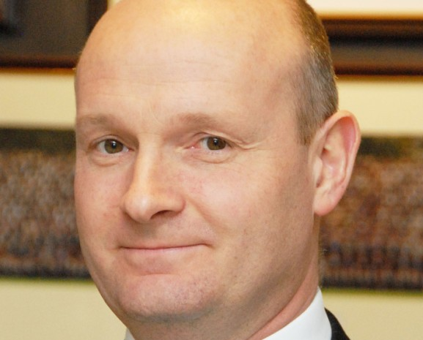
The best schools do everything well - academic, pastoral, sport, music, drama, Duke of Edinburgh’s Award, trips and visits. By virtue of a committed staff working with willing students and an appreciative Leadership Team, we have all these in abundance and to a high standard.

Support

We have no ‘mission statement’ - merely a very short purpose statement: Best Atmosphere, Best Support, Best Results. The order is deliberate; we believe that if we get the first two right then, given our able students and a committed staff, good results will follow. The atmosphere is special and is cherished by us all.

I write as a fellow teacher. It is important to me that I am a teacher for a significant part of my time. I do not run other schools. I am not always out at meetings and conferences.

I am entirely committed to ensuring that Bourne Grammar offers the best experience to its students and, importantly for those who read this, a pleasant and rewarding
experience to its teaching staff.

Jonathan Maddox
Headteacher

Results

We are a large and busy school, educating the top 25% by academic ability. That means that we do have a range of ability here. Some do very well indeed; practically all achieve at least pass grades in all their GCSE subjects.

The students want to be here and their parents/carers want them to be here. Most of the students, most of the time, want to learn and enjoy lessons which are well- planned, well-taught and are engaging.

We have expanded considerably because of demand for our places. A full, expanded school means that our income allows us to run a financial surplus. There have been no redundancies and departments are well funded. We pay salary increments. Our estate and IT systems are in good order. A new, £4m Science Block enhances an estate which is modern and well maintained. We are adding not losing subjects in our large and expanding Sixth Form which will soon have 27 A-level subjects; there is no minimum set-size.

I didn’t go to a grammar school

Neither did I. There are only 164 selective schools in the country so it is not surprising that only a handful of our staff were educated at grammar schools. We recruit teachers who were educated and may now work in comprehensive, selective or independent schools.

I don’t have a degree from a top-class university

We don’t demand that. Colleagues here come from across the entire range of higher education. What matters to me is that you want to teach here.

Behaviour?

Behaviour will be a revelation if you have not worked in a school such as ours. Students want to be here, they want to learn, they do not want to make your life a misery. If you engage well with the students and keep them interested, you can expect calm lessons, which leave you feeling positive, fulfilled and worthwhile. You will not drive home feeling shattered.

Please get in touch

We always welcome visits by prospective applicants, although I understand that it isn’t always easy or possible to come here before you apply. In any event, Stella Chamberlain is at the end of the phone, and she responds quickly to email. Please do contact her. She can put you through if you wish to discuss the role.

The best atmosphere, the best support, the best results

The Science Department

A new Science Block costing £4 million was opened in Autumn 2017. It contains 15 spacious, state of the art, air-conditioned laboratories, which provide a very pleasant environment for teaching and learning. The Block contains a large prep room for each of the three science subjects as well as generous staff facilities. All Science teachers have their own laboratory.

Science is a successful and forward-looking curriculum area, which was complimented in the last OFSTED report. The staff are dedicated and highly-qualified professionals, committed to raising standards and improving still further the quality of teaching and learning. All the Sciences are taught by specialists: five Chemists, five Biologists and, currently, four Physicists. The Science Faculty is very ably supported by experienced laboratory technicians.

In Years 7 and 8, students are divided into mixed-ability groups and have seven one-hour Science lessons per fortnight. Students are placed in ability sets in Year 9 and above. At KS4, there are four periods of each Science per fortnight.

Recent examination results in all three Sciences at both GCSE and A level have consistently been very good. All GCSE students follow the AQA Science specifications, sitting exams at the end of Year 11. Approximately two-thirds of students each year take separate Science GCSEs while one third will take Double Award Science.

The Physics Department

Physics is taught separately by specialist teachers from Year 9 upwards. Throughout Key Stage 4 we set students by ability and currently have seven sets of thirty students in Year 11, with ten sets in Year 10 and eight sets in Year 9. Results at Key Stage 4 are among the best in the School, with 69.9% of students in 2017 gaining a grade from A* to A in GCSE Physics and 95.1% gaining at least a grade B.

Physics is also a popular A-level choice, with three teaching sets in each of Years 12 and 13 (containing 60 students in total) following the AQA A Level Physics specification. Results are strong with 34.4% of students in 2017 achieving at least a grade A, and 87.5% achieving grades from A* to C. Many of our students go on to study Physics at university, as well as related subjects such as Engineering or Mathematics.

The Physics department currently consists of four full-time specialist teachers, including the Subject Leader of Physics.

The Post

We seek to appoint a dynamic and passionate teacher to join this highly successful, cohesive and supportive department. The post is for a September 2018 start.

Application process

Arrangements can be made by telephoning Stella Chamberlain on 01778 391648 or emailing recruitment@bourne-grammar.lincs.sch.uk

Go to our website for more information about the School: www.bourne-grammar.lincs.sch.uk

Informal visits are welcome

We are happy to accept a CV or an application form.

Closing date for application is Friday 5 January 2018

