 | Kingsthorpe College  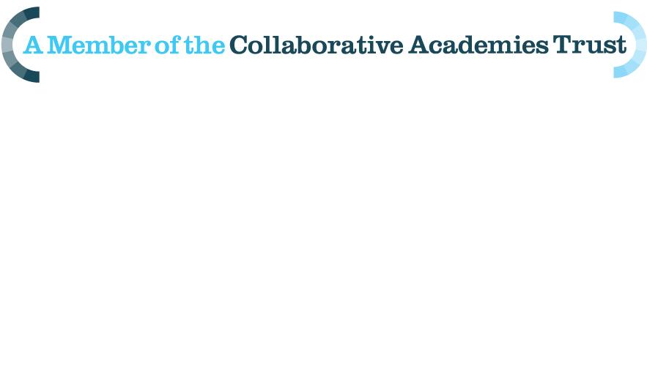  Job Description – Senior IT System Engineer

Position: Senior IT Systems Engineer
Line Manager: IT Services Manager
Grade: NJC Scale K 38-42
Contract: 37 hours per week/52 weeks a

Main Purpose:

The purpose of a Senior IT Systems Engineer is to maintain uptime of IT systems. Provide 1st, 2nd & 3rd line support to customers and provide technical expertise to new initiatives.

To act as a deputy for the IT Service Manager

Main Duties and Responsibilities

- Responsible for maintenance and development of network infrastructure, servers, workstations, applications and other systems as required under the direction of IT Services Manager
- To act as deputy for the IT Services Manager. Assisting with planning, coordination, development and administration of the IT Services Department and related projects
- To manage and direct other members of the IT Services team in support of the IT Services Manager
- In the absence of the IT Services Manager attend Operations Team and planning meetings and to ensure that IT Services Team daily stand-up meetings take place.
- Managing and monitor E-safety systems, antivirus and malware protection, internet\email filters and other systems as appropriate, to ensure security and safeguarding.
- Where appropriate take a technical lead in researching, creating, deploying and managing new and innovative systems to further improve existing working practices under the direction of the IT Services Manager.
- Provide an advanced level of technical support and training to staff, students and other stakeholders where appropriate.
- Provide regular in-house training ensuring that knowledge on technology used by KC and its partners is shared with relevant members of staff and students.
- Create and document technical procedures, policies, processes and standards, in-line with the College’s ICT support service definition.
- Act as technical authority in communications with Third parties to enable fixes on managed services
- Ensure that the necessary checks and regular maintenance in the form of daily, weekly, monthly and yearly schedules and carried out.
- Responsible for keeping all IT and related systems up-to-date and patched, working with the IT Services Manager to ensure that systems meet the needs of business.
- Work with the IT Services Manager to manage the IT Service desk, call management, procedures, escalations and reporting
- Manage system monitoring and pro-active maintenance, recording events and reporting issues that could affect BAU activities to the IT Services Manager.
- Perform root cause analyses and diagnostics on systems that are not functioning correctly.
- Support and advise customer sites (primary schools) with a view to promote KC as a centre of excellence. This may include subcontracted work on their sites.
- Provide IT event support for specific lessons, events or assemblies
- Utilise the ITSM tools to accurately record changes, incidents, service requests, problems, projects & standards.
Professional Development and Conduct

- Display appropriate conduct and behaviour towards students and other members of staff, including a commitment to equal opportunities.
- Undertake relevant training that will enhance your role within the College.
- Work towards ensuring adequate cover for absent colleagues.

Health & Safety

- Be aware of and adhere to KC procedures for health and safety.
- Report all faulty equipment to the IT Service Manager
- Liaise with the ICT suite manager with regard to ICT equipment and systems.
- Participation in the maintenance of satisfactory standards of safety and security in relation to IT equipment and procedures, in accordance with College/LA policy.
- Health & Safety checks of equipment as required by reference to member of staff responsible.
- Standard safety precautions should be taken when working with IT equipment

General

- Other duties in support of the College as decided by the Headteacher within the scope of this post

It is the practice of this College to examine job descriptions and to update them to ensure that they relate to the jobs as they are being performed or to incorporate whatever changes are being proposed. It is the College’s aim to reach agreement on any alterations. If this is not possible the Headteacher reserves the right to insist on changes to your job description after consultation with you.

Kingsthorpe College is committed to safeguarding and promoting the welfare of children and young people and expects all members of staff to share this commitment.
Kingsthorpe College, Boughton Green Road, Northampton, NN2 7HR - Telephone: 01604 716106

