

JOB DESCRIPTION

JOB TITLE: Lecturer/Assessor– Engineering

REPORTS TO: Head of School Engineering

AREA: Engineering

LOCATION: Woodlands Campus

GRADE/SALARY: Lecturers Scale, points 6 to 14 £29,736 to £40,551 per annum
Level 5 Teaching Qualified up to £44,661 per annum

CLOSING DATE: Sunday 17 August 2025

DBS: Enhanced DBS check with children’s barred list check

PURPOSE:

To teach/assess on, and contribute to, the development and support for a range of programmes, with responsibility for the signup, induction, and assessment of engineering apprentices for both frameworks(legacy) and standards up to level 6 as appropriate. The post holder will ensure that all elements of the quality cycle are followed in-line with college policy. The post holder will work as part of a team and contribute to the delivery of assessment where applicable as part of the holistic apprenticeship journey.

PRINCIPAL DUTIES:

- To teach and develop curriculum on a range of programmes within the specified area of Engineering, which includes, full-time, part-time, HE and apprenticeship provision.

- To provide high levels of assessment for candidates to achieve a high level of occupational competence against apprenticeship frameworks/standards, instilling the necessary skills, knowledge, behaviours required in their occupation.

- To coach and mentor apprentices towards completion of their EPA, ensuring they are ready for completion.

- To support candidates with portfolio/e-portfolio preparation and other advice as appropriate.

- To develop and contribute to the underpinning skills, knowledge, and behaviours for all aspects of apprenticeship delivery for candidates.

- To sign up and induct new candidates into the qualification as per college process and policy.

- To manage an agreed caseload of candidates and track performance of these candidates, providing specific measurable interventions if apprentices fall off track.

- To co-ordinate and manage the registration, enrolment, induction, and achievement of all apprentices within the caseload.

- Ensure that delivery of the required contact hours including all off the job hours as appropriate, providing tracking against achievement dates relative to each apprentice.

- Develop plans for assessing skills, knowledge, and behaviours to show occupational competence with candidates in line with qualification requirements.

- Judge evidence against criteria to make assessment decisions and provide feedback and support to candidates on these decisions.

- To support the internal quality assurance process for engineering, in line with the college’s quality cycle and participate in the reviewing and improving of systems and procedures where appropriate.

- To liaise with different stakeholders to support all elements of an apprentice’s journey.

- To liaise with the External Verifier as appropriate and make available and present portfolios/e-portfolios for external validation.

- To promote occupational competence within the school to ensure engagement throughout the learner’s journey, including classroom delivery where applicable.

- To co-ordinate the requests for certification to the Awarding Body (e.g., ‘direct claims’) where unit certification is appropriate.

- Be wholly familiar with codes of practice and national standards, including their implications in the delivery of the programme.

- To act as course tutor and/or a course co-ordinator for agreed programmes where appropriate.

- To contribute to the marketing of programmes, recruitment, and interviewing.

- To play an active part in the development of the flexible curriculum and the learning materials to support this, including the College’s virtual offer.

- To develop external contacts and promote industry-based work including work experience placements where applicable.

- To contribute to the co-ordination and administration of identified programmes.

- To demonstrate commitment to professional development. and industrial updating as required to maintain competence.

- To be an ambassador of Solihull College & University Centre and the Engineering curriculum area in all dealings with external partners.

- To embed sustainability within the curriculum.

- To adhere to policies, procedures and values of Solihull College & University Centre.

- To undertake all mandatory training in a timely manner as required e.g. Safeguarding, Prevent.

- To actively promote equality, diversity & inclusion and to champion anti-racist practice.

- To support the college to become a Sustainable Net Zero organisation by 2030 and support the delivery of its Sustainability Strategy.

- To undertake necessary Health and Safety responsibilities, duties and training as required by this post.

- To undertake any necessary Data Protection responsibilities, duties and training as required by the post.

- Such other duties as required which are broadly consistent with the general functions and grading of this position.

EQUAL OPPORTUNITIES:

Solihull College & University Centre is committed to a comprehensive policy of Equality. All employees are required to abide by this policy and ensure its compliance throughout the College.

SAFEGUARDING:

Solihull College & University Centre is committed to ensuring a safe environment for all students and expects all staff to engage fully with this commitment.

CORE VALUES:
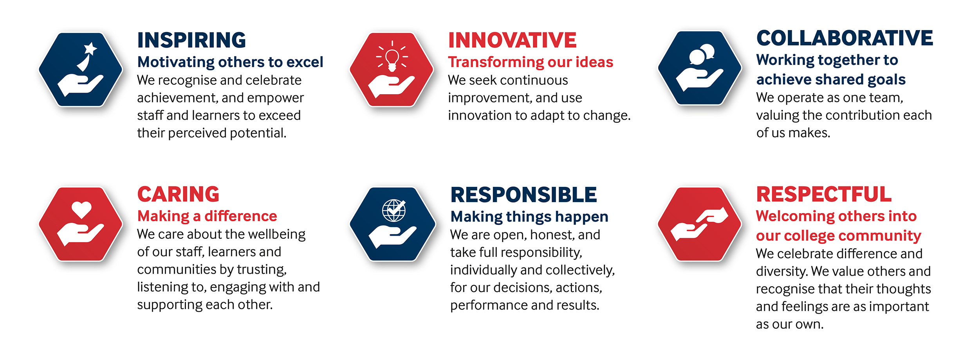

SOLIHULL COLLEGE & UNIVERSITY CENTRE
PERSON SPECIFICATION

JOB TITLE: Lecturer/Assessor – Engineering

SPECIFICATION | ESSENTIAL | DESIRABLE
EDUCATION/  TRAINING | Level 4/5 Engineering qualification  Relevant Level 4/5 teaching qualification (or committed to work towards in line with contractual requirements)  Level 3 Award in Assessing Competence in the Work Environment, or  D32 and/or D33 or A1 and/or A2 (as appropriate to Aerospace Engineering) | Award in Internal Quality Assurance of Assessment Processes and Practice or equivalent
RELEVANT  EXPERIENCE | Experience of assessing on Engineering frameworks/standards  Industry related work experience, particularly in Aerospace Engineering  Detailed knowledge of the assessment process | Curriculum development experience
SKILLS/  APTITUDES | Good communication and Information technology skills  Good administrator – well organised  Ability to work as part of a team  Flexible and well motivated, able to work on own initiative  Ability to support research study  Enthusiastic, flexible and dynamic  An awareness of sustainability and climate change and how it applies to FE and can be embedded into the curriculum
OTHER  REQUIREMENTS | A sense of humour and an understanding of the needs and challenges of teaching a range of students  Awareness of cultural diversity  Strong commitment to Equal Opportunities  A commitment to the Safeguarding of Young People and Vulnerable Adults and an awareness of the Government ‘Prevent’ strategy  Commitment to the College’s Values

