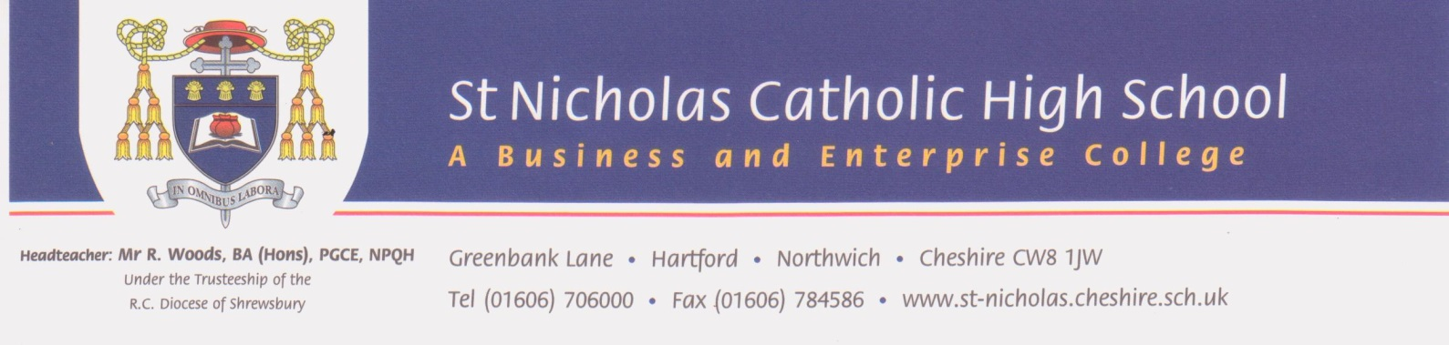
March 2019

Dear applicant,

Thank you for your interest in the post of Part Time Teacher of Geography at St Nicholas Roman Catholic High School. This post will be a 0.8 FTE contract although full time will be considered for the right candidate.

This is an exciting time for us as we look to further strengthen our Geography department here at St Nicholas. We are an excellent Catholic school with a fantastic reputation for the very highest of standards, outstanding students who are eager to learn and exceptional staff who walk the ‘extra mile’ to ensure that every student in our care lives life and lives it to the full.

We are looking to appoint a teacher with a passion and vision for learning and teaching in Geography across all Key Stages - a highly effective practitioner who will make a difference by inspiring a love of learning in their students. The successful candidate will join a forward thinking and forward looking department who are keen to build upon the many successes within the school’s external inspection reports from both the Diocese and Ofsted.

If you feel that you have what it takes to deliver our vision, please send your application either via the TES website, by email to h.fitzgerald@st-nicholas.cheshire.sch.uk or by post for the attention of Mrs Hannah Fitzgerald.

The deadline for applications is Monday 18 March at 12 noon, shortlisting w/c 18th March and interviews w/c 25th March. Tours of the school are available on appointment via Mrs Vicky Hill, PA to the Headteacher at v.hill@st-nicholas.cheshire.sch.uk.

I look forward to receiving and reading your application and I thank you for your interest in St Nicholas RC High School.

Yours sincerely
Richard Woods
Headteacher

