



Careers at
SHARE Multi-
Academy Trust
Application Pack
Valuing People, Supporting Personal Best




Administration Support Assistant
Todmorden High School, A SHARE Academy


John McNally
Chief Executive Officer
SHARE Multi-Academy Trust
Quality is our driving force

Welcome to SHARE Multi-Academy Trust, a supportive and close-knit family partnership of nine academies across West Yorkshire,
and a Teaching School Hub.

We are proud to be an employer of choice.
I believe our role as educators is to help children and young adults to instil a desire to learn, to overcome barriers to success, and to encourage an ambition to achieve. To reach this standard, we must first deliver for our people and ensure they feel valued, listened to and have a strong sense of belonging. In turn, our colleagues, pupils, and society all benefit enormously.

Two of our guiding principles are that ‘quality is our driving force’, and ‘teams drive success’. We know that recruiting and retaining an outstanding workforce is fundamental to achieving our aims. We therefore make it our mission to ensure every colleague within the trust has access to exceptional training and personal development opportunities, alongside a positive teaching environment, clear and ambitious progression pathways, and highly competitive packages.

We are also committed to sharing best practice across our trust, creating networks for colleagues to learn from one another, and fostering a learning environment and workplace where everyone feels supported and inspired, and can truly thrive. As a result, we are proud to be an employer of choice.

Thank you for your interest in our academies and trust. I hope you will consider joining us as we continue to deliver the very best education for our pupils. Whether you are an education practitioner looking to start your journey, or an established professional wanting to bolster your career – we look forward to working together soon.
We must
first deliver
for our people and ensure they feel valued.
At SHARE, we are committed to delivering strong educational standards within our
academies and providing our people with excellent careers. This is all underpinned by an unwavering commitment to our vision of Valuing People, and Supporting Personal Best.

Teams drive success






ABOUT US
TESTIMONIALS
JOB DETAILS


About
our Trust

SHARE Multi-Academy Trust was first established in
2014, and since then, we have built a solid reputation
for high standards and strong achievements.

We operate four successful primary academies and
five high-performing secondary academies across
the region. Our outstanding provision is supported
by our Calderdale and Kirklees Teaching School Hub
and national training accreditations, which enable us
to deliver exemplary training and development opportunities for education practitioners at every stage of their career, from initial training to executive leadership.

Our academies achieve excellent outcomes across the board. This includes academic attainment and school improvement, as well as maintaining exceptionally high standards in all aspects of school life including behaviour and attendance.

As a result of the trust’s supportive and inclusive approach, senior leaders invest significant time in supporting positive pupil behaviour and attendance. Our pupils attend well and are positive about learning. In turn, this creates a positive and respectful teaching and learning environment for staff, with teachers able to focus on delivering an excellent education to students without distraction, and with a manageable workload.

Behaviour is excellent, and there are high levels of mutual respect and tolerance amongst pupils and staff.

Ofsted, 2023*

Whilst being close-knit, we are ambitious for the future.


We are always looking for additional ways to expand our positive impact, be that by working with new schools
on exciting initiatives, or by collaborating with our
talented team of staff.

Our aim has long been to be the best trust, not
the biggest. Our priority for the future is to keep
improving standards, building on our successes,
and raising aspirations so we can support even
more pupils to achieve even better outcomes.


*2023 Ofsted report for Thornhill
Community Academy, A SHARE Academy
ABOUT US
TESTIMONIALS
JOB DETAILS


Jack Wyatt
Associate Principal
Shelley College
often exceed them. We continue to contribute to the generous Teachers and Local Government Pension

School Teachers’ Pay and Review Body. We use the flexibilities available to us as an academy to enhance our offers where we can.

Schemes and at least match pay awards agreed or recommended by the Local Government Association and

Your Career
at SHARE
Our vision of ‘Valuing People, Supporting Personal Best’ underpins everything we do. Central to our work and ability to deliver a transformational education, is our dedication to developing our greatest asset, our staff.
That is why we have an outstanding pledge to teachers and support staff to provide professional development and training opportunities, particularly through our Teaching School Hub. We are committed to investing in our staff, ensuring that they have fulfilling careers and enjoy their jobs every day. This is fundamental to our ability to turn academies around and
deliver the very best education to pupils.
We offer a competitive package
to all our colleagues.
We work as a collective group of professionals to achieve common goals. Watching new teachers and leaders become established in their roles gives me an immense sense of professional pride, as they help our pupils to achieve excellent outcomes.
As well as two generous pension schemes, we also offer

employee assistance and wellbeing packages; and flexible

and family-friendly policies, such as flexible working, shared parental leave and enhanced maternity,
paternity, and adoption entitlement, giving colleagues

the control and freedom to work in a way that suits their needs. We offer incremental progression and cost-of-living pay increases, subscribe to local
and national discount schemes, and provide exceptional onsite catering facilities.
We have committed to offering our colleagues pay and conditions that are at least as good as those available to colleagues in maintained schools. In practice, we
ABOUT US
TESTIMONIALS
JOB DETAILS
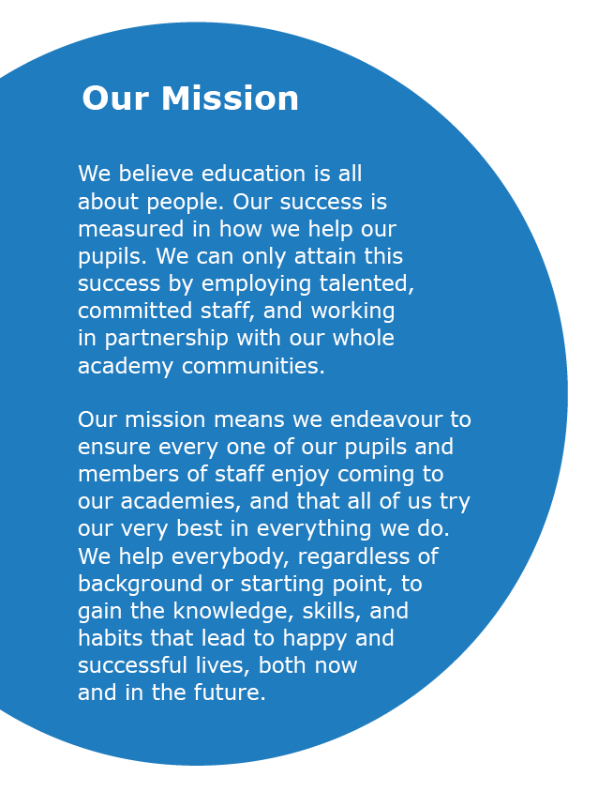



ABOUT US
TESTIMONIALS
JOB DETAILS
Our Shared Vision and Mission




ABOUT US
TESTIMONIALS
JOB DETAILS
Build positive communities that achieve outstanding outcomes, together
Overcome disadvantage, so all pupils achieve outstanding outcomes
Deliver an outstanding curriculum and pedagogy
Recruit and retain an outstanding workforce
Provide outstanding leadership, management and trust infrastructure
People thrive in communities
Teams drive success
Quality is our driving force
Everyone can achieve
We have a clear and ambitious strategy as a trust, so that we can ensure we collectively fulfil our overarching vision and mission. This is built upon our guiding principles, with distinct goals and objectives linked to accountability and performance measures.

Our Guiding Principles




Calderdale and Kirklees
Teaching School Hub
Royds Hall
Ofsted: Good
Luck Lane
Ofsted: Good
HUDDERSFIELD
WAKEFIELD
BRADFORD
LEEDS
HALIFAX
Woodside Green
Ofsted: Good
SHARE Multi-Academy
Trust Central Office
Shelley College
Ofsted: Outstanding
Thornhill
Community Academy
Ofsted: Good
Millbridge
Ofsted: Good
Whitcliffe Mount
Ofsted: Good
Heaton Avenue
Ofsted: Requires Improvement
Todmorden High School
Ofsted: Good*
*Most recent Ofsted prior to academisation in 2025.
ABOUT US
TESTIMONIALS
JOB DETAILS
Click below to select the location of the vacancy you are interested in to find out more.
Our primary academies
Our secondary academies
Academies

ABOUT US
TESTIMONIALS
JOB DETAILS
Alongside our successful Teaching School Hub and
training accreditations, we take great pride in one
another’s individual successes. Many of our most
senior leaders have progressed through the routes.
That includes the countless colleagues who have enjoyed varied, rewarding, and long careers with our academies and trust, as well as those who are just starting on their journey and are glowing with potential.

We remain committed to developing our staff, who are our greatest asset in achieving our mission.

Through our broad curriculum, first-class careers
education and guidance, and our wide-ranging enrichment offer, we successfully prepare our young people for life beyond the classroom. We ensure no child is left behind, and do so by fostering a safe, inclusive, and nurturing environment where all barriers can be overcome.
enrichment offer, we successfully prepare our young people for life beyond the classroom. We ensure no child is left behind, and do so by fostering a safe, inclusive, and nurturing environment where all barriers can be overcome.
At SHARE, we are proud of the high standards and expectations we set and uphold, across the board. Consequently, we consistently surpass both national and regional school results. Our academies consistently secure excellent academic outcomes, with achievement levels being amongst the highest in our region.
Supported by robust, well-resourced, and accountable improvement plans, we have a proven track record of significantly improving our academies, as reflected in national performance measures and our strong Ofsted outcomes.

Our Outcomes


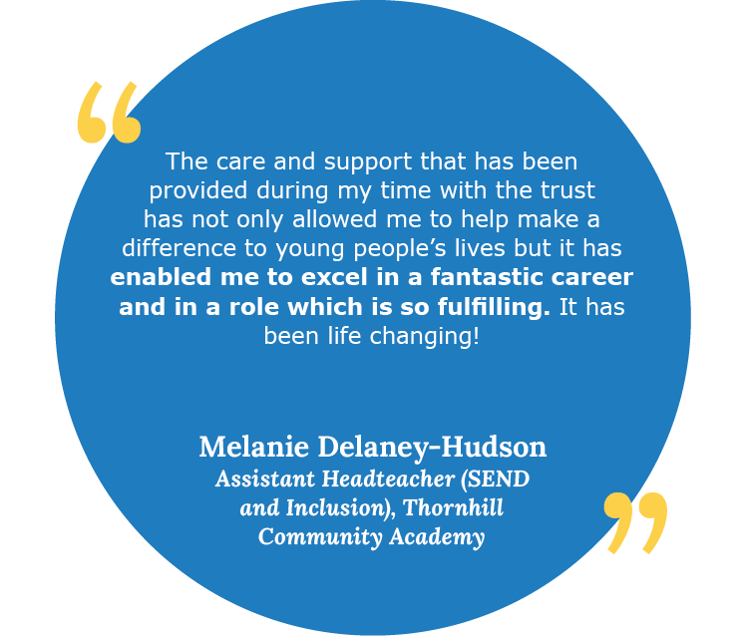
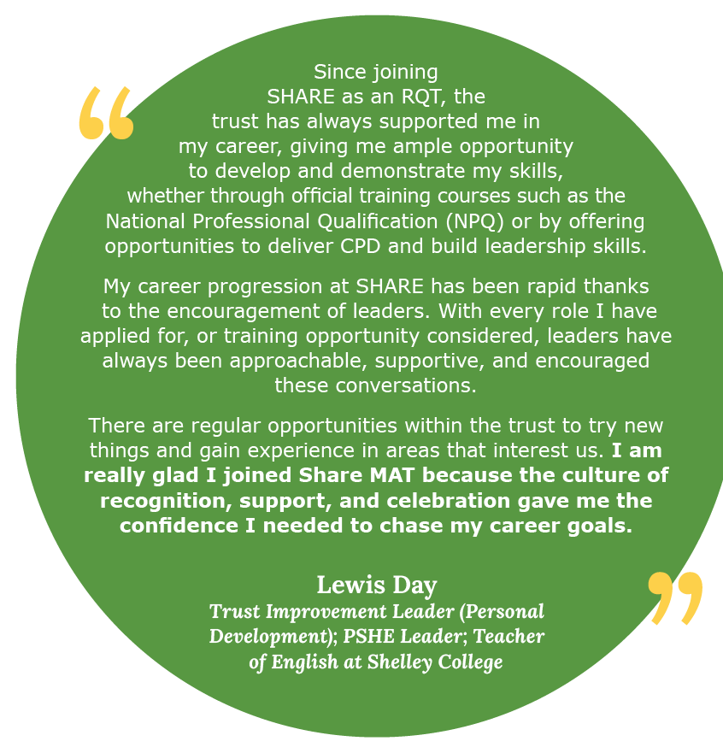
ABOUT US
TESTIMONIALS
JOB DETAILS

What our colleagues say


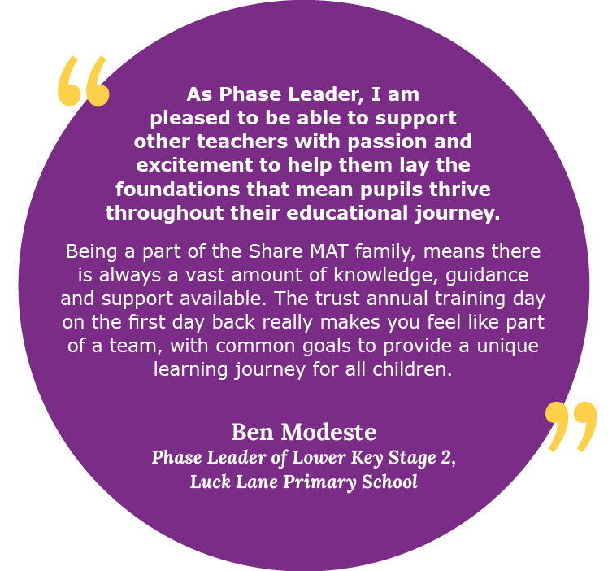

ABOUT US
TESTIMONIALS
JOB DETAILS
What our colleagues say



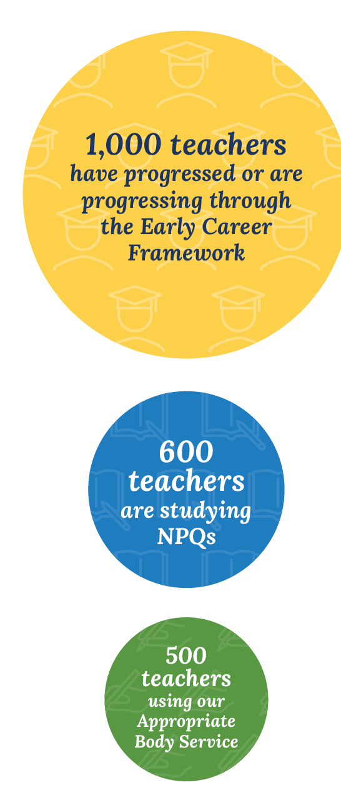
ABOUT US
TESTIMONIALS
JOB DETAILS
specialist and leadership National Professional Qualifications (NPQs), offer Lead Practitioner positions for those with classroom-based preferences, alongside middle and senior leadership training programmes for new and aspiring leaders. With additional development opportunities for staff including research projects, subject enhancement training, and access to The National College online development platform, we are dedicated to supporting our staff to develop and grow as educators.

Our success as a trust depends entirely on our colleagues who are the bedrock of all we do. That’s why we’re determined to recruit and retain the best staff by offering first-class training and support, alongside highly competitive packages.
First-class careers, through
bespoke training and support
Across the trust, we pledge to deliver outstanding professional development and training opportunities that are bespoke for our teaching and support staff. We support colleagues through ongoing training, coaching, and mentoring using the latest evidence-based research, to strengthen their expertise.

Alongside career pathways carved out for our support staff, we similarly offer a variety of progression and promotion routes for teachers. In addition to the traditional progression journey, we deliver a full suite of specialist and leadership National Professional Qualifications (NPQs), offer Lead Practitioner positions for those with classroom-based preferences, alongside middle and senior leadership training programmes for new and aspiring leaders. With additional development opportunities for staff including research projects, subject enhancement training, and access to The National College online development platform, we are dedicated to supporting our staff to develop and grow as educators.

We also champion cross-trust collaboration and best practice sharing, maximising the opportunities and expertise available across our schools. All colleagues are encouraged to meet regularly, including through various forums where they can discuss ideas, and share experiences and resources.

We also champion cross-trust collaboration and best practice sharing, maximising the opportunities and expertise available across our schools. All colleagues are encouraged to meet regularly, including through various forums where they can discuss ideas, and share experiences and resources.

Alongside career pathways carved out for our support staff, we similarly offer a variety of progression and promotion routes for teachers. In addition to the traditional progression journey, we deliver a full suite of
We are committed to protecting our staff’s wellbeing by providing the support, guidance, and training needed to achieve the highest standards they are capable of.

Just as we encourage our pupils to achieve their personal best, we want the same for our staff, with colleagues having their own personal development plans.

ABOUT US
TESTIMONIALS
JOB DETAILS
Since its launch, we are delighted that 1,000 new teachers have progressed or are progressing through our Early Careers Framework Course, with over 600 studying NPQs. We also continue to provide the Appropriate Body Service for nearly 500 new teachers.
Having the Hub as a central part of our trust family means it continually informs our approach to staff development and how we can enhance our training based on learnings and insights. It has also shaped our approach in recognising that development is a long-term, meaningful investment in our colleagues and therefore our pupils.

Endless opportunities through our Teaching School Hub and Training Accreditations
Our commitment to professional development and raising opportunities and aspirations in the communities we serve and beyond, is best reflected through our Teaching School Hub and Training Accreditations.

We are immensely proud to be the Teaching School Hub for Calderdale and Kirklees, enabling us to connect with, shape, and inspire teachers and practitioners of the future.
Through our Teaching School Hub and training platforms, we induct Early Career Teachers (ECTs) into the profession through an outstanding Initial Teacher Training programme. All our academies similarly play an important role in supporting trainee teacher placements through the Hub and with other local trainee teacher providers. We also offer a full suite of specialist and leadership NPQs through the Hub, including for staff themselves to facilitate Early Career and NPQ frameworks.

JOB ADVERT

Job title:
Administration Support Assistant |  |  |  | 
Academy:
Todmorden High School, A SHARE Academy
Headteacher:
Emily Rawlinson, Headteacher
Section: |  |  |  | 
Support Staff
Reporting to:
Assistant Headteacher
Contract type:
Permanent | Fixed Term

Time commitment:
Term Time Only – 37 hours per week plus 3 training days
Band/Range:
Band C, SCP 5-6 £24,790-£25,183 FTE
Actual Salary £21,405 - £21,744
Further salary information:
Academy information:
Todmorden High School is a large secondary academy in Todmorden. The academy is committed to creating a culture where all students and colleagues at all levels can feel proud of who they are and their achievements. In keeping with our values, we strive to create a school that celebrates difference. Ambition, Respect, Care and Honesty remain at the forefront of everything we do; we are trusted to do the right thing for each other, our students and the wider community.

The academy is a proud partner of the well-regarded and high-performing SHARE Multi-Academy Trust and is part of the Teaching School Hub for Kirklees and Calderdale. Todmorden High School provides staff with a wealth of support and a wide range of opportunities to collaborate, network, and share best practice.

Todmorden High School has a wonderful academy community and is a great place to work, where all team members play a vital role in making a positive impact on the life chances of others.

The academy is proud to offer:

- A supportive and ambitious environment where all students are encouraged to go beyond what they think they can achieve and to enjoy learning, helping them to lead successful, healthy and happy lives

- A vibrant place to work which equips staff to deliver their best every day, under the strong belief that Valuing People, Supporting Personal Best is the key

- A commitment that staff are happy, engaged and well supported at work, taking pride in students’ attendance, behaviour, progress and development as well as their own

- Excellent training and guidance relevant to individual job roles, so expectations are understood and staff are motivated

- Great benefits, as an employer of choice, including outstanding CPD, supportive line management, and meaningful networking opportunities across the trust to aid personal development

- Supportive leadership, encouraging healthy work-life balance

- A high-quality teaching and learning environment, alongside good facilities

- A culture where children are happy, settled and confident, accessing a broad and balanced curriculum which provides a memorable educational experience for pupils and staff.

We are committed to supporting the wellbeing and inclusion of all staff. A private space is available for those who need to express milk or require a quiet area for prayer. If you have any other specific needs or adjustments you would like us to consider during the recruitment process or in the workplace, please let us know on your application form or contact us directly via email to: Elaine Crossley, elaine.crossley@sharemat.co.uk.

We are looking to recruit:
We are looking to recruit a highly organised and proactive individual to support the school’s attendance and administrative functions, ensuring accurate record-keeping, effective communication with families and staff, and flexible support across key operational areas including first aid, behaviour, and student wellbeing.
The ideal candidate will:
The post holder will provide administrative support for student attendance forming part of the school’s wider support team, using Arbor daily to maintain accurate student records in relation to attendance and ensure all registers are completed and are compliant.
For more information, get in touch with:
Andrew Nalborczyk, Assistant Headteacher: a.nalborczyk@todhigh.co.uk

JOB DESCRIPTION
Overall purpose of the role:
The post holder will provide essential administrative support for student attendance, forming a key part of the school’s wider support team. This role involves daily use of Arbor to maintain accurate attendance records and ensure compliance with register completion requirements. The successful candidate will demonstrate excellent administrative, interpersonal, communication and organisational skills.

The post holder will also contribute towards the safety of the students during social time and transition time by being a member of the whole school Duty Team undertaking duties to suit the needs of the school and the team.

Safeguarding requirements:
This post requires the post holder to work in settings with children and young adults. Any employment offer is therefore subject to the results of an Enhanced Disclosure from the Disclosure and Barring Service (DBS). People who may have contact with younger children (i.e. primary school age) are also required to complete a declaration about family or other members of their household.

Applicants MUST complete the MAT’s standard application form to be considered, will be required to provide evidence of identity and qualifications and offers of employment will be subject to satisfactory references. For applicants who work or have recently worked in a school, one of the references must be from the Headteacher.
Key Outputs:
Attendance Administration
- Maintain accurate student attendance records using Arbor.
- Ensure all registers are completed in a timely and compliant manner.
- Generate and review daily absence reports following AM and PM registers.
- Monitor missing students by checking classrooms and other areas; contact parents/carers as necessary.
- Send and monitor Truancy Call notifications for absent students.
- Update Arbor with attendance-related information, including sickness, holidays, medical appointments, exams, and school trips.
- Support staff in completing registers by sending timely reminders and finalising all outstanding registers by 3pm.
- Produce and manually input assembly and paper registers as required.

Collaboration and Communication
- Liaise with the Lead Attendance Officer regarding student absences.
- Work in partnership with the Student First Aid Administrator, including deputising for this role when needed.
- Support the First Aid Administrator in checking students in/out, recording medical room attendance, and liaising with parents.
- Coordinate with the school photographer for Year 7 and Year 10 photos; ensure all students are present and upload images to Arbor.
- Liaise with all Local Authorities regarding Free School Meals (FSM); update Arbor weekly based on intranet updates.

Behaviour and Uniform Support
- Run the daily detention report and organise the rota for detention collections.
- Manage forgotten uniform items (e.g., ties, blazers, shoes) for students.

General Administrative Support
- Provide flexible administrative assistance across the school as required.
- Support other members of the support team during busy periods or staff absence.
- Undertake additional duties as directed by line management, in line with the evolving needs of the school.
The specific responsibilities will be shaped by the skills and experience of the successful candidate, and it is possible that not all listed duties will be required.

Employees will be expected to comply with any reasonable request from the Headteacher to undertake work of a similar level that is not specified in this job description.

Dimensions:
• Range of Teachers/Support Staff – approximately 60 teaching staff and 60 support staff across the Academy.
• Range of Students approximately 900.
Work/Business contacts:
Internal: All teachers and support staff including liaising with MAT colleagues, particularly Assistant Headteacher and Senior Leadership Team.
External: Parents/Carers and Families.
Expertise in role required (At selection – Level 1):
ESSENTIAL
- Good knowledge and use of IT systems including Word, Excel, PowerPoint and Outlook.
- Ability to carry out general administrative skills and to deal with a variety of tasks such as filing, typing, distribution of post, etc.
- Experience of working in a busy environment and of meeting tight deadlines.
- Ability to comply with strict regulations about confidentiality and behave according to the appropriate protocols.
- Ability to demonstrate strong organisational skills, prioritise own workload; and the ability to work to deadlines and under pressure.
- Excellent communication skills both written and verbal.
- GCSE English and mathematics (Grace C and above).
- Excellent IT skills.
- An understanding and commitment to equality and diversity.

DESIRABLE
- Experience of education sector.
- Willing to travel around the MAT, if required.
- Willing to work flexibly within scope of overall hours, e.g. occasional evening meetings
- Has a full current UK/European Driving Licence.
- Has access to a motor vehicle and is prepared to use it for business.
Expertise in role – After initial and advanced development:
- Applies a strong understanding of school systems and procedures to support student wellbeing and engagement.
- Maintains a high standard of organisation, confidentiality, and attention to detail in all aspects of the role.
- Provides flexible administrative support across departments, adapting to changing priorities and school needs.
- Supports key school operations such as detentions, uniform provision, and student check-in/out with efficiency and professionalism.

Structure/Department Information:

HOW TO APPLY
Please note that CVs will not be accepted. To apply, please complete an application form on the Every Candidate Portal using the application link below.
Application link:
https://www.tes.com/jobs/vacancy/administration-support-assistant-calderdale-2235549
Closing date:
Monday 14th July 2025 at 9am
Interview date:
Wednesday 16th July 2025

Share MAT is committed to the Equalities Act 2010 and also to promoting the welfare and safeguarding of children and young people, by adhering to the “Keeping Children Safe in Education” guidance. All staff and volunteers are regularly trained regarding our expectations in keeping our students safe. An enhanced DBS is required for every post. An online search will be undertaken for all shortlisted candidates.


www.sharemat.org
todhigh.co.uk
Ready to start your career with Share MAT?
Get in touch:
Visit
Email
todmorden.office@sharemat.co.uk
Call
01706 813558
Address
Todmorden High School, A SHARE Academy
Ewood Lane, Todmorden
OL14 7DG
Visit the trust website
Valuing People,
Supporting Personal Best

