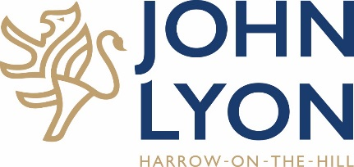

Job Description

Job Title: French Assistant
Reporting to: Head of French

Context
John Lyon is, with Harrow School, part of John Lyon’s Foundation. The School provides an independent education for boys between the ages of 11 and 18. Established in 1876, the School has an excellent and growing reputation for academic success and for valuing each boy as an individual.

Principal Responsibilities
The French Assistant Teacher is primarily responsible to prepare and support Year 11 to Year 13 students towards their speaking examination and to support Able, Gifted and Talented student across the school. The French Assistant will be expected to work closely with the colleagues in the department in order to plan and devise engaging resources.

Specific responsibilities include:

- To work with the teacher in the classroom to support individual students.
- To work on your own with small groups of pupils or in the forum of one to one tuitions.
- To help prepare pupils for oral and written examinations.
- To make recordings in your own language which the school can use as an example of native-speaker speech.
- To work on specific topics with small groups of older students.
- To organise a stimulating language club and participate in the ongoing development of the department.
- To contribute to an international project if necessary.
- To attend regular meetings with the Head of French to discuss student progress, assessment and performance.
- To adapt to pupils’ strengths and needs in order to develop their confidence, fluency and accuracy.
- To instil a passion for French culture and society by researching and using authentic materials and drawing on their own cultural knowledge and experiences.
- To record pupils’ progress regularly and ensure an effective communication with the class teacher.
- To communicate effectively and regularly with the Head of Department to ensure the smooth running of the speaking sessions
The post holder’s responsibility for promoting and safeguarding the welfare of children and young persons for whom s/he is responsible, or with whom s/he comes into contact will be to adhere to and ensure compliance with the School’s Safeguarding and Child Protection Policy Statement at all times. If, in the course of carrying out the duties of the post the post holder becomes aware of any actual or potential risks to the safety or welfare of children in the school s/he must report any concerns to the School’s Designated Safeguarding Lead.
In accordance with the Health and Safety at Work Act 1974 all employees have a duty to look after their own and others’ health and safety.
The John Lyon School is an Equal Opportunity Employer

