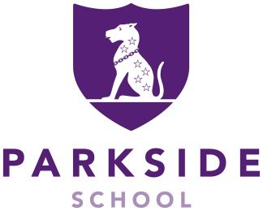

Parkside School

Estates Assistant – Full-time

Interviews: TBC
Salary: £23,000 - £27,000 pa
Location: Cobham, Surrey
Contract type: Permanent contract
Position: Full-time, 40 hours per week, typically 8.00am-5.00pm daily

Parkside School is a boys’ independent Preparatory School and co-ed Nursery, with a strong, nurturing and family ethos; set in beautiful grounds of 45 acres and only 40 minutes to London.

We are looking for an enthusiastic individual with a keen eye for detail and some experience in buildings and facilities maintenance to join our experienced Estates team. The role will largely relate to the internal upkeep of the school’s buildings and facilities but the post holder may also be required to provide support to the external grounds staff with various tasks.

Candidates will be able to demonstrate some experience in maintenance and ideally some a practical horticulture skills. Of paramount importance is the ability to take instruction, turn their hand to a wide variety of tasks, and willingness to learn and develop current skills to support an already established team.

This is an exciting opportunity to join a successful school dedicated to the highest standards of teaching, learning and care.

To be considered for the post please return the completed Application Form by the closing date to: hr@parkside-school.co.uk

SAFER RECRUITMENT STATEMENT: Parkside School is committed to safeguarding and promoting the welfare of children and young people and expects all staff and volunteers to share this commitment. Applicants must be willing to undergo child protection screening, including checks with past employers and the Disclosure and Barring Service.

IAPS boys’ day school
260 pupils aged 2 -13 years


September 2023


