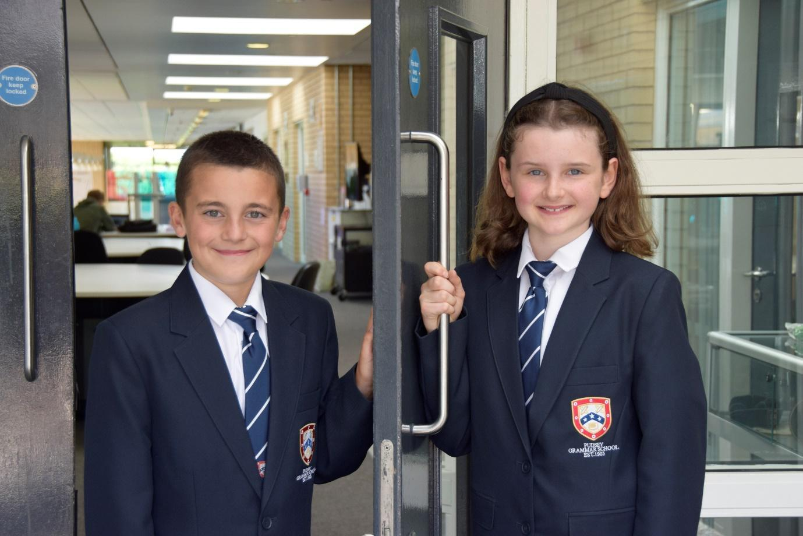

TEACHER OF
ENGLISH

APPLICATION PACK

Academic Support Tutor

C1 £26,421 - £28,770 FTE
(Actual salary £22,725 - £24,745)
37 hours per week Term time only plus 5 days
Working pattern to be confirmed (the school will operate an early finish on Fridays from September 2024)

From September 2024

Contents
Introduction from the Headteacher
General school details
Information on the post
Job description
Person specification
Enhanced disclosure

Introduction from the Headteacher

Thank you for the interest you have shown in the post of Academic Support Tutor. This is an excellent opportunity to join our passionate Special Educational Needs (SEN) Support Team.

We are looking to appoint an inspirational individual who is committed to working with vulnerable young people, developing appropriate strategies to allow them to enjoy their learning, access the curriculum and achieve.

The successful candidate will have genuine ambition for all, care deeply and share our passion for learning and will provide focused support to accelerate the learning of our most vulnerable under-achieving or SEND students, meeting their specific needs and ensuring the highest levels of engagement.

Pudsey Grammar School is a heavily oversubscribed mixed comprehensive secondary school located in the heart of the market town of Pudsey. Situated between Leeds and Bradford, the town has always valued its independence from its two larger neighbours. The school has a long and proud history stretching back to 1905. The school has 1350 students with a thriving and expanding Sixth Form of over 250 students, all taught in a state of the art building. The innovative and unique style of the building creates a calm atmosphere very different to many secondary schools.

I was appointed in 2014 and since then we have received a letter from Amanda Spielman (HMCI Ofsted) which stated we ‘have transformed all aspects of the school.’ This assertion was further underlined in 2018 when the increase in our exam results resulted in the school being the most improved school in Leeds and one of the most improved in the country (we were delighted to follow these achievements up with our best ever GCSE exam results in 2019 which were above the national average). The pattern of improvement continued in 2020 with our Year 11 students achieving grades which were outstanding. The school had a highly successful Ofsted inspection in April 2019 and was judged as good in all areas, including our Sixth Form. The school underwent an ungraded inspection in April 2024 which saw, for the first time in the school’s history, a second successive Ofsted judgement of being a good school. This is testament to the consistently high quality of education which the school provides for all of our students and is one of the reasons why we remain one of the most popular schools across the city of Leeds with over 900 applications received for 215 Year 7 places for September 2024.

In 2022, the school was selected to be a national Behaviour Hub school. This is a Department for Education programme led by the Governments’ School Behaviour Advisor, Tom Bennett, which identifies schools who have ‘an exemplary behaviour culture’. We are one of only 20 secondary schools out of 4000 who have achieved this prestigious accolade and we are working with other schools across the north of England to improve their behaviour cultures.
In 2023, the school was awarded £4 million by the Department for Education to build a new Sixth Form to support the growth in student numbers across Leeds. This exciting new development is scheduled to open in early 2025.
We have a comprehensive House system which runs across all year groups with over 30 diverse competitions across the year for students and one each half term for staff too. House assemblies take place once every three weeks lead by our eight House Leaders. At the end of each academic year, the winning House is awarded our 80-year-old Victor Ludorum Cup.
We are aiming to be a centre of excellence and every indicator we have, we are on track to achieve this goal. Continuing to recruit high calibre staff is a key priority of our strategy.

The following quotes are taken from the latest Ofsted report:

- The school is welcoming and pupils respect the differences in other people.
- Safeguarding is very well led and pupils feel safe
- Pupils get on very well with each other
- Teachers have strong subject knowledge
- Pupils behave well in lessons and the vast majority focus on their work
- The school has developed an ambitious curriculum for pupils
- Staff have high expectations of all pupils. The vast majority of pupils rise to these expectations and work hard
- Pupils benefit from the curriculum and are well prepared for their next steps
- The House system plays a central role in the school and provides a sense of belonging. Pupils who earn House ties for their dedication to House competitions wear them with pride
- If bullying happens, pupils are confident that staff will deal with it quickly
The school has a long tradition in the town, being established as Pudsey Grammar School in 1905. Although the school is taught in a state of the art building, our core values of respect, resilience, integrity, compassion and ambition are highly traditional and are based on the goal of ensuring that every student reaches their true potential.

Our school is not just about the students gaining knowledge and qualifications, although these are extremely important. We believe in teaching young people core values of decency, social skills and how to be a good citizen in an ever changing world. We want their character to develop and grow, and for them to leave us with an inquiring and independent mind. We want our students to gain the best qualifications they are capable of whilst experiencing a range of opportunities which are second to none. As a result, the school is extremely popular with our community and is significantly over-subscribed every year.

Our Sixth Form, which is rated as good by Ofsted, has grown rapidly in recent years following significant investment and we now have over 250 Post-16 students studying at Pudsey Grammar. We have a strong tradition of ensuring students access the best universities, including Oxford and Cambridge.

Our staff show exceptional dedication and commitment to our students. Relationships in the school are extremely strong and this underpins the ethos of the school. We pride ourselves in the care and support that we give our staff and, as a result, there is a real team spirit in the school where people enjoy being part of our school community. Teaching and learning is the key focus of the organisation and everything that we do is designed to ensure that the classroom experience for
the students is excellent. We are currently redesigning our curriculum to ensure that the education we offer is second to none.

We offer fantastic support and professional development to staff, which ensures that they are equipped with all the necessary skills to deliver excellent lessons to the students on a daily basis.

The school is a Foundation Trust school and our partners include global companies such as Asda and HSBC bank, alongside leading local business and training provider, Appris. These high quality links allow our school to offer excellent careers opportunities to students across the ability range. As a result, the school has 0% NEETs at Year 11.

We are currently part of the Red Kite Teaching Alliance, which is providing outstanding opportunities and CPD for all of our staff. Subject Leaders attend their Collaborative Learning Groups, which allows them to network and share best practice. This is further disseminated through the school via regular Department meetings and weekly Teaching & Learning briefings.

This clearly is an exciting time to join our school.

If you have a desire to be part of one of the most exciting and rewarding schools to work in, which will also provide you with excellent development opportunities, please complete the application form. Any further details can be obtained directly from the school’s HR Team: recruitment@pudseygrammar.co.uk) or our website www.pudseygrammar.co.uk

Mark McKelvie
Headteacher
Pudsey Grammar School

Details of advert

Job Title: Academic Support Tutor
Hours and working pattern: 37hpw, term time only plus 5 days, actual working pattern to be confirmed (the school will operate a flexible early finish on Fridays from September 2024)
Grade: C1, Pt. 12 - 17
Salary: £26,421 - £28,770 FTE (£22,725 - £24,745 Actual)
Start date: September 2024

We are looking to appoint an exceptional individual to join our SEND team. The Academic Support Tutor will be highly efficient and have exceptional organisational skills, the ability to prioritise between competing workloads with a consistently professional approach to all aspects of the role and the drive and focus for continuous improvement.

The role will involve:

Provide focused support to accelerate the learning of our most vulnerable under-achieving or SEND students, meeting their specific needs and ensuring the highest levels of engagement

No two days will be the same, we need an individual that will understand no two students can be treated the same. Our students are in need of an academic support tutor who will support them with an array of complex, challenging learning needs and behaviours to remove their barriers to learning.

Applicants will need to demonstrate:

- Excellent attention to detail, effective analytical skills and strong inter-personal and communication skills are essential, together with the ability to work as part of a successful team.
- Applicants should have appropriate qualifications and/or relevant experience in working with young people.
- A commitment to:
  - Working in line with statutory safeguarding guidance (e.g. Keeping Children Safe in Education, prevent and our safeguarding and child protection policies)
  - Working with the designated safeguarding lead (DSL) to promote the best interests of students, including sharing concerns where necessary.
  - Promoting the safeguarding of all students in the school

Why work at Pudsey Grammar School?

- Be a part of our rapidly improving school
- An organisation which has staff wellbeing as its core
- The opportunity to play a key part in the continuing transformation of the school
- The successful candidate will join a dynamic and enthusiastic team of staff who are ensuring our students are successful in every way
- Have the opportunity to work alongside hub-schools in the Yorkshire and Humber region and University College London, with access to high quality Teaching and Learning training, networking events, CPD and national teacher meetings held annually in London.
- Be part of a supportive organisation which prides itself on high standards for staff and students
- Work in an award-winning state of art building

This school is committed to safeguarding and promoting the welfare of children and expects all staff and volunteers to share this commitment. Appointments will be subject to an enhanced DBS disclosure. If shortlisted, you will be required to disclose relevant information regarding criminal history and an on-line search will be conducted. This includes only information publicly available on-line.

We promote diversity and want a workforce that reflects the population of Leeds.

Employment is conditional on confirmation of the right to work in the UK – either as a UK or Irish citizen, under the EU Settlement scheme or having secured any other relevant work visa. If you do not have the right to work in the UK and the role does not meet eligibility for sponsorship, please consider carefully whether you meet the eligibility to apply for this position.

Application Process
Should you wish to apply for this position, please send the following to recruitment@pudseygrammar.co.uk.

- A completed application form. Applications should be made electronically in Word or PDF format
- Please be aware that we do not accept Curriculum Vitaes
- In support of your application you may include a covering letter. This should be in addition to the completed application form.

Closing date for applications: Wednesday 3rd July 2024 at 12 noon
Successful candidates will be contacted direct with details of the interview.
Interview date: TBC

Job Description
Post Title: | Academic Support Tutor
Post Purpose: | Provide focused support to accelerate the learning of our most vulnerable under-achieving or SEND students, meeting their specific needs and ensuring the highest levels of engagement  No two days will be the same, we need an individual that will understand no two students can be treated the same. Our students are in need of an academic support tutor who will support them with an array of complex, challenging learning needs and behaviours to remove their barriers to learning.
Reporting to: | Director of SEND
Working time: | 37hpw, term time plus 5 days. Working pattern to be confirmed (the school will operate a flexible early finish on Fridays from September 2024)
Salary/Grade: | C1, pt. 12 – 17 £26,421 - £28,770  Actual salary - £22,725 - £24,745
Main (Core) Duties:
- Assist, advice and provide support for individual students, as appropriate.
- Provide regular one-to-one support for students to monitor progress and outcomes.
- Identify the special need requirements of assigned students.
- Work with a caseload of students with varying SEND needs
- Select, adapt and devise materials for use with assigned students.
- Liaise with subject and other staff regarding student support requirements.
- Support subject teachers with information to enable them to adapt and amend teaching and learning to meet needs.
- Maintain records of ongoing support and support needs, ensuring Individual Provision Maps are updated and records are complete.
- Collect evidence of impact of the support provided to individual students.
- Make and support referrals to/from external professionals and agencies.
- Support students with EHCP using the outcomes as reference to direct the support needed.
- Assist students to use equipment/resources effectively.
- Assist the SENCO in student/parent meetings/administrative support.
- Assist assigned students with integration into the school community and environment.
- Deliver 1-1 and group support to students with emotional difficulties, anger management, self-esteem, and friendship/relationship difficulties and assist them in developing strategies which will improve their behaviour and help them overcome barriers to learning.
- Record data and set targets as part of Individual Education Planning development for pupils with SEND.
- Work with the parents of SEND students building positive relationships and provide regular feedback.
- Work with some of the hardest to reach students to provide interventions that help to support re-engagement with school
- Develop relationships with students across the school, acting as a positive role model and enforcing the school’s behaviour policy.
- Support students with reintegration into mainstream school from the Inclusion Room and Offsite provision
- Communicate effectively with parents by email, phone call or face to face.
- Support students using a variety of strategies when they are dysregulated.
- Manage and support in the SEND area as part of the schools on call system

- Adopt an outward facing approach that seeks to learn from best practice in order to develop context specific solutions.
- Support with mobility, where pupils required it.
- Work with and supervise individuals and groups of children, inclusive of specific learning needs, to enable access to learning for all students.
- To undertake any other duties that are compatible with the post.To assist with the development and implementation of Provision maps for pupils who have SEND ensuring plans are regularly monitored and updated following the assess, plan, do review process.
- Assist with the running of the SEND Homework Club.
- To set challenging and demanding expectations and promote self-esteem and independence.
- To provide both written and verbal feedback in relation to progress and achievement under guidance of the teacher.
- To maintain a SEND in class support folder that contains the annotated seating plans for the classes in which you support, provision maps, the most recent class data and, as a minimum, schemes of work for the classes you are supporting.
- To monitor and record pupil’s responses to learning activities, providing feedback to stakeholders seeking guidance and support as required.
- To administer routine tests, invigilate exams and assist with and provide access arrangements.
- To attend and participate in relevant meetings as required.
- To participate in training and other learning activities and performance development as required. · Support our weakest Year 7 and 8 readers as a reading buddy, reading with a pupil twice a week.
Manage Own Performance and Development | - Take responsibility for their own professional development.  - Share corporate responsibility for the implementation of school policies and practices.  - Provide a role model to all students they encounter, in their presentation and their personal conduct.  - Evaluate their own performance and use this to improve their effectiveness.  - Participate in appraisals in line with the school performance management process.
Safeguarding | - Promote good practice by encouraging and promoting the Child Protection policies and procedures in school.  - Maintain accurate, confidential and up to date records, on all cases of safeguarding and child protection and maintain confidentiality at all times  - Work directly with children in need and their families in order to promote, strengthen and develop the potential of parents/carers and their children to prevent children becoming at risk of significant harm.  - Act as a Designated Child Protection Officer, as part of the wider Safeguarding and Child Protection Team.  - Attend and participate in Child Protection Conferences and Planning and Review meetings whilst working closely with colleagues in Children’s Services as required.  - Participate in and co-ordinate Early Help Plans  to prevent and address Child Protection issues and children in need within the school.  - Attend training courses in order to keep up to date with relevant policies and procedures.  - Participate in and deliver training to ensure that staff are aware of the relevant guidance and information.  - Prepare referrals to wider agencies to enable students’ and their families to access suitable support.
Any Special Conditions of Service: No smoking policy

This job description is to assist staff joining Pudsey Grammar School to understand and appreciate the work content of their post and the role they are to play in the organisation.

Whilst every endeavour has been made to outline the main duties and responsibilities of the post, a document such as this does not permit every item to be specified in detail. This job description is not a definitive list of responsibilities but identifies the key components of the role. The post holder will, therefore, be required to undertake other reasonable duties commensurate with the purpose and salary level of this post.

Employees should not refuse to undertake work, which is not specified on this form, but they should record any additional duties they are required to perform, and these will be taken into account when the post is reviewed.

All new appointments of support staff are made subject to the satisfactory completion of a six-month probationary period.

Statement:
This school is committed to safeguarding and promoting the welfare of children and expects all staff and volunteers to share this commitment. Appointments will be subject to an enhanced DBS disclosure. If shortlisted, you will be required to disclose relevant information regarding criminal history and an on-line search will be conducted. This includes only information publicly available on-line. The employee may be subject to rechecking as required from time to time.

All appointments are subject to satisfactory references.

Pudsey Grammar School is an equal opportunities employer and requires its employees to comply with all current equality policies both in terms of equal opportunity for employment and access to the school’s services.

We promote diversity and want a workforce which reflects the population of Leeds.
Dated: 13th June 2024

Person Specification

SKILLS | Ess | Des
Very good numeracy/literacy skills | *
Passion for the role and improving learner life chances | *
Ability to relate well to children and adults, building positive relationships | *
Confidence in working with students with Special Educational Needs and Disabilities | *
Ability to work constructively as part of a team | *
Flexible and able to use own initiative | *
Negotiating skills | *
Good written and spoken communication skills | *
Ability to work flexibly and manage changing priorities, showing independence and being proactive | *
Good organisational skills | *
Good analytical skills | *
Ability to use IT systems competently to aid analysis (e.g. Arbor, Classcharts) | *

KNOWLEDGE/QUALIFICATIONS | Ess | Des
At least Level 3 NVQ equivalent or higher | *
Degree level qualification |  | *
Evidence of relevant training and/or qualifications or equivalent through experience | *
Willingness to undertake further training relevant to the post | *
Experience of formulating and implementing Individual Learning Plans for learners. |  | *
Specific training undertaken to support students – lifting/handling, personal care, team teach etc |  | *
Good understanding of different types of SEND | *
Understand EHCP’s and the statutory requirements schools must meet to remove barriers to learning |  | *
Understanding of pre-teaching and over learning |  | *
Experience working with children of relevant age | *
Training in relevant strategies e.g. literacy and/or in  particular curriculum or learning area e.g. bi-lingual,  sign language, dyslexia, ICT, maths, English etc. |  | *

EXPERIENCE | Ess | Des
Experience working with children or young people in an educational setting | *
Experience providing targeted support based on individual needs |  | *
Experience providing 121 or group interventions |  | *
Experience of having responsibility for the provision and support of individuals with learning difficulties or behavioural issues. |  | *
Experience of supporting students with different types of SEND | *
Supported students in exams and assessments with their individual access arrangements |  | *

BEHAVIOURAL AND OTHER RELATED CHARACTERISTICS | Ess | Des
Willing to abide by the Council’s Equal Opportunities Policy in the duties of the post, and as an employee of the Council. | *
Willing to carry out all duties having regard to an employee’s responsibility under the Council’s Health and Safety Policies | *
To display a responsible and co-operative attitude to working towards the achievement of the school’s aims and objectives | *
An ability to respect sensitive and confidential work. | *
A supportive and empathetic approach to students and the ability to relate well to staff | *
Commitment to own personal development and learning. | *
Able to work collaboratively with the wider Student Support Team | *
A willingness to become involved in the wider aspects of the school |  | *

School Location and Travel Information

Pudsey Grammar School
Mount Pleasant Road
Pudsey
Leeds
LS28 7ND

Tel: 0113 2558277
Twitter - @PudseyGS
www.pudseygrammar.co.uk

