

NQT & Mentor

Support & Guidance
Overview

2017-2018

NQT PROTOCOLS
NQT Reporting Dates
- December
- March
- July
ONGOING CPD
NQT arrives

New staff Induction Programme.
Child Protection, Go4Schools, log-ins and passwords etc.

Initial introduction meeting with Induction Coordinator.

Initial meeting with Mentor and Director – introduction to key departmental procedures.
Review own progress against Teacher Standards using BlueSky and complete Personalised Action Plan (use of CEDP from training year).

Begin to build a portfolio of evidence on BlueSky.

Weekly meeting with Subject Mentor, minutes kept and agreed (see mentor
meeting’s agenda).
Action plan reviewed and annotated weekly.

Agree on three VCPD sessions each half term based on Action Plan.
Attendance at other Wednesday CPD, Monday ITT CPD and other specified
meetings with Induction Coordinator.

Half termly formal observation with Induction Tutor/Director/AP.
Follow up professional/formal review meeting with Mentor/Director.

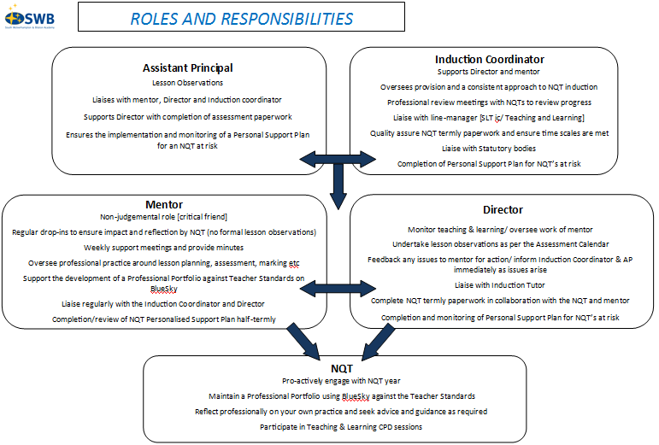

NQT Induction Programme
Your induction programme will be personalised for you by your mentor and Director in the first term and involve a combination of monitoring, support and assessment. It is a programme designed to enable you to satisfactorily meet the Teachers’ Standards by the end of the induction period.

Your mentor will expect that you will take increasing responsibility for your own professional development, as your induction progresses. Through regular meetings you will be expected to critically reflect on your practice and pupils’ learning. You will increasingly be expected to articulate, and realise for yourself the steps which need to be taken to progress and develop.

In order to plan your induction programme, you and your mentor will need to devote time to each of the following:

- Identifying your development needs
- Use of your induction release time – for example, observation of other teachers, shadowing more experienced colleagues, reading/researching T&L strategies etc.
- Attendance at CPD sessions, personalised to you
- Observations of your teaching by your Director/AP; and
- The requirements of the Teachers’ Standards in terms of the knowledge, understanding and skills that need to be demonstrated

Week | Mentor meeting agenda | Possible use of release time
Week 1 | Induction to key school and department procedures.  Review of self-evaluation since training year (CEDP); agree objectives and write personalised action plan (PAP). | Focus: Teaching and Learning  Peer observations of teaching in and out of department.  Read T&L policy and discuss with mentor.
Week 2 | Review lesson plans and reflection of lessons from first week.  Agree diary dates for first observation of teaching by Director/SLT and times for mentor drop-ins. | Focus: Teaching and Learning  Collaborative planning with mentor using a four part lesson.
By the end of the 4th week | Observation of teaching (by Director/SLT) and feedback given.  Meet with NQT to agree initial objectives and complete/amend PAP.  Ensure familiarity with uploading progress and evidence towards the Teacher Standards onto BlueSky. | Focus: Assessment  Discuss department approach to effective feedback in books.  Use of data to inform planning and seating plans.
Week 5 | Review lesson plans and reflection of lessons from previous week.  Review actions against objectives from PAP.  Discuss use of release time and any CPD attended from previous week and its impact.  Review progress towards the Standards.  Any other issues from the NQT. | Focus: Behaviour Management.  Read Behaviour Policy.  Reflect on own practice.  Observe others teaching with a focus on positive behaviour management strategies.

Week | Mentor meeting agenda | Possible use of release time
Week 6 | Review lesson plans and reflection of lessons from previous week.  Review actions against objectives from PAP.  Discuss use of release time and any CPD attended from previous week and its impact.  Review progress towards the Standards.  Any other issues from the NQT. | Focus: Inclusion  Research and trial differentiation strategies to support weaker students.  Discuss impact with mentor.
Week 7 | Professional Review meeting (mentor)  Review of progress towards meeting the Teachers’ Standards focussing on  − the support provided and whether it is it meeting your needs;  − the extent to which you are making progress towards the Teachers’ Standards and your targets;  − amending, revising and setting new targets in the light of experience;  − agreeing how evidence for future targets will be collected – lesson observations, work scrutiny, etc. | Focus: Induction programme  Progress review
Weeks 8 - 13 | Review lesson plans and reflection of lessons from previous week.  Review actions against objectives from PAP.  Discuss use of release time and any CPD attended from previous week and its impact.  Review progress towards the Standards.  Any other issues from the NQT. | Focus: Teaching and Learning  Focus should be on targets from Professional Review meeting.  Examples could include:  - Peer observations of teaching in and out of department.  - Collaborative planning with mentor.  - Coaching or support from specialist colleagues (e.g. SENCO)  - Developing strategies for teaching specific groups (e.g. SEN/HPA/EAL)  - Personal enquiry and reading.  - Joint/moderation of marking and feedback
Week 14 | Formal Assessment meeting (Director and mentor)  Review of progress towards meeting the Teachers’ Standards focussing on  − the support provided and whether it is it meeting your needs;  − the extent to which you are making progress towards the Teachers’ Standards and your targets;  − amending, revising and setting new targets in the light of experience;  − agreeing how evidence for future targets will be collected – lesson observations, work scrutiny, etc. | Focus: Induction programme  Progress review

Initial Meeting |  | Autumn 1 | Autumn 2 | Spring 1 |  | Spring 2 | Summer 1 |  | Summer 2
Meeting to discuss targets from training year (CEDP) and the department priorities | Ongoing weekly mentor meetings, including regular drop-ins to ensure impact and reflection
 |  | Lesson observation followed by professional review meeting* | Lesson observation followed by  formal assessment meeting** | Lesson observation followed by professional review meeting | Lesson observation followed by formal review meeting |  | Lesson observation followed by professional review meeting | Lesson observation followed by formal review meeting
Mentor and Director |  | Mentor | Mentor and Director | Mentor | Mentor and Director |  | Mentor | Mentor and Director
First observation should take place within the first 4 weeks of NQT teaching |  |  | Assessment paperwork 1 due December |  | Assessment paperwork 2 due March |  |  | Assessment paperwork 3 due July  Discuss developmental opportunities for year 2 of teaching and CPD

Review Meetings & Assessment

*NQTs should be kept up-to-date on their progress throughout the year – there should be no surprises.
**Any concerns regarding a NQTs progress should be reported to the Director, AP and JLO immediately. Action to improve must not be delayed until a formal assessment meeting has taken place.

