

JOB DESCRIPTION

Trust Maintenance Officer
Band 4
37 hours per week

Current Post holder:  Evaluation Date: | Vacant  March 2023

Job Purpose
The Trust Maintenance Officer (TMO) will support the Trust Estates function in ensuring the continuity of site services across the Trust estate ensuring the safe and efficient use of facilities at all times by students, staff and visitors. The post-holder may be deployed to any of the trusts sites and will be required to travel to and from each academy using their own transport claiming reasonable expenses.

Under the direction of the Trust Maintenance Manager (TMM), the Maintenance Officer will install, remove and maintain the Trust’s assets including buildings, structures, roofs, surfaces and finishes, plant and machinery, floors, furnishings, fixtures and fittings and other equipment and carry out hard and soft landscaping works to ensure that buildings and facilities are accessible, are maintained in a safe and effective manner and are suitable for their intended purpose. Providing these services in an effective and efficient manner is key to supporting the Trust and supporting and empower Head teachers to deliver the best possible education across the Trust by ensuring the reliability, accessibility and safety of the Trusts buildings, facilities and assets.

Under the direction of the Trust Maintenance Manager, the Maintenance Officer will be required to assist academy site teams and to cover site manager / site technician absences on a first-day basis. When covering absences the Maintenance Officer will be required to assume the responsibilities of the RPO (Site manager) and / or site technician which may include key-holder and security duties, ensuring that Trust and school standards are maintained, supervising a housekeeping team, ordering / replenishing stock and consumables and attending to the requirements of hirers of school premises.

Line Management
Reports to: Director of Estates and Facilities through the Trust Maintenance Manager
Responsible for: None

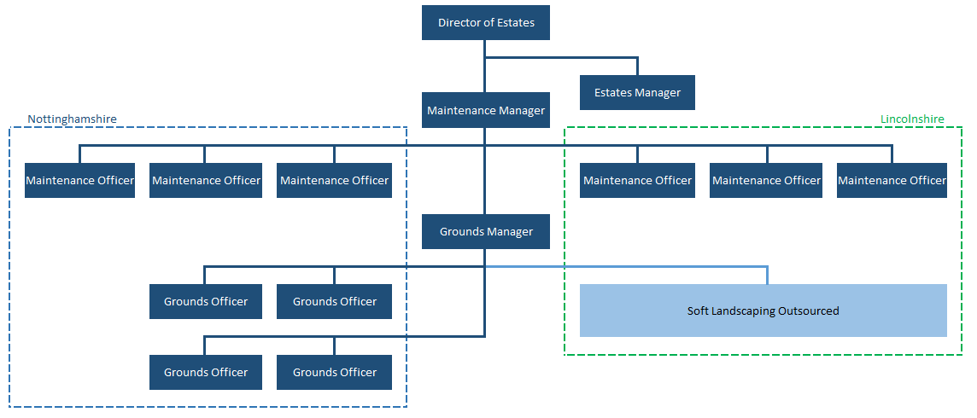

Specific Responsibilities – People and Resource Management
- Work proactively with the Director of Estates and Facilities and Head Teachers (reporting through the Trust Maintenance Manager) to ensure 100% business and operational continuity at all times.
- Assume the full responsibilities of an RPO (Site manager) and to provide effective supervision of the site technicians and assistant Site Managers when required.
- Maintain appropriate procurement records, timesheets and other work records to ensure that accurate and timely information is passed to the Finance and HR teams for processing.
- Carry out planned and preventative maintenance and build projects under the direction of the Trust Maintenance Manager (TMM).
- Contribute towards the development of site maintenance plans and work with the Trust Director of Estates and facilities and the Trust Maintenance Manager (TMM) to ensure their implementation.
- Liaise with external contractors ensuring safe working practises.
- Assist with Estates and Facilities-related administration to ensure statutory compliance e.g. maintenance logs utilising both paper and electronic records.
- Procuring supplies and materials only from approved suppliers to enable the proper execution of allocated tasks.
- Cover for absent site colleagues as and when required to include the full range of site management duties.
- Support colleagues during times of heavy workload.

Health and Safety, Risk and Disaster Management
- Work at all times in compliance with the Trust Health and Safety Policy and the local Health and Safety Policies in force at any site.
- Work proactively with the Trust Director of Estates and facilities, the Trust Maintenance Manager (TMM), Head Teachers and RPOs (Site Managers) to ensure that the Trust’s buildings, facilities and assets remain compliant at all times and submit reports as and when required to verify compliance.
- Carry out Portable Appliance Testing in accordance with Trust policies and procedures.
- Support the review and implementation of health and safety policies and procedures within the Trust.
- Ensure the display of hazard warning notices throughout the course of his/ her work.
- Ensure the safe and appropriate use of chemicals and hazardous substances in accordance with COSHH assessments.
- Ensure that inspections of work equipment are up to date in accordance with Trust procedures, legislation and approved codes of practise and not to use any equipment that the post holder has not received suitable training to operate or which he/she believes may be faulty or unsuitable for the task.
- Maintain premises-related health and safety documents and records and submit reports to the Trust Director of Estates and Facilities at specified intervals.
- Ensure that the Trust’s rules and procedures regarding the management of contractors are adhered to at all times with particular emphasis on safeguarding, risk assessments, method statements and contractor induction procedures.
- To adhere strictly to Local Asbestos Management Plans (LAMP), ensuring that procedures are followed at all times and reporting issues and non-compliances immediately.
- Take reasonable care for the health and safety of him/herself and of any other person who may be affected by his/her activities and, where appropriate, safeguard the health and safety of all persons under his/her control and guidance in accordance with Health and Safety legislation.

Site and Buildings
- Undertake the maintenance, refurbishment and replacement of the Trust’s assets.
- Work proactively with the Trust Director of Estates and the Trust Maintenance Manager (TMM) in the preparation of maintenance schedules and the efficient operation of all buildings, plant, systems and assets including the installations and plant for lighting, heating, hot water, cooking, ventilation, water softening, energy conservation etc.
- Undertake a range of duties subject to the proviso that if a qualified tradesman is required to carry out the task, then an appropriate contractor will be employed.
- Be available to attend in cases of emergency outside the working week, e.g. intruders, fire and flood, in line with the school policy and procedures for emergency cover.
- Assist representatives of the Trust, the Diocese of Nottingham and enforcement agencies during property inspections/visits.
- Attend the premises during the winter months during periods of bad weather to clear paths and other areas to ensure the academy can open as planned wherever practically possible. Occasional overtime may be required for this duty for which an appropriate payment will be made.

Skills and Abilities
The post holder will be expected to demonstrate the following skills and abilities at all times during the discharge of their duties:

- Skilled in a primary building or building services discipline; semi-skilled in a broad range of building or building services disciplines.
- Ability to supervise and motivate team apprentices taking strengths and skills into account.
- Ability to address a broad range of planned and reactive tasks delivering solutions to a professional standard in compliance with Trust procedures and other relevant standards.
- Proactive, supportive, approachable, team player.
- Ability to solve unexpected or new problems in a methodical, efficient manner.
- Carry out tasks to a professional standard with health, safety and safeguarding at the fore.
- Willingness to develop, to learn new skills and expand current skill set.
- Ability to work collaboratively and to pass on knowledge, best working practice, skills and techniques to others.
- Demonstrate good general interpersonal, communication and de-escalation skills.
- Deal with conflicting demands and work flexibly.

Whole Trust Responsibilities
- Be a positive influence on the climate and culture of the Trust and be a positive example at all times.
- Support the Catholic ethos of the Trust.
- Be aware of and comply with policies and procedures relating to child protection, health, safety and security, confidentiality and data protection, copyright etc. reporting all concerns to his/her line manager.
- Be aware of and support difference and ensure equal opportunities for all.
- Contribute to the overall aims of the Trust.
- Appreciate and support the role of other colleagues.
- Attend and participate in relevant meetings as required.
- Participate in training and other learning activities and performance development as required.
- Recognise own strengths and areas of expertise and use these to advise and support others.

General

The Trust Maintenance Manager will work the hours to be agreed with the Trust Maintenance Manager (TMM). This will generally be a 37-hour five-day week; however, the post holder will be flexible and work the days required by the Trust. Whilst shifts will be generally between 6am and 6pm there may be a need to work outside of these hours, including evening and weekend work when required, to meet the changing needs of the business and to address short-term or medium-term issues and deficiencies. When more than 37 hours are worked in one week, additional will be taken as time off in lieu of hours worked as agreed in advance with the Trust Maintenance Manager (TMM).

This job description contains the main accountabilities relating to the post and does not describe in detail all the tasks required to carry them out. All staff are expected to be flexible to ensure the most effective organisation and delivery of services.
The duties and responsibilities of the post will evolve with the natural development of the Trust and associated sites, buildings, facilities, assets and services. Such changes are, therefore, a normal part of the post and the post holder must be prepared to undertake any other duties commensurate with the general level of responsibility of the post which may be determined from time to time subject to the proviso that any permanent, substantial, changes shall be incorporated into the job description and evaluated as such.

PERSON SPECIFICATION

Post: Trust Maintenance Officer Nov 2019

Requirements | Post holder requirements  Essential (E)  Desirable (D) | How this element will be verified  Application (A)  Interview(I)  Practical Tasks (T)
Education/experience
Experience in an estates and facilities management or similar building services related role | E | A
Experience of working in an educational environment | D | A
Willingness to develop, acquire knowledge and advance. | E | A / I
Knowledge of Health & Safety regulations relating to building projects and Estates functions. | E | A / I/ T
IOSHH qualification | D | A
Ability to contribute to developing and reviewing planned maintenance schedules | E | I
Previous experience of maintaining buildings | E | A
Previous experience of managing contractors | E | A
Leadership and skills
Initiative and problem-solving skills | E | A / I
Motivate, enthuse and inspire colleagues | E | I
Supervise junior team members and hold to account | E | I
Familiarity with Microsoft Office applications and the ability to acquire and update skills as software packages develop | E | A / T
Work proactively as a team member liaising with colleagues | E | I
Skilled to a professional level in joinery | D | A / T
Skilled in a broad range of building or building services disciplines | E | A / T
Ability to carry out maintenance tasks including planned and reactive maintenance, installations, refurbishment of buildings, plant, machinery, fixtures, fittings and other assets | E | A / T
Attributes
A flexible attitude towards the role, duties and hours | E | I
Committed to the aims of the Our Lady of Lourdes Trust | E | I
Understanding of the distinctive nature and Catholic ethos of the trust | E | I
Clear view of what high standards and performance looks like | E | I
Commitment to Safeguarding principles | E | I

