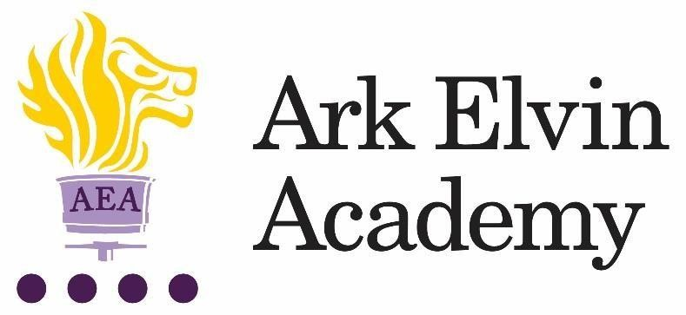

Job Description: Operations Administrator

Reports to: Office Manager
Start date: Monday 30th October 2023
Salary: Grade 5, Point 5-13 £25,762 - £29,419
Contract: Full Time, 26 days annual leave
Hours: 36 hours per week

The Role
The Operations Administrator will provide a comprehensive administrative support to the school including providing support to the Senior Leadership Team, staff, governors, students and parents. You will collaborate with the other members of the front office team to uphold the vision and ethos of the school at all times and provide excellent customer service to a range of stakeholders.

Key Responsibilities
- Establish and maintain efficient administrative systems and processes to support the effective running of the school
- Provide general clerical and administrative support for the school
- Maintain manual and computerised records and management information systems, producing accurate lists or data as required by colleagues or compliance bodies
- Liaise with colleagues and external contacts at all levels of seniority with confidence, tact and professionalism
- Assist with student welfare and liase with parents where necessary
- Maintain stationery and photocopier paper supplies, manage stock cupboard and distribute as required
- Arrange school trips efficiently, taking responsibility for bookings and coordination of all school trip requirements
- Provide cover for the reception desk as necessary

Other
- Actively promote the safety and welfare of our children and young people
- Ensure compliance with Arks data protection rules and procedures
- Liaise with colleagues and external contacts at all levels of seniority with confidence, tact and diplomacy
- Work with Ark Central and other academies in the Ark network, to establish good practice throughout the network, offering support where required

- This job description is not an exhaustive list and you will be expected to carry out any other reasonable tasks as directed by your line manager.
Person Specification: Operations Administrator
Qualifications
- GCSE English and Mathematics Grade C or above
Knowledge, Skills and Experience
- Experience of running effective administrative systems, preferably in a school environment
- Experience of data entry into databases and other IT systems
- Excellent communication, writing and editing skills
- Excellent organization and time-management skills
- High level of proficiency with Microsoft Office
- Able to build relationships with a range of stakeholders and anticipate others’ needs
- Able to manage several projects at once, prioritising accordingly to meet all deadlines
- Able to take ownership of tasks and work with minimal supervision

Behaviours
- Genuine passion for and a belief in the potential of every pupil
- A robust awareness of keeping children safe, noticing safeguarding and welfare concerns, and you understand how and when to take appropriate action
- Belief that every student should have access to an excellent education regardless of background
- Professional outlook, detailed orientated and able to multi task and meet deadlines
- A team player that can work collaboratively as well as using own initiative
- Calm and professional under pressure
- Understanding of the importance of confidentiality and discretion
- Flexible attitude towards work and demonstrates sound judgement

Other
- Right to work in the UK
- Commitment to equality of opportunity and the safeguarding and welfare of all students
- Willingness to undertake training
- This post is subject to an enhanced DBS check

This post is covered by Part 7 of the Immigration Act (2016) and therefore the ability to speak fluent English is an essential requirement for the role.

Ark is committed to safeguarding and promoting the welfare of children and young people in our academies. In order to meet this responsibility, we follow a rigorous selection process. This process is outlined here, but can be provided in more detail if requested. All successful candidates will be subject to an enhanced Disclosure and Barring Service check.

