

HR Manager
Baskerville School
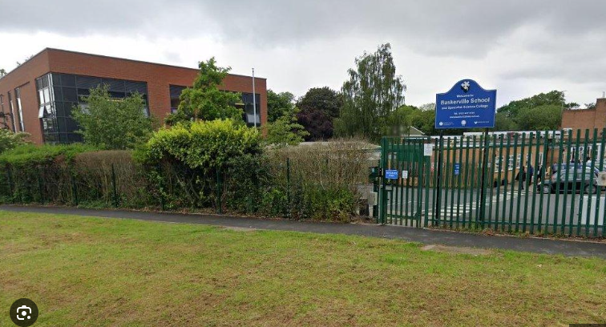


Post Title and Grade | HR Manager  GRADE: Grade 4 - FTE - £33,366 - £40,476 –per annum – Pro-Rata Term Time Only plus two weeks
Location: | Baskerville School, Fellows Lane, Harborne, Birmingham B17 9TS  Telephone Number 0121 427 3191
Reporting to: | School Business Manager / Head teacher
Direct reports: | HR Assistant / Cover Supervisor
Hours of work: | 36.5 hours per week  08.00am – 16:00pm Mon – Thurs - 08:00am – 15:00 Fridays
Start date | ASAP
About us
Baskerville is a secondary school for students with Autism. Our students have a very wide range of abilities and needs, from those with severe learning difficulties through to those successfully completing GCSE courses. The school is situated on a beautiful site, with lots of outdoor learning opportunities.

We are looking for enthusiastic and dynamic colleagues to join our popular and ambitious school. We are particularly looking for applicants who are keen to work with students with Autism/SLD and complex Autism.

What we can offer:

- Working as part of an experienced, supportive, and motivated team
- Purposeful, exciting CPD opportunities
- Collaboration and opportunities with our 6 fellow Co-operative Trust Schools
- Forest School provision
- Aspirational Senior and Middle Leadership Teams
- Peace Garden
- Specialist rooms
- Strong Governing Body
- A culture of staff well-being

Purpose of the role
- To provide an efficient and professional HR Support Service to the Headteacher and School.
- Supporting the Management Team in relation personal development

Responsibilities and duties
- Management of staff including cover for absences and training course attendance as necessary
- Liaise with agencies and support staff to ensure suitable cover arrangements are in place.
- Work with the SMT to develop a workforce plan and monitor turnover
- Annual review of Job Descriptions and Person Specifications to ensure roles deliver the service needed for schools development
- Undertake all recruitment campaigns as required including designing adverts, Job Descriptions, and Person Specifications
- Preparation and presentation of all papers in relation to grievances and discipline cases
- Ensure we have policies in place for staff
- Preparation of all documents in relation to employees employment for school and LA
- Manage DBS checks within legal guidelines
- Manage maternity leave and risk assessment
- Communicate with the Unions with regard to employee issues
- Resolve any pay queries
- Deal with OH Requests
- Monitoring of annual reviews of performance for all staff
- Development of training plan for all employees and delivery of that plan
- Work with the Assistant Headteacher to organise training onsite
- Undertake staff inductions
- Monitor probationary periods for all new staff and make recommendations for future employment
- Identify potential teachers for the future and discuss training with the Deputy and Head
- Provide manpower reports in relation to recruitment/turnover, absences and cover costs
- Work as part of the SMT contributing to meetings
- Provide SMT with statistical data as requested
- Support the Managers in dealing with staff
- Support the Head as required

General responsibilities and duties
General Duties
- To perform other such duties as the Head Teacher may from time to time determine.
- This allocation of duties is subject to regular review.
- Individuals have a responsibility for promoting and safeguarding the welfare of children and young people he/she is responsible for or comes into contact with.
- To ensure all tasks are carried out with due regard to Health and Safety
- To undertake appropriate professional development
- To adhere to the ethos of the school
- To promote the agreed vision and aims of the school
- To set an example of personal integrity and professionalism
- Attendance at appropriate staff meetings and parents evenings
- Any other duties as commensurate within the grade in order to ensure the smooth running of the school

If you feel you have the skills to lead and inspire both staff and students, we would like to hear from you, please contact the School’s HR Manager, Yasir Idris at the school on 0121 427 3191 or by email at y.idris@baskvill.bham.sch.uk
Informal enquires are most welcome.

Baskerville School is committed to safeguarding and promoting the welfare of children. Successful candidates will be required to undertake an enhanced Disclosure and Barring Service check.

Baskerville School’s Safer Recruitment and the Recruitment of Ex Offenders Policy can be found on the links contained herein or on the School’s website.

This job description reflects the current requirements of the post. As duties and responsibilities change and develop due to changes in organisational and other circumstances, so the actual duties and responsibilities will vary from the particulars of this job description. Job descriptions will be updated or amended from time to time to reflect such changes.

