

JOB DESCRIPTION

JOB TITLE: Software Developer - Level 4 Apprenticeship

(Further Education Web and Learning Technology Support)

CONTRACT: Up to 2 years

REPORTS TO: Web Developer

AREA: Learning Technologies

GRADE/SALARY: Support Staff Scale 4 points 20 to 23, £23,620 to £25,734 per annum

POST NO: SS500

CLOSING DATE: Tuesday 12th March 2024

DBS: Enhanced DBS check with children’s barred list check

PURPOSE:

To support and enhance the College's ILT (Integrated Learning Technology) solutions, working closely with the Web Developer and Learning Technology teams to deliver robust and innovative software solutions tailored to the unique needs of a Further Education environment.

PRINCIPAL DUTIES:

- Support Web Integration: To Collaborate with the team to develop technologies that seamlessly integrate course information into web environments and support the main developer in strategic initiatives.

- Technical and Staff Development: To aid in the provision of technical support and help drive staff development initiatives related to custom developments.

- VLE Management: To assist in the management, maintenance, and control of the VLE software and its associated software, ensuring they're optimally hosted on College servers.

- VLE Design & Continuity: To support in ensuring the design, functionality, usability, and accessibility of the VLE and other web applications, always adhering to development standards.

- Technical Development Recommendations: To engage in discussions and recommend technical enhancements to improve the VLE and associated web applications.

- Development Methodology: To ensure adherence to reliable software development practices while creating and refining solutions.

- Documentation: To collaborate in creating and maintaining robust technical documentation, ensuring clarity and comprehension for all stakeholders.

- Audio-Video Integration: To contribute to initiatives that expand the use of audio and video captures within ILT projects.

- R&D Activities: To engage in research and development tasks supporting the College's strategy and as specified by the Learning Technologies Manager.

- End User Support: To provide dedicated software support for key users, ensuring smooth and continuous operations.

- Availability: To remain available, sometimes outside regular working hours, to address any issues with the VLE and associated web applications.

- Training & Compliance: To undertake necessary training, particularly in Health and Safety and Safeguarding, and ensure adherence to the Data Protection regulations as relevant to the role.

- To engage in other tasks consistent with the role's function and grading, ensuring a comprehensive approach to all duties.

- To adhere to policies, procedures and values of Solihull College & University Centre.

- To undertake all mandatory training in a timely manner as required e.g. Safeguarding, Prevent.

- To actively promote equality, diversity & inclusion and to champion anti-racist practice.

- To support the college to become a Sustainable Net Zero organisation by 2030 and support the delivery of its Sustainability Strategy.

- To undertake necessary Health and Safety responsibilities, duties and training as required by this post.

- To undertake any necessary Data Protection responsibilities, duties and training as required by the post.

- Such other duties as required which are broadly consistent with the general functions and grading of this position.

EQUAL OPPORTUNITIES:

Solihull College & University Centre is committed to a comprehensive policy of Equal Opportunities. All employees are required to abide by this policy and ensure its compliance throughout the College.

SAFEGUARDING:

Solihull College & University Centre is committed to ensuring a safe environment for all students and expects all staff to engage fully with this commitment.

CORE VALUES:
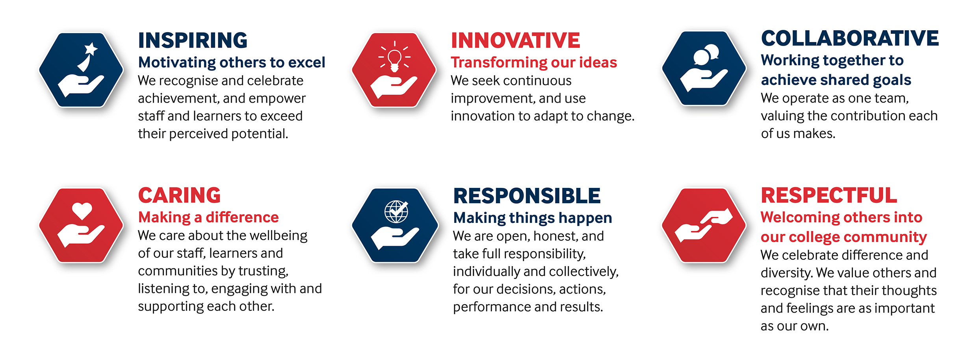

SOLIHULL COLLEGE & UNIVERSITY CENTRE
PERSON SPECIFICATION

JOB TITLE: Software Developer Level 4 Apprenticeship

(Further Education Web and Learning Technology Support)

SALARY: Support Staff Scale 4 points 20 to 23, £23,620 to £25,734 per
annum

POST NO: SS500

SPECIFICATION | ESSENTIAL | DESIRABLE
EDUCATION/  TRAINING | Level 2 English and maths qualifications grade 9 to 4 (formerly grade A* to C) or equivalent  Good general education | Level 3 qualification in an IT related subject
RELEVANT EXPERIENCE | Some knowledge and experience of programming using PHP, MySQL, HTML, CSS, and JavaScript  Some experience of supporting and developing mobile-friendly web-based solutions | Knowledge of SQL Server  Knowledge of TALL stack  Experience of IIS web service management  Experience of version control and Agile development
SKILLS / APTITUDES | Demonstrate a customer focused approach  Ability to develop own personal skills as well as those of others without direct supervision  Ability to work on own or as part of a team  Work calmly under pressure  Analytical and problem-solving skills  Ability to communicate clearly with others of similar and less technical experience  An awareness of sustainability and climate change and how it applies to Further Education
OTHER  REQUIREMENTS | A commitment to the Safeguarding of Young People and Vulnerable Adults and an awareness of the Government ‘Prevent’ strategy  Strong commitment to Equal Opportunities  Commitment to the College’s Values

