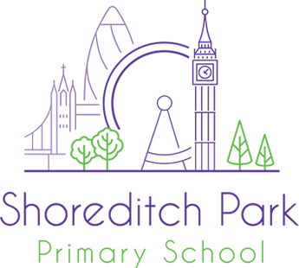

EYFS Teacher, Hackney

Employer | Shoreditch Park Primary School
Location | Hackney
Salary | MPS/UPS (TLRs may be available for a high performing candidate)
Contract type | Full Time
Contract term | Permanent
Job dates
Posted | 22nd March 2024
Closing date
Job starts | September 2024

Welcome to Shoreditch Park Primary School. We are a forward thinking, inclusive two form entry primary school set in the heart of Hackney. We are looking for an ambitious class teacher who has a genuine commitment to inclusive and innovative education. We particularly welcome applications from people of Black, Asian and other minority ethnic descent.
Shoreditch Park is a high performing school in Hackney. You will be joining us on an exciting part of our journey to excellence. We have achieved many successes such as the Rights Respecting School awarded by UNICEF and we are a Flagship School for Excellence for Inclusion (IQM). At the heart of our achievement is the core belief that every child can flourish in a calm, structured and stimulating environment. Pupil behaviour is exemplary and outcomes are high. Teachers are free to teach and experience real success in the classroom.
At Shoreditch Park we have wonderful children and dedicated staff that go that extra mile every day. This is underpinned by our whole school ASPIRE ethos.
We are looking for a class teacher who:
· Demonstrates a clear understanding of what constitutes outstanding teaching and learning
· Adapts teaching based on research driven development courses.
· Shows a commitment to ensuring equality of opportunity for all learners.
· Is reflective, open to feedback and driven to be outstanding
· Is a dedicated team player and works well as part of a high functioning team.
· Demonstrates optimism about children and expect the highest possible standards.
We offer:
· A passionate, driven and successful school where you will feel well supported in your role.
· A robust induction process with a dedicated mentor.
· School systems that are committed to ensuring that every child succeeds.
· Individualised professional development and career enhancement opportunities.
· A comprehensive Wellbeing Policy which includes benefits such as free membership to Employee Assistance Program and discounted gym rates for local gyms.
· The support of an experienced Senior Leadership Team.
Please visit our website, www.shoreditchpark.hackney.sch.uk, for further information about Shoreditch Park Primary School and to download an application pack.
Visits to the school are strongly recommended. Tours will take place with the deputy headteacher on:
Monday 4th 11am
Monday 11th 4pm
Monday 18th 11am

Contact David at vacancies@shoreditchpark.hackney.sch.uk to arrange a visit to the school.
Closing date for applications: March 21st
Shortlisting: March 22nd
Interviews: Week beginning March 25th. Please note we reserve the right to interview exceptional candidates prior to this date as applications are sent.
Shoreditch Park Primary School is committed to safeguarding all children. Successful candidates will require a DBS clearance and suitable references before commencing employment. We are committed to diversity, equality and inclusion and welcome applications from all section of the community, regardless of gender, race, religion, disability, sexual orientation or age. We actively welcome applicants from ethnic minority backgrounds and under represented groups in primary settings

