Application Information

Contents
Contents 2
Message from the Principal 3
Our vision, mission and values 4
The curriculum 5
The UTC calendar 6
Proposed staff structure 7
Staff – principles and expectations 8
About the sponsors 10
How to apply 10

Message from the Principal

Thank you for your interest in working with us at UTC South Durham. This is an exciting opportunity to join us in the creation of a very different type of education for students who have a strong interest in STEM subjects.

The chance to create an innovative education establishment is very rare and this is a wonderful opportunity to be involved from the start. As a key member of a small team you will shape how we work and our students’ educational experience.

Our education system tends to separate students into those who are academic and those who are vocational. I see no reason why talented young people, both boys and girls, who are interested in STEM subjects, cannot gain academic qualifications, build technical expertise and develop workplace skills through real experience in businesses.

A flexible approach to the role will be needed as we create a culture amongst staff and students and establish systems. Ensuring that our students are safe and developing as young citizens is also vital.
We’ll be the first university technical college in the North East and will play a significant role in the provision of education and skills for the engineering and manufacturing industry in the area. Our business sponsors, Gestamp Tallent and Hitachi Rail Europe, are two of the biggest and most influential engineering employers in the North East. The University of Sunderland has a proud record of combining educational excellence with a deep commitment to the well-being of the local area.

The UTC will open in September 2016 in a new state-of-the-art building on Aycliffe Business Park. The sponsors are fully committed to this project and are demonstrating that in their level of support, but we do not underestimate the importance of appointing staff whose experience, energy, ambition and values match our own.

We have tried to give you a clear picture of our aspirations for the UTC in this pack and additional information can be found on our website www.utcsouthdurham.org.

Please don’t hesitate to contact me if you have further questions.

UTC South Durham offers a very different approach to education. We require staff with an attitude towards our students as young adults. If you are excited by this prospect then we look forward to receiving an application from you.

Yours sincerely

Tom Dower
Principal
UTC South Durham

Our vision, mission and values

Excellence
We strive for excellence in all that we do with every activity focused on providing an outstanding academic and practical technical education for students.

Innovation
We are inspired by and enthusiastic about science, technology, engineering and maths. We encourage our students and staff to experiment, invent and pioneer new technology, products, processes and learning methods.

Collaboration
We encourage partnerships amongst students and with employers, education providers and community groups, enabling students to develop workplace skills, form close links with businesses and prepare for their future careers.
Accessibility
We welcome to our community people from different backgrounds, gender, abilities and locations. All students, irrespective of their starting point, will thrive and progress to meaningful education, employment or training.

Integrity
We expect high standards of our students and staff and we show mutual respect to others reflecting the UTC’s ethos as a grown-up place to learn.

The curriculum

The curriculum at UTC South Durham is designed to offer a different type of education for young people in order to prepare them effectively for the world of work. We’ll provide an educational experience which is both academic and vocational. As a school, we are bound by the statutory KS4 curriculum, have an important duty to deliver a wider moral and social education and will be inspected by Ofsted using the normal framework. The key elements are:

- Academic subjects – students will study GCSEs, A-levels or nationally recognised equivalent qualifications.
- Technical education – all students will study engineering and have a choice of other technical subjects.
- Workplace learning – all students will undertake visits and placements in companies as well as projects within the UTC.

KS4 curriculum

30 core periods plus 3 x session 7

English | Maths | Engineering | Science | Option 1 | Option 2 | Ind. Study | PE | Session 7
5 | 4 | 6 | 6 | 2 | 2 | 3 | 2 | 3
Language  Literature | Maths | Cambridge National  Double award  Manufacturing  Design  or  Systems & Control | Physics  Chemistry  Biology | Geography  Computer Science  Product Design  Business |  | Independent study  Mentoring | Sport &  Fitness | Challenge clubs  Projects  Briefings  SMSC  PSHE  Careers/IAG
 |  |  | Combined Science
1 x project | 1 x project | 2 x project | 2 x project

Post-16 curriculum

30 core periods plus 3 x session 7

Maths | Engineering | One or two from |  | Enhancement | Ind. Study | Session 7
5 | 6 | 5 | 5 | 2 |  | 4
A-level Maths  Core Maths | Engineering  Foundation  Tech Level | Physics  Chemistry  Computer Science  Product Design  (Biology)  Engineering (double, Tech Level)  Applied Science  IT  Business |  | EPQ (Extended Project Qualification)  or  ECDL Advanced | Independent study  Projects | Challenge clubs  Projects  Careers/IAG  Mentoring

Subjects in italics are not A-levels but are equivalent qualifications

1 year pre-apprenticeship programme - level 2 (approximately 15% of cohort)

English | Maths | Engineering  employability | Engineering | Option 1 | Option 2 | Ind. Study | Period 7
4 | 4 | 6 | 8 | 3 | 3 | 2 | 4
GCSE  re-sits or  extension | GCSE  re-sits or  extension | Selection of  short practical  accredited  programmes | Level 2  Engineering  (x2) | D&T  (Geography) | Business  (Comp Sci.) | Independent  study  Literacy  Numeracy  Placements | Challenge clubs  Projects  Sports leadership  Careers/IAG  Mentoring

Support and SEND

Our students will be supported by robust pastoral and safeguarding systems, with mentoring and SEND support for individuals as appropriate. We’re a small school and will know our students well.

The UTC calendar

The UTC year

The UTC will operate the same term dates as Durham LA schools, minimising disruption for families with siblings at other schools and staff with children.

The UTC day will be longer, reflecting a grown-up working environment and allowing time for all students to undertake projects, visits, enrichment activities and have independent study time. No formal homework will be set, though we will expect students to carry on thinking, researching and designing outside school on their stimulating projects and undertake exam revision both inside and outside school.

Students will be encouraged to undertake activity such as relevant work experience during holiday periods in order to enhance their experience and skills in areas of interest.

The UTC day

Students will clock in and out, simulating the world of work and for registering/
safeguarding. There will be no bells as students and staff will take responsibility for their own timekeeping.

Period 1 | 8.30
Period 1 | 8.45
Period 2 | 9.45
Break | 10.45-11.00
Period 3 | 11.00
Period 4 | 12.00
Lunch | 1.00-1.30
Period 5 | 1.30
Period 6 | 2.30
Break | 3.15-3.30
Period 7 | 3.30-4.30

Students will leave at 3:15pm on Wednesdays when staff CPD will take place until 5:30pm. We will all finish at 3.15 on Fridays.

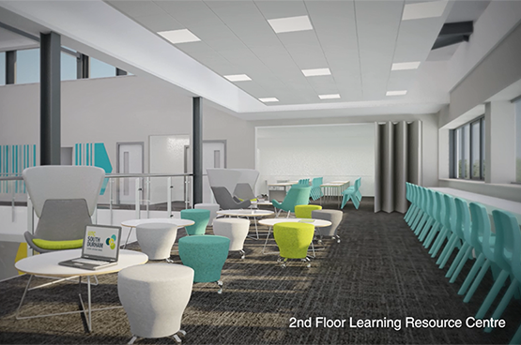

Proposed staff structure

Faculty Director
Core
Faculty Director
Engineering
Faculty Director
Science
Business
Manager
Deputy
Principal
Tom Dower
Principal
English
teaching
Maths
teaching
PSHE
teaching
Learning support
staff, HLTA, TA
Humanities
teaching
Business
teaching
Computer
Science teaching
Science
teaching
PE
teaching
EPQ/PSHE
teaching

Science
Technician
Engineering
teaching
D&T
teaching
Electronics
teaching
Engineering
Technicians
Workplace Learning
Manager
Marketing/
Recruitment
Catering/Cleaning
Cover
Supervision
Admin/
reception
Data Officer
Facilities Mgt. and SLAs
Office and MIS Manager

Notes
- The boxes do not define number of people – the structure will be scaled (and may be changed) depending on student and staff recruitment. In year 1 in particular some of these roles will be part-time or combined.

Staff – principles and expectations

All staff of the UTC will be expected to:

- Model only the highest of standards in relation to work ethic, behaviour, dress code and conduct.
- Demonstrate personal and professional integrity, promoting the vision and values of the UTC.
- Enable a climate that engenders personal growth and success for all staff and students.
- Commit to the provision of a curriculum which enables real workplace experiences and the opportunity to engage in employer-led and industry-sponsored projects.
- Demonstrate and develop in students the workplace skills of: attitude, self-management, communication, teamwork and a professional approach.
- Positively promote the belief that all young people can achieve beyond national expectations given their starting points and that all, without exception, will progress to university, employment and/or training.
- Commit unconditionally to ensuring that all groups of students, irrespective of their starting points will thrive, eradicating any notion of ‘gaps’ in performance or ‘labelling’ between groups.

Terms and conditions

For clarity of understanding and expectations, the main UTC staff policies and terms and conditions will be based on nationally-recognised policies and terms and conditions that have been adapted to make them relevant to the operation of the UTC, with the differences made explicit. The key differences are:

- We are creating a different learning climate for students and this means a different way of working for staff.
- Main-scale teachers will prepare and deliver a ‘standard’ teaching load of 23 subject lessons a week, plus enrichment and support time. This will be adjusted appropriately for those with leadership responsibilities, NQTs and part-time staff.
- Staff will be required to be on site for the full UTC day unless they have a part-time contract. They are longer days than most schools. This means that more planning, preparation and assessment time is built into the working day allowing staff to undertake more of their work on site.
- We will follow Durham LA’s term dates. Five training days will be built into the school year (as with most schools) and most staff will be expected to work the equivalent of two additional days a year. This will be taken in the form of events for student recruitment or education. Flexibility is assumed in this approach to allow for individual needs and appropriate notice will be given of the events.
- Most staff will be expected to attend businesses on visits with students as appropriate and to act as mentors for students.
- As a small team running a new school, many processes will not be fully established prior to opening of the UTC and as such flexibility will be needed in every role.

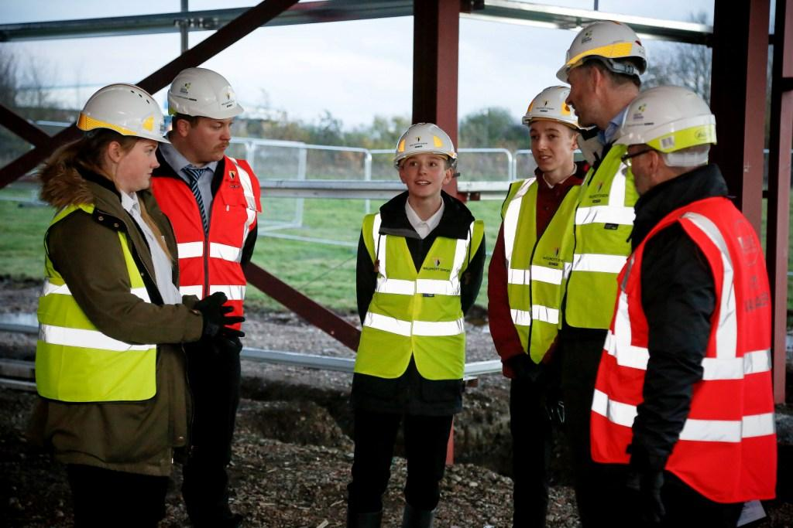

About the sponsors

University of Sunderland
The University of Sunderland is one of a new generation of civic universities, innovative, accessible and outward looking, with global influence and remarkable local impact. Excellent teaching, internationally recognised research and an extensive business engagement portfolio all contribute to the University’s success.

Hitachi Rail Europe
Hitachi Rail Europe Ltd is one of the most significant inward investors in County Durham. The company is a total railway system supplier offering rolling stock, traction equipment, signalling, traffic management systems and maintenance depots. Hitachi draws on many years of experience as a leading supplier of metro, commuter and high-speed trains such as the Shinkansen (bullet train) for the Japanese and international markets. The new manufacturing and assembly plant in South Durham is being developed to support the Department for Transport-led Intercity Express Programme and future Hitachi projects.

Gestamp Tallent
Gestamp Tallent Ltd is part of Gestamp Automocion, an international group dedicated to the design, development and manufacture of metal components and structural systems for the automotive industry. Today, Gestamp Automocion is present in 22 countries, has 95 production centres across the world and employs over 25,000 people. In line with the demands of global customers for a global supply network, Gestamp is a truly international business, but the British operation has remained as robust as ever. As one of the five plants within the UK, the Newton Aycliffe plant is one of the region’s largest employers with a workforce of over 1,400 people.

How to apply

Applicants are required to submit an electronic application form which is downloadable from www.utcsouthdurham.org/vacancies. Applications should be returned to jobs@utcsouthdurham.org by the closing date.

To arrange an informal discussion, please email: Tom Dower, Principal, tom.dower@utcsouthdurham.org

