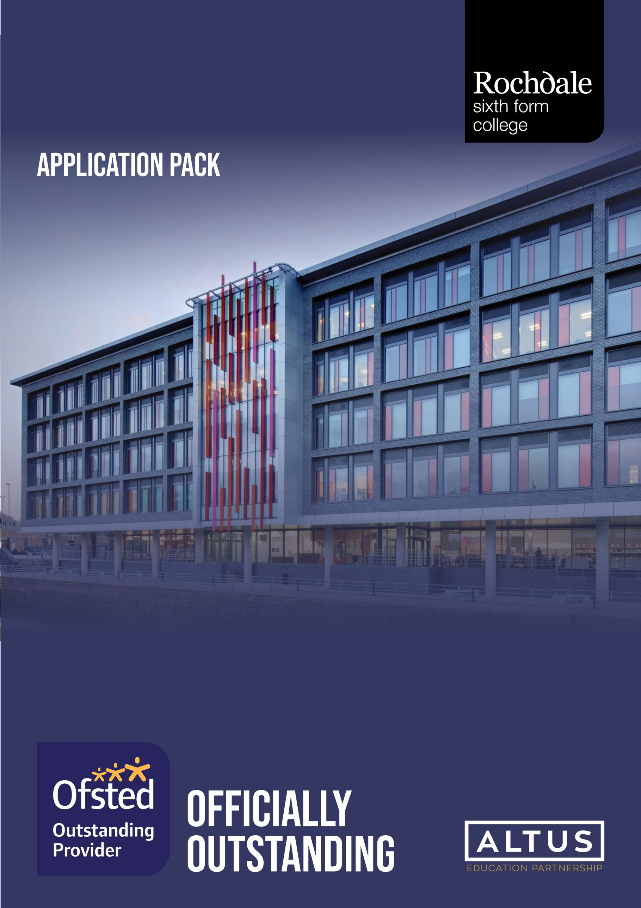
Cleaner

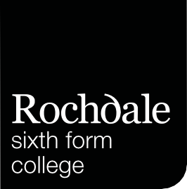

Thank you for your interest in working at Rochdale Sixth Form College. I hope that you will find this pack useful in completing your application.

Rochdale Sixth Form College (RSFC) opened in 2010 to address the significant underachievement in A Level performance in the borough. Since then, it has raised achievement in the area dramatically and is recognised nationally as a centre of excellence. The college is rated Ofsted outstanding and, is consistently ranked as one of the highest performing colleges in the country according to the DfE's performance tables and national achievement rate tables.

The Altus Education Partnership was formed in April 2017. It is a multi-academy trust formed by the governing body of Rochdale Sixth Form College and dedicated to the improvement of education in the borough of Rochdale. The Trust's mission arose from and builds upon the successes and values of the sixth form college. In short, our mission is to create a family of academies from early years to 18 that enables students in the borough to progress to an aspirational career, a fulfilling life and to make a positive contribution to society.

To work at RSFC you must aspire to be an outstanding colleague. You must be willing to share and learn. You must be prepared to go the extra mile, be a leader not a follower. Above all else, you must like young people and aspire to make them outstanding citizens.

We wish to appoint someone who will help us to continue to make a positive difference to the lives of young people in the borough. In return we promise a supportive and enjoyable working environment, and the resources needed to carry out the role to the highest standards.

I very much look forward to hearing from you.

Yours faithfully
Karl Smith
Principal
Making your application

I hope that when you read this pack you are inspired to apply for the post.

Application

- Complete the Altus Education Partnership application form.

- Provide a supporting statement of no more than two sides of A4 which should address the criteria in the person specification.
- Send your completed application form by email to recruitment@altusep.com

Deadline

The deadline for the post is Monday the 28th of January 2025, to arrive no later than 12.00pm.

The interview date is the 6th of February 2025.

Shortlisting

We will unfortunately be unable to notify candidates who are not on the shortlist; therefore, if you have not heard from us your application has been unsuccessful on this occasion.

Salary

The post will be paid on the Sixth Form Colleges Support pay spine, Scale Point 3, currently £22,312.00 per annum. Actual for term-time only plus 4 weeks is £9,093.12 per annum.

Start Date

As Soon As Possible

For an Application Form

- Visit www.rochdalesfc.ac.uk or www.altusep.com
- Contact: recruitment@altusep.com

Altus EDUCATION Partnership is committed to safeguarding and promoting the welfare of children, young people and vulnerable adults and expects all staff to share this commitment. This position is subject to an Enhanced DBS check under the Rehabilitation of Offenders Act 1974.

In accordance with the recommendations set out in KCSIE the Trust carries out online searches on shortlisted candidates.

RSFC Vision, Mission, Values & Beliefs

Our Vision

We aim to be the Sixth Form College of choice for the young people of the Borough of Rochdale and aim to develop confident and articulate students, respectful and respected, capable of independent and critical thought and appropriately prepared for higher-level achievement.

Our Mission

At RSFC our central purpose is to help our students realise their academic potential. We believe every young person can succeed and we devote ourselves to improving student achievement, through high quality teaching and student support. Our young people are challenged to achieve through high expectations within a "you can do it culture". We always aim to build aspiration, to inspire and to motivate our students so they have the opportunity for greater choice in life.

Our Values and Beliefs

As a Sixth Form College and as individuals we value and champion:

Care for the Individual, Empathy and Compassion– our priority is to connect with our students, be interested in their lives and backgrounds and listen actively to what they say, treating every student in every class as an individual and continuously boosting their self-esteem and confidence, whilst showing empathy and compassion towards their needs.

Achievement, Success and Excellence – an unceasing focus to improve standards of academic achievement to better the lives of our students, and a passionate desire for their success through a culture of high expectations and aspirations.

Learning, Creativity, and Innovation – we are driven to pursue effective learning for all students and first class teaching and support by all colleagues – day in, day out.

Relationships, Collaboration and Teamwork – students and staff working together to foster a real sense of community and mutual respect. A partnership with parents/carers to ensure our 16–19-year-olds are confident and mature individuals who can become responsible and valued members of our wider society. We maintain close and meaningful partnerships with schools, other colleges, and universities to further enhance the learner journey. Relationships with our community in Rochdale will reflect our commitment to the social and economic well-being of the Borough and increase the range of opportunities for our students to become active citizens.

Inclusivity, Belonging and Respect – we embrace diversity and strongly commit to the equality of opportunity for students, staff, their friends and families and our wider community to create a sense of belonging.

Honesty, Openness and Fairness – the life of the College community is based on the values of honesty and fairness, and we commit to conducting ourselves with openness, trust, and respect for the individual.

Positivity, Enthusiasm and Fun – shown by and towards all students and staff at RSFC.

The Ambition is that by the time students leave RSFC they will:

    - Have achieved their personal academic potential giving them a greater choice in life
    - Have the highest aspirations and developed the self-esteem, confidence, and emotional resilience to exploit their potential
    - Be contributing members of the community and have compassion for others
    - Be able to celebrate their success and that of others
    - Have developed the confidence to overcome barriers to success
    - Be articulate, creative, and prepared for future growth and learning
    - Be happy!

Shared Objective for all Staff

"To maximise students' achievements"

    - At RSFC we do this through engaging our students in their subjects and inspiring them to enjoy their studies in a totally positive atmosphere
    - Our students are challenged to achieve through a culture of high expectations and a belief in their ability
    - Above all, staff at RSFC like their students and demonstrate this through their daily conduct and interaction

Working for Altus

We have a wide range of competitive employee benefits to offer for all members of staff in our trust.

- PAM Assist wellbeing app – all staff have access to the PAM assist mental wellbeing app and phoneline, this is a 24/7 service that is external to the trust. We encourage all staff to use this app and helpline for all confidential mental health issues.
- Your Trust Gym Memberships – all Trust staff have access to our exclusive membership deal via Your Trust fitness facilities. The deal consists of a 10% discount to monthly and yearly memberships at: Rochdale Leisure Centre, Littleborough Sports Centre, Middleton Arena, Heywood Sports Village and Hollingworth Lake Water Sports – contact HR for more details.
- Cycle-to-work Scheme – all staff have the ability to sign up to the government cycle to work scheme. This is a salary sacrifice to purchase a bike to use to commute to work. The salary sacrifice will provide a discount to your income tax on each payment that the payment is deducted from.
- Highfield Private Hospital – we also offer a “MyWay Membership” via Highfield Private Hospital for access to various private healthcare benefits. You can gain extra healthcare benefits including 24/7 virtual consultancy and discounted specialist GP appointments, starting from £19.99 per month.
- Pension Scheme – all staff are automatically enrolled into either the Teachers’ Pension Scheme or Greater Manchester Pension Scheme, the pension contributions are both paid from the employer and employee before tax, providing a discount to tax towards your pension. This scheme can be left at any time upon request from the employee.

Job Description

Job Title: | Cleaner
Number of Posts: | 1 post available.
Reports to: | Cleaning Manager
Remuneration:
Contract: | Permanent – Term-time only plus 4 weeks.
Start Date: | ASAP

Overall Purpose of the Post
- To undertake general cleaning of the building including deep cleans and detailed cleaning tasks, including cleaning classrooms, corridors, and toilets.
- General housekeeping/health and safety checks.

Responsibilities and Roles

- In the event of any spillages immediately clean and make safe the area.
- Ensure that students are always behaving appropriately in line with the schools’ behaviour policy and deal with any inappropriate behaviour according to the behaviour policy.
- To engage with the students during lunch time, ensuring that it is a positive experience, promoting healthy eating and assisting any that may need additional support.
- Deal with any first aid incidents.
- Operate cleaning equipment and use designated chemicals and other cleaning products safely and in accordance with instructions.
- Refilling and restocking cleaning supplies and toiletries (handwash, toilet paper, paper towels).
- Ensuring sufficient supplies of cleaning products and equipment are ordered and maintained.
- Checking and maintaining of cleaning equipment to ensure they are fit for purpose.
- To make lunch times an enjoyable experience for all.
- Be a strong, positive role model for the students.

 |  |  | Assessed by:
No. | CATEGORIES | Essential/  Desirable | App  Form | Interview
QUALIFICATIONS AND EXPERIENCE
1 | Appropriate knowledge of first aid or willing to train. | E | √ | √
SKILLS AND KNOWLEDGE
2 | Experience of cleaning and using appropriate cleaning equipment. | E | √ | √
3 | Knowledge/understanding of Health & Safety including COSHH regulations. | E | √ | √
4 | Ability to stay calm and be patient and understanding when dealing with the students. | E | √ | √
5 | To be able to deal fairly and consistently when dealing with the students. | E | √ | √
6 | High degree of energy, resilience, and enthusiasm | E | √ | √
7 | Have excellent oral communication skills and a calm and confident manner | E | √ | √
8 | To be able to take charge of students if needed and maintain acceptable behavioural standards. | E | √ | √
9 | To be able to work as part of a team or work alone and use own initiative. | E | √ | √
10 | Able to maintain confidentiality. | E | √ | √
11 | Understanding of matters relating to safeguarding of children in terms of their health, safety, welfare, and mental wellbeing. | E | √ | √

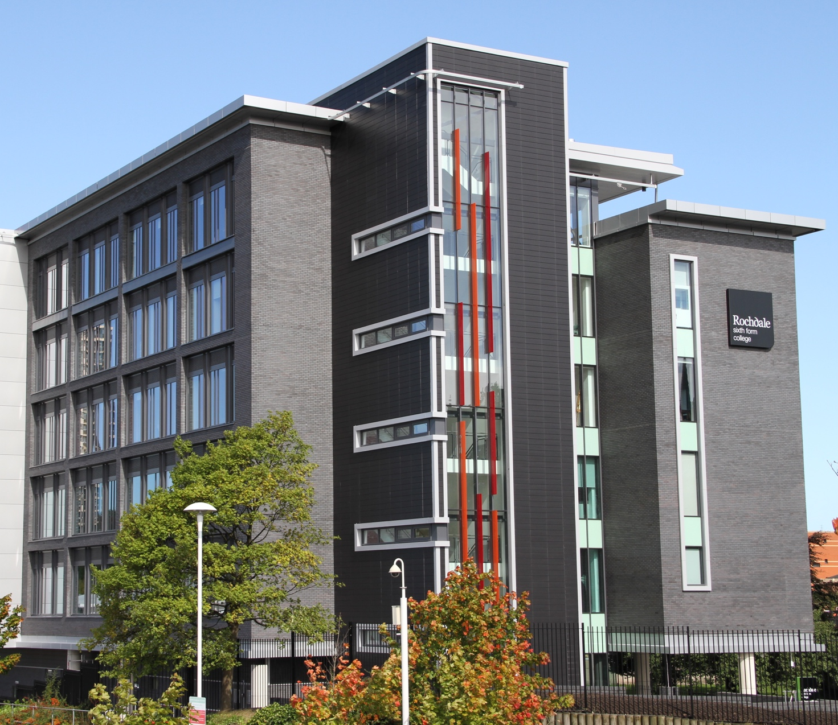

Rochdale Sixth Form College
College Road
Rochdale
OL12 6HY

Tel: 01706 769800
Email: info@rochdalesfc.ac.uk

www.altusep.com
Altus Education Partnership
College Road
Rochdale
OL12 6HY

Tel: 01706 769800
Email: info@alltusep.com

www.altusep.com

