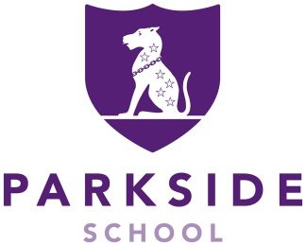

Maths Teacher

Apply by: 3rd October 2023
Interviews: 12th and 13th October 2023
Salary: Competitive Parkside Pay Scale
Location: Cobham, Surrey
Contract type: Permanent
Position: Full-time
Start Date: As soon as possible

Parkside School is a boys’ independent Preparatory School and co-ed Nursery, with a strong, nurturing and family ethos; set in beautiful grounds of 45 acres and only 40 minutes to London.

We are looking to appoint an outstanding and enthusiastic Maths Teacher, who is inspirational and passionate about teaching. Our thriving and well-resourced School has excellent facilities, a dynamic and diverse curriculum and a vibrant, happy, strong and dedicated staffing body. This is an exciting opportunity to join a successful school dedicated to the highest standards of teaching, learning and care, as reported in our recent ISI Inspection September 2022.

The successful candidate will have experience of or demonstrate the potential to deliver excellence, work within an already successful team and motivate the pupils to achieve their full potential. Experience of teaching Years 5 – 8 is essential and the ability to offer another subject would be an advantage.

For further details including the Job Description and Application Form please go to the School’s website: www.parkside-school.co.uk

To be considered for the post please return the completed Application Form by the closing date as indicated on the advert to the HR Officer by email: hr@parkside-school.co.uk

SAFER RECRUITMENT STATEMENT: Parkside School is committed to safeguarding and promoting the welfare of children, young people and expects all staff and volunteers to share this commitment. Applicants must be willing to undergo child protection screening, including checks with past employers and the Disclosure and Barring Service. We particularly welcome applications from under-represented groups including ethnicity, gender, transgender, age, disability, sexual orientation or religion.

IAPS boys’ day school with a co-educational Nursery
260 pupils aged 2-13 years



September 2023

