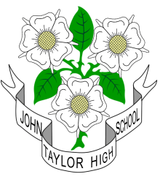
 JOHN TAYLOR HIGH SCHOOL
Dunstall Rd, Barton under Needwood,
Burton upon Trent, Staffs DE13 8AZ

mixed 11-18 comprehensive with over 1550 students on roll
including nearly 400 at post 16

“Outstanding”
(OFSTED 2014)

Requires a Cover Supervisor to supervise whole classes during the short-term absence of teaching staff and to undertake administrative tasks when not covering classes.

You will be required to work 32.5 hours per week
(Term-time only)

Payable on Grade 5 SCP 16 - 20
Pro-rata salary range: £15,060 - £16,799

For further details and an application form please visit:-
JTHS website: www.jths.co.uk
Once completed please return to recruitment@jths.co.uk

Closing date 9am Friday 5th January 2018
Start date: as soon as possible

This school is committed to safeguarding and promoting the welfare of children and young people/vulnerable adults and expects all staff and volunteers to share this commitment
An enhanced disclosure check will be a requirement of the post.

